Focus on Success
Presents
Success Building Program:
“A Road to Success”
Program Workbook

Overcoming Life’s Obstacles through Stress Management

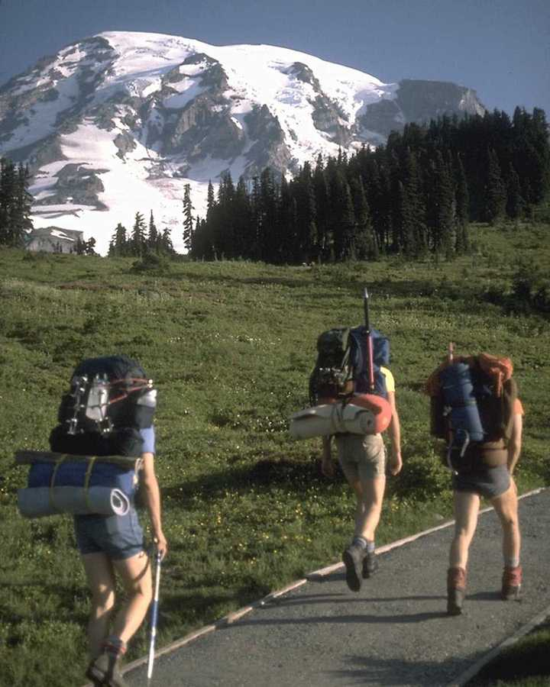
Success is the Journey not the Destination…

Developed by

Robert Knapick, LMFT, QMHP

Workbook Index

Page Title Page Number

Acknowledgements 3

Forward 4

How To Use This Program 5

Module 1- Making A Plan: An Overview Of Stress Management 6

Module 2- Assessing Your Life: What Stresses You 11

Module 3- Adjusting Your Attitude: Understanding Your Feelings 18

Module 4- Equipping Yourself For Your Journey: Assertion Training 21

Module 5- Training: Relaxation Skills For Daily Living 24

Module 6- Mapping Your Journey: Goal Setting 28

Module 7- Setting Your Course: Time Management 35

Module 8- Establishing A Base Camp: Healthy Living 40

Module 9- Taking Personal Inventory: Improving Your Self Esteem 44

Module 10- Making The Climb: Putting It All Together 47

Our Final Thoughts 57

About The Author 58

References 60

Acknowledgements

The author would like to acknowledge the efforts and contributions fellow professionals made in the development of this program. The long hours and hard work that the author has put in to the development of this program have resulted in this completed program. The author believes that this program resulted from his 30+ years of professional experience in the human services field.

The author would like to thank all of the individuals who have successfully completed this program. The positive feedback that was received by the author from these individuals helped to motivate the author to market this program to a national market.

Robert Knapick, LMFT,QMHP

Forward

It has taken several years to develop this program and to field test it and to publish it and to bring it to national distribution. This program embodies the knowledge and the 30 years of professional experience that the author has accumulated and focused upon the development of this program.

The development of this program required hundreds of hours of thought, writing, programming and proof reading by the author. This program was written with the idea in mind that family members were going to use this program to improve the quality of their lives while improving their coping skills and stress reduction abilities. This program is a labor of love by the author in his attempt to make the world a better place and to improve the human condition.

The author acknowledges that there are many books and programs that have been written on the subject of stress management. However, this program is unique because the author has worked the program himself and has had family members work the program. As a result of working this program, I am pleased that family members noted improvements, after they worked this program. In addition, I have been using this program in my private practices for several years and I have been given feedback, by my clients, that it works!

What also makes this program unique is the electronic and paper formats of the program which allow individuals to work the program in different formats depending upon their particular needs. You will find this program to be “user friendly” in that it is written in a straight-forward and concise manner that is easy to complete.

This program is designed to be educational and self help in its approach. It is designed to assist you in your efforts to improve yourself and the quality of your life. We believe that you can improve your stress management knowledge and skills in the comfort of your own home or office. It is not intended to replace professional counseling or psychotherapy services if they are needed.

We want to thank you for purchasing this program and for embarking on this program of stress management skill development as a part of your quest for self-knowledge and improvement.

The Author

How To Use This Workbook

This workbook was designed to be user friendly and to be an important aid to you in the learning process. Each exercise that appears in this workbook is also located in the computer program that you have purchased with this workbook. Each exercise in this workbook is numbered to correspond with the exercise in the computerized version of this program. When an activity in the workbook is labeled as number 1.1, it is also 1.1 in the computer program. This will allow you to easy switch between the computer program and the workbook for learning and task completion purposes.

We advise that you start out working the program at a pace that is consistent with your learning style and preference. We recommend that you work slowly and steadily at first so that you can become familiar with the learning activities and how you can optimally respond to them in the most efficient manner.

This program was designed by the author to maximize your learning experience while providing you with hands on learning activities. I believe that learning occurs in various forms for each of us and we have provided you with a multi-sensory learning experience. There are “notes from the author” at the bottom of each exercise page that offer encouragement and information about the exercise and how to proceed on through the program.

The index in this workbook offers you the exact page locations of each learning activity so that you can have this information at your finger tips. In addition, each learning module has a tab that identifies it for the learner. Each module is located sequentially for your immediate use. The learning activities match up with the exercises in the computer program so that you can use the computer program and the workbook simultaneously together.

Now that you are ready to begin on your journey through the stress management program and the accompanying workbook, we want to take this opportunity to wish you success on your path to stress free living and happiness.

I want to thank you for your purchase of this program and for your motivation to eliminate your stress and improve the quality of your life.

The Author

Module 1

Making A Plan:
An Overview of Stress Management

Murphy’s Law States:
Anything that can go wrong will go wrong!

Road to Success States:
Anything that can go wrong will go wrong, so be prepared…


Soar To New Heights With Module One
What is Your Stress Level?

Personal Stress Assessment (Activity 1.1)

Read each statement below and then circle the number under the heading at the right that best describes your situation…

Statement | A  Not True or Rarely True | B  Sometimes True | C  Often or Always True
My sleep patterns have changed. | 1 | 2 | 3
I am often angry or irritable. | 2 | 3 | 4
My concentration and attention span are not good. | 1 | 2 | 3
I am using drugs, legal or illegal, to lower my stress. | 3 | 4 | 5
I seem to be having more accidents or making more mistakes. | 2 | 3 | 4
I feel like running away from everything | 3 | 4 | 5
I have frequent daydreams about a better time and place. | 1 | 2 | 3
I have destroyed property or caused injury in anger. | 3 | 4 | 5
I have more and more sickness and health problems. | 2 | 3 | 4
My memory is no longer reliable and seems to get worse, not better. | 2 | 3 | 4
I use gambling or shopping to forget about my troubles. | 3 | 4 | 5
I have nightmares. | 1 | 2 | 3
I feel I have a lot of responsibilities but not much authority. | 1 | 2 | 3
How I feel and what I do bothers me and seems to concern others. | 3 | 4 | 5
My appetite has either increased or decreased dramatically in recent times. | 2 | 3 | 4
More and more I prefer my own company and I actively avoid social contacts. | 2 | 3 | 4
I do not have enough time to do what needs to be done. | 1 | 2 | 3
I believe that I have stress related problems, which are serious. | 3 | 4 | 5

Total each Column
Add the totals at the bottom of all three Columns | A
 | B
 | C

Total of all three Columns

If you have a score of: 36-44 You have a Low Level of Stress
  - You have a Moderate Level of Stress
63-72 You have a High Level of Stress
How will this assessment and “A Road to Success” help me?

Now that you have taken the stress assessment, you have a score to interpret and to follow up on. The scores for this measure are as follows:

If you have a score of: 36-44 You have a Low Level of Stress
  - You have a Moderate Level of Stress
  - You have a High Level of Stress

If you scored between 36-44 this indicates that you presently are experiencing a Low Level Of Stress. However, that could change tomorrow! If you are presently experiencing a lower level of stress, this will allow you to take the time to address the stressors in your life one at a time. You have the good fortune of being able to spend your time and energy resolving your stressors without feeling compelled to act to “put out a fire”.

If you scored between 45-63 this indicates that you are presently experiencing a Moderate Level of Stress. This indicates that you are likely not overwhelmed at this time, but the addition of any additional stressors may over whelm you and exceed your coping capacities. You need to take action to begin to resolve your stressors immediately. Our program will give you the tools to begin work immediately upon your identified stressors so that you can gain relief from them.

If you scored between 63-72 this indicates that you are presently experiencing a High Level Of Stress. This indicates that you may presently be over whelmed or nearing that point. You need to take immediate action to begin to resolve your stressors. Our program will give you the tools to begin work immediately upon your identified stressors so that you can gain relief from them. Please do not delay starting on your stress management program today!

A note from the author: No matter what circumstance you find yourself in with regard to your stress levels, our program will assist you to resolve your stress and to improve your coping skills immediately. No stressor is too big or too small to address with our program.

Assessing Your Response to Stress (1.2)

We respond to stress and its demands individually. Our reactions tend to vary according to the situation and our perception of our ability to cope.

To better understand your coping style(s) that you use when you encounter stress:

- On a scale from 1 to 4, place a mark on the line to indicate how you respond in each area. For example, if you tend to get overwhelmed very often, place a mark under the “1” or “2.” If you’re usually calm, make a mark under the “3” or “4.”
- Put stars next to your five strongest traits/behaviors. You will want to count on these strengths to help you meet the new expectations of your circumstances. Remember these for use later in the Stress Management Program.
- Circle the five traits/behaviors that you struggle with most. These will require intervention.

1 2 3 4
Overwhelmed _____________________________________ Calm
Controlling _____________________________________ Ability to let go
Tense _____________________________________ Relaxed
Depressed _____________________________________ Upbeat/Cheerful
Rigid _____________________________________ Flexible
Exhausted _____________________________________ Energetic
Fearful _____________________________________ Challenged
Dependent _____________________________________ Self-reliant
Insecure _____________________________________ Confident
Impatient _____________________________________ Patient
Defensive _____________________________________ Open
Humorless _____________________________________ Sense of humor
Risk avoidance _____________________________________ Risk seeking
Moody _____________________________________ Even-tempered
Passive _____________________________________ Assertive
Disorganized _____________________________________ Organized
Pessimistic _____________________________________ Optimistic
Closed to change _____________________________________ Open to change
Negative body language _____________________________________ Positive body language

A note from the author: Make a list of the responses that indicate that you get overwhelmed and the responses that indicate that you cope with them successfully. Keep these lists for use later in the Stress Management Program. Be thinking about your reactions and about which reactions that you may want to change in the future. Next, work on the Personal Stressors Chart and fill it in with what you know about your stress patterns.

My Personal Stressors Chart (1.3)

Stressor | My Reaction  To The Stressor | Yes/No-Can I Control This? | Positive Response  To The Stressor

Module 2

Assessing Your Life:
What Stresses You?

Murphy’s Law States:
It is impossible to make anything fool proof because fools are so ingenious.

Road to Success States:
Preparation for Life’s Pitfalls, is 90% of the Journey


Take Off With Your Learning In Module 2 of the Stress Management Program

Exercise 2.1

- Why is it important to identify your stressors? What are some of yours?
______________________________________________________________________________________________________________________________________________________________________________________________________________________________
__________________________________________________________________________

2. What can you do to recognize your stress sources and your daily stressors and become
aware of them in your daily living?
______________________________________________________________________________________________________________________________________________________________________________________________________________________________

3. What can happen if you don’t recognize or become aware of your stress levels and stressors?
______________________________________________________________________________________________________________________________________________________________________________________________________________________________

4. How do you manage your stressors? Does that vary from situation to situation? If so, how?
______________________________________________________________________________________________________________________________________________________________________________________________________________________________

5. What can you do to modify and/or change your stressors?
______________________________________________________________________________________________________________________________________________________________________________________________________________________________

6. How can I apply this new learning to reduce my stress today? Apply it in my thinking or
in my actions?
______________________________________________________________________________________________________________________________________________________________________________________________________________________________

A note from the author: This activity is designed to get you thinking about your stress and what you can do about it. This activity will assist you to begin the stress management process.

How To Take Control Of Your Stress (Exercise 2.2)
Determine what stressors can be controlled and what cannot be controlled. Avoid wasting time and energy on what you can’t control; focus on where you can make a difference. These actions are basic to managing stress.
- Mastery is taking action on things you can control related to your stress.
- Letting Go is not trying to do the impossible. It involves accepting the situation and moving ahead.
- Wheel Spinning is trying to affect things beyond your control that are causing you stress.
- Giving Up is not taking action on things you could do something about. It is acting helpless and like a victim. This prolongs your stress reactions.

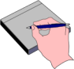 | My Personal Power Grid For Managing My Stressors:  For a recent stressor, indicate the actions you need to take (or stop) in each of the four areas.

 | I Can Control The Stressor |  | I Cannot Control The Stressor
Taking Action | I Can Obtain Mastery Of: |  | I Am Spinning My Wheels About:
 | Risk Zone
Taking  No Action | I Am Giving Up On: |  | I Am Letting Go Of:

A note from the author: This exercise will allow you to begin to take charge of your personal stressors and will provide you with the opportunity to rank them in the four categories listed above. You can decide which stressors you want to master and which ones you want to let go of. Use this page over and over again over time so that you can continue your stress management activities well into the future.

Stress Adjustment Scale (Activity 2.3)
List points for events, which you experienced within the past six months or are experiencing.

Points Event Scale of Impact
______ DEATH OF SPOUSE 100
______ DIVORCE 73
______ MARITAL SEPARATION 65
______ JAIL TERM 63
______ DEATH OF CLOSE FAMILY MEMBER 63
______ PERSONAL INJURY OR ILLNESS 53
______ MARRIAGE 50
______ FIRED AT WORK 47
______ MARITAL RECONCILIATION 45
______ RETIREMENT 45
______ CHANGE IN HEALTH OF FAMILY MEMBER 44
______ PREGNANCY 40
______ SEX DIFFICULTIES 39
______ GAIN OF NEW FAMILY MEMBER 39
______ BUSINESS READJUSTMENT 39
______ CHANGE IN FINANCIAL STATE 38
______ DEATH OF A CLOSE FRIEND 37
______ CHANGE TO DIFFERENT LINE OF WORK 36
______ CHANGE IN # OF ARGUMENTS IN FAMILY 35
______ MORTGAGE OVER $30,000 31
______ FORECLOSURE OF MORTGAGE OR LOAN 30
______ CHANGE IN RESPONSIBILITIES AT WORK 29
______ TROUBLE WITH In-Laws 29
______ OUTSTANDING PERSONAL ACHIEVEMENT 28
______ SPOUSE BEGINS OR STOPS WORK 26
______ BEGIN OR END SCHOOL 26
______ CHANGE IN LIVING CONDITIONS 25
______ REVISION OF PERSONAL HABITS 24
______ TROUBLE WITH BOSS 23
______ CHANGE IN WORK HOURS OR CONDITIONS 20
______ CHANGE IN RESIDENCE 20
______ CHANGE IN SCHOOLS 20
______ CHANGE IN RECREATION 19
______ CHANGE IN CHURCH ACTIVITIES 19
______ CHANGE IN SOCIAL ACTIVITIES 18
______ MORTGAGE OR LOAN LESS THAN $10,000 17
______ CHANGE IN SLEEPING HABITS 16
______ CHANGE IN # OF FAMILY OUTINGS 15
______ CHANGE IN EATING HABITS 15
______ VACATION 13
______ MINOR VIOLATIONS OF THE LAW 12
______ MAJOR HOLIDAYS 11
______ TOTAL POINTS

Persons who have total points of 300 or more have an 80% higher chance of developing a major illness that those below 300. That does not mean that you should panic or think that you are going to have a heart attack or some type of physical crisis. What it does mean is that you have encountered significant stressors and you are attempting to cope with them. The higher the score that you obtain, the greater the self care and support you should obtain. You have been coping with stress for years. A higher score means that you need to immediately attempt to eliminate some of your identified stressors and focus upon increased self- care and support.
The Stress Adjustment Scale was just presented on the last page. It is part of your stress assessment. Please complete it and then review your score to determine your total points on the scale. Then, make a list of your identified stressors and write the points for each one next to that particular stressor. Next, look at the stressors and rank order them in order of importance and priority. Then, ask yourself the following questions and answer them in Exercise Activity 2.4:

1. What identified stressor(s) can I work on and change that have a higher probability of getting resolved and reducing my over all stress level?

____________________________________________________________________________________________________________________________________________________________________________________________________________________________________________________________________________________________________________

2. What identified stressor(s) can I ask someone to assist me with that have a higher probability of getting resolved and reducing my over all stress level?

____________________________________________________________________________________________________________________________________________________________________________________________________________________________________________________________________________________________________________

3. What stressor(s) depend on some actions being taken by others and can I request that the action be taken so that the stressor(s) will have a higher probability of getting resolved and reducing my over all stress level?

_______________________________________________________________________________________________________________________________________________________________________________________________________________________________________________________________________________________________________________________________________________________________________________________

4. What stressor(s) are immediate and which ones are capable of being postponed until I have a higher probability of being successfully resolved at some future time?

____________________________________________________________________________________________________________________________________________________________________________________________________________________________________________________________________________________________________________

5. What stressor(s) are out of my control that I should be aware of but not try and continue to worry and fret about them to the detriment of my mental health and well being and daily functioning?

________________________________________________________________________________________________________________________________________________________________________________________________________________________________________________________________________________________________________________________________________

6. What stressor(s) are likely longer term that I have to develop a plan to cope with over the long haul?

________________________________________________________________________________________________________________________________________________________________________________________________________________________________________________________________________________________________________________________________________

7. What stressor can I start work on today that has a high probability of improving today or soon?

________________________________________________________________________________________________________________________________________________________________________________________________________________________________________________________________________________________________________________________________________

8. What stressor(s) can I turn over to my Higher Power to let it go so I can go on with my plan?

________________________________________________________________________________________________________________________________________________________________________________________________________________________________________________________________________________________________________________________________________

9. What stressor(s) will probably remain the same if I do nothing about it?

________________________________________________________________________________________________________________________________________________________________________________________________________________________________________________________________________________________________________________________________________

10. What stressor(s) are wasting my time that I can write on a piece of paper and throw it away
and finally be done with it?
______________________________________________________________________________________________________________________________________________________________________________________________________________________________

11. Has stress become my life or can I reclaim my life or can I decide to live a quality life in spite of the stress that I am encountering.
______________________________________________________________________________________________________________________________________________________________________________________________________________________________

Exercise 2.5

- What are three physical signs/symptoms of stress that you are experiencing?
______________________________________________________________________________________________________________________________________________________________________________________________________________________________

- Do you think that you are having psychosomatic symptoms? If so, what are they?
______________________________________________________________________________________________________________________________________________________________________________________________________________________________

- What warning signs of stress are you having?
______________________________________________________________________________________________________________________________________________________________________________________________________________________________

- What stress sign is most important to you? Which one is least important to you?
______________________________________________________________________________________________________________________________________________________________________________________________________________________________

- What can you do to prevent stress signs/symptoms?
______________________________________________________________________________________________________________________________________________________________________________________________________________________________

A note from the author: Stress affects every aspect of your life. It is important to understand the impact that stress has upon you in your daily living. This exercise is designed to assist you to identify your warning signs of your stress and to inform you about the physical impact of stress on your body.

Module 3
Adjusting Your Attitude:
Understanding Your Feelings

Murphy’s Law States:
If there is a possibility of several things going wrong the one that will cause the most damage will be the one to go wrong.

Road to Success States:
Attitude: If we allow ourselves to make mistakes and learn from them,
we can never fail.

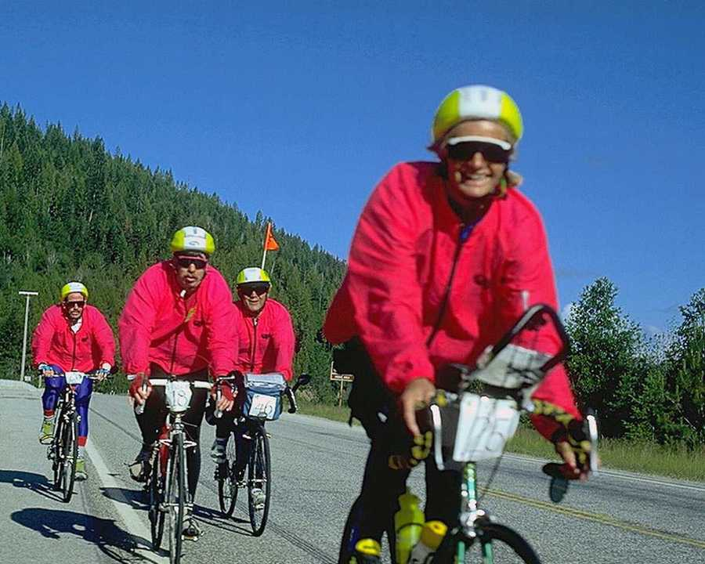
You’re On Track To Stress Management....
Exercise 3.1

- List 5 positive feelings that apply to you?
______________________________________________________________________________________________________________________________________________________________________________________________________________________________

- What made you choose those feelings?
______________________________________________________________________________________________________________________________________________________________________________________________________________________________

- When do you have those feelings most?
______________________________________________________________________________________________________________________________________________________________________________________________________________________________

- List 5 feelings you would like to use that you are presently not using?
______________________________________________________________________________________________________________________________________________________________________________________________________________________________

- What can you do to help you develop those feelings?
______________________________________________________________________________________________________________________________________________________________________________________________________________________________

A note from the author: It is important to understand your feelings and how they work and how they contribute to your stress management activities. Your feelings are an important part of the stress management process. Your feelings influence your thoughts and vice versa. It is important that you pay attention to your emotions and that you understand their contribution to your daily functioning and activities and stress management skills.

Exercise 3.2

- List 5 negative feelings that apply to you?
______________________________________________________________________________________________________________________________________________________________________________________________________________________________

- How did you develop those feelings?
______________________________________________________________________________________________________________________________________________________________________________________________________________________________

- When do you have those feelings most?
______________________________________________________________________________________________________________________________________________________________________________________________________________________________

- List 5 feelings you would like to change?
______________________________________________________________________________________________________________________________________________________________________________________________________________________________

- What can you do to help you change those feelings?
______________________________________________________________________________________________________________________________________________________________________________________________________________________________

A note from the author: It is important to understand your feelings and how they work and how they contribute to your stress management activities. Your feelings are an important part of the stress management process. Your feelings influence your thoughts and vice versa. It is important that you pay attention to your emotions and that you understand their contribution to your daily functioning and activities and stress management skills.

Module 4

Equipping Yourself For Your Journey:
Assertion Training

Murphy’s Law states:
“If everything seems to be going well, you have obviously overlooked something. “

A Road to Success States:
“Mistakes are a part of life…
Be responsible for yours and everything will be okay.”

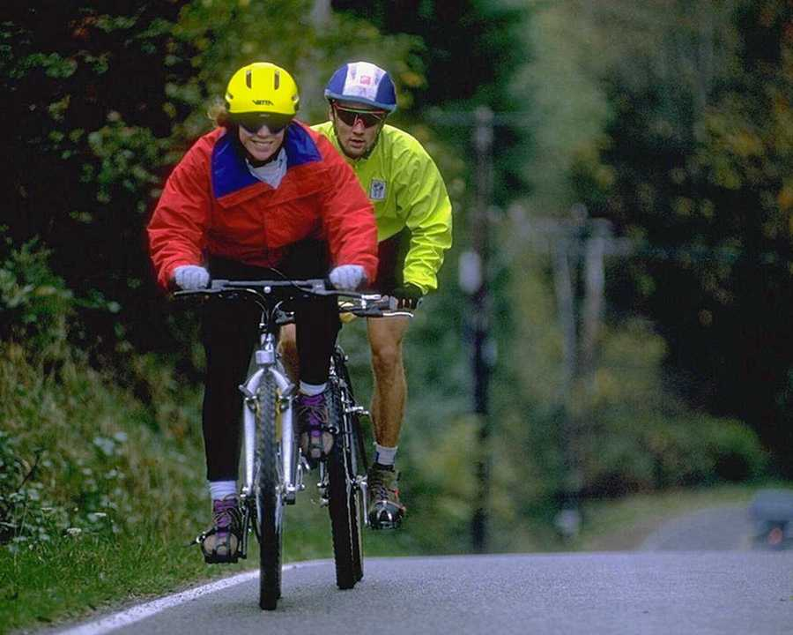
Continue Your Journey Through Module 4

Exercise 4.1

- How would you describe your assertiveness skills today?
______________________________________________________________________________________________________________________________________________________________________________________________________________________________

- What Right(s) do you feel you have difficulty standing up for?
______________________________________________________________________________________________________________________________________________________________________________________________________________________________

- Who/What makes you feel inferior and unable to stand up for your rights? Why?
______________________________________________________________________________________________________________________________________________________________________________________________________________________________

- What can you do if you feel inferior in certain situations?
______________________________________________________________________________________________________________________________________________________________________________________________________________________________

- What are three things you will do different the next time someone asked you to do something you don’t want to do?
______________________________________________________________________________________________________________________________________________________________________________________________________________________________

A note from the author: Stress can come from being used or abused by others. The abuse may or may not be intentional. It really does not matter. What matters the most is that we must stand up for ourselves when we need to. That does not mean that you should become aggressive or physical in your attempts to stand up for yourself. What it does mean is that you must develop assertiveness skills to use in situations that require their use. Being unassertive often means that you take better care of others than you do yourself. That is very stressful for you! Decide how you want to handle situations that require assertiveness and role play and practice them in the mirror or with someone you trust before you use them in real life.

Exercise 4.2

- What assertive techniques have you used in the past week? Were they successful?
______________________________________________________________________________________________________________________________________________________________________________________________________________________________

- What non-verbal skills do you use when you are assertive?
______________________________________________________________________________________________________________________________________________________________________________________________________________________________

- What assertive techniques are you willing to use to stand up for your rights?
______________________________________________________________________________________________________________________________________________________________________________________________________________________________

- What prevents you from standing up for your rights?
______________________________________________________________________________________________________________________________________________________________________________________________________________________________

- How will you feel when you stand up for your personal rights?
______________________________________________________________________________________________________________________________________________________________________________________________________________________________

A note from the author: Applying your assertiveness skills in real life is very important. Decide what techniques you want to apply and begin to use them. You are the boss when it comes to your assertiveness. It feels good to be equal to others and to be as important as they are.

Exercise 4.3

- How can you use reframing in your day to day life?
______________________________________________________________________________________________________________________________________________________________________________________________________________________________

- What is the goal of reframing? What goals do you try and accomplish using reframing?
______________________________________________________________________________________________________________________________________________________________________________________________________________________________
3. What is a problem that you can reframe immediately and start to solve?
____________________________________________________________________________________________________________________________________________________
____________________________________________________________________________________________________________________________________________________
4. Reframe the problem below in new terms that are more positive and will more likely lead
to the resolution that you are seeking:
__________________________________________________________________________________________________________________________________________________________________________________________________________________________________________________________________________________________________________________________________________________________________________________

A note from the author: Reframing means looking at something from another perspective. It allows you to make lemonade when life gives you lemons! There are so many ways of looking at things and we just have to find the one that works for us! Try reframing simple things first and them moving to more complicated ones.

Module 5

Training:
Relaxation Skills For Daily Living

Murphy’s Law states:
“When the plane you are on is late, the plane you want to transfer to is on time.”

A Road to Success States:
“When the world make too much noise…
escape by relaxing your mind through being at peace with yourself.”


Take A Moment To Relax Because You Are Half Way There!
Exercise 5.1

- What relaxation techniques are you presently using?
______________________________________________________________________________________________________________________________________________________________________________________________________________________________

- Plan a relaxation exercise that you can do each day!
______________________________________________________________________________________________________________________________________________________________________________________________________________________________

- What are 3 goals you have for learning relaxation skills and for relaxing?
______________________________________________________________________________________________________________________________________________________________________________________________________________________________

4. Where and when and how will you begin your relaxation activities?
______________________________________________________________________________________________________________________________________________________________________________________________________________________________

A note from the author: Relaxation is an important part of our lives. We need to build it into our daily living. Start putting relaxation back into your life if you do not already have it in your life.

Exercise 5.2

- What types of relaxation skills do you want to learn?
______________________________________________________________________________________________________________________________________________________________________________________________________________________________

- What type of relaxation do you feel you can utilize in your life?
______________________________________________________________________________________________________________________________________________________________________________________________________________________________

- What prevents you from relaxing? From taking the time to relax?
______________________________________________________________________________________________________________________________________________________________________________________________________________________________

- When and where can you relax?
______________________________________________________________________________________________________________________________________________________________________________________________________________________________

5. What do you need to obtain in order to start your relaxation process?
______________________________________________________________________________________________________________________________________________________________________________________________________________________________

A note from the author: Pick a relaxation skill and start working on developing it. You can get a relaxation CD or tape from any book store to assist you or you can make your own. We have a format listed in the stress management program in this module.
Ready or not, begin relaxing!

Exercise 5.3

- What resources do you have to help you become more relaxed?
______________________________________________________________________________________________________________________________________________________________________________________________________________________________

- Make a relaxation plan to help you in your everyday living?
______________________________________________________________________________________________________________________________________________________________________________________________________________________________

- Name three obstacles you have that prevent you from relaxing?
______________________________________________________________________________________________________________________________________________________________________________________________________________________________

- How can you overcome these obstacles?
______________________________________________________________________________________________________________________________________________________________________________________________________________________________

- How will you feel if you accomplish your goals for relaxation?
______________________________________________________________________________________________________________________________________________________________________________________________________________________________

We call have obstacles in our lives that seem to prevent us from doing what we want to do or from being who we want to be or having what we want to have. Find out what those obstacles are and side step them or minimize them in your daily living. You can relax and still accomplish what you want to accomplish!

Module 6

Mapping Your Journey:
Goal Setting

Murphy’s Law States:
The only perfect science is hind-sight.

A Road to Success States:
Meeting your long range goal is not as important as the success of meeting your short range goals.

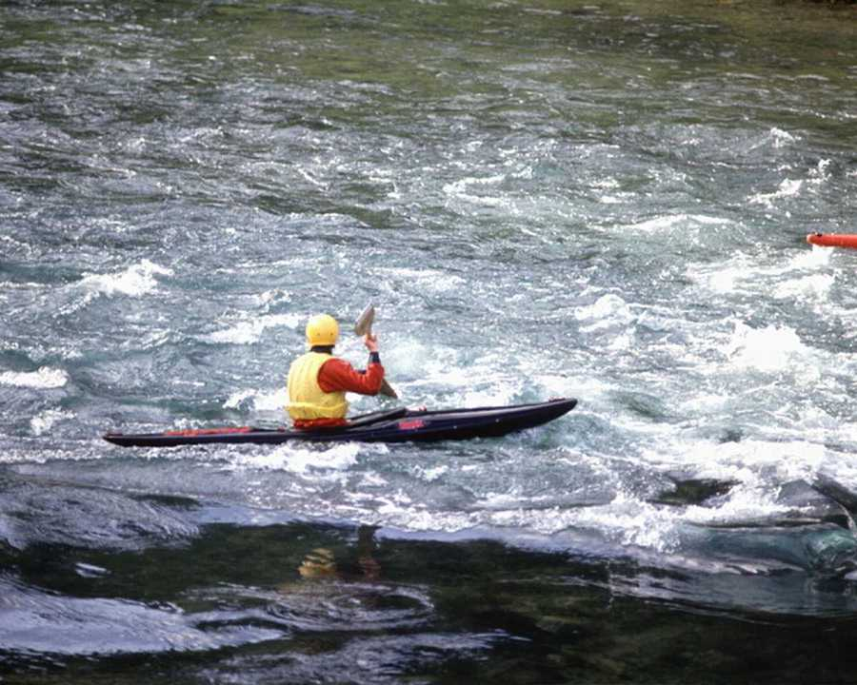
Sometimes, it’s easier to go down stream than up stream!

Exercise 6.1

- What beliefs keep you from achieving your goals? Do you self talk yourself out of the goal?
______________________________________________________________________________________________________________________________________________________________________________________________________________________________

- Do you make time to Plan your goals or do you just set them and wait for them to be achieved?
______________________________________________________________________________________________________________________________________________________________________________________________________________________________

- What steps do you need to complete in order to achieve your goal(s)?
______________________________________________________________________________________________________________________________________________________________________________________________________________________________

- What are three things you will do this week to start your goal?
______________________________________________________________________________________________________________________________________________________________________________________________________________________________

Exercise 6.2

The first step in reaching your goals is to list a several long range goals. This is one time that you can dream and wish for the stars. You can wish for a 36-foot sail boat, a college degree, a home, a $50,000.00 income, or any other dream you might have. List your Long Range Goals in the boxes below:

A note from the author: In order to change, we must have a plan or a map to plan the change. It is stressful to change without having a plan to do so. Ready, set, go!

Exercise 6.3

LIFE GOALS

Now choose three to four of your long range goals you wish to work on and use the following outline for each goal.

LIFE GOAL I:
_____________________________________________________________________________

_____________________________________________________________________________

LIFE GOAL II:
_____________________________________________________________________________

_____________________________________________________________________________

LIFE GOAL III:
_____________________________________________________________________________

_____________________________________________________________________________

A note from the author: Start with a long term goal and then work on refining that goal to the point where it is workable and can be accomplished.

Exercise 6.4

LIFE GOAL OUTLINE

Long Range Goal: _____________________________________________________________________________
__________________________________________________________________________________________________________________________________________________________

I. Medium Range Goal:___________________________________________________________
__________________________________________________________________________________________________________________________________________________________

Summary of Short Range Goals:
_______________________________________________________________________________________________________________________________________________________________________________________________________________________________________

II. Medium Range Goal:__________________________________________________________
__________________________________________________________________________________________________________________________________________________________

Summary of Short Range Goals:
_____________________________________________________________________________
__________________________________________________________________________________________________________________________________________________________

III. Medium Range Goal:_________________________________________________________
__________________________________________________________________________________________________________________________________________________________

Summary of Short Range Goals:
__________________________________________________________________________________________________________________________________________________________
__________________________________________________________________________________________________________________________________________________________

A note from the author: Please note that the Medium Range Goals are in relation to the Long Range Goals and the Short Range Goals are in relation to the Medium Range Goals. As one Medium Range Goal is met the next Medium Range Goal begins. This outline can be used for any project or projects you are working on. Start goal setting today so that you can begin the process of personal change and manage the stress that you are experiencing.

Exercise 6.5

- What are three long range goals for your life?
_____________________________________________________________________________

_____________________________________________________________________________

_____________________________________________________________________________

- How do your medium range goals contribute to rewards that you are seeking?
_____________________________________________________________________________

_____________________________________________________________________________

_____________________________________________________________________________

- List 3-5 rewards you can give to yourself when you complete a medium range goal?
_____________________________________________________________________________

_____________________________________________________________________________

_____________________________________________________________________________

- List 3 short range goals for this week.
_____________________________________________________________________________

_____________________________________________________________________________

_____________________________________________________________________________

5. How will you feel if you accomplish your goals for today?
_____________________________________________________________________________

_____________________________________________________________________________

_____________________________________________________________________________

A note from the author: Now is the time to put a plan into action. You can start today and begin work on your first plan knowing that you can change it at any time you like.

Exercise 6.6

- Name three rewards you like to receive for your efforts?
_____________________________________________________________________________

_____________________________________________________________________________

_____________________________________________________________________________

- How often do you reward yourself? Hourly, daily, weekly, monthly?
_____________________________________________________________________________

_____________________________________________________________________________

_____________________________________________________________________________

- Is there anything that prevents you from rewarding yourself?
_____________________________________________________________________________

_____________________________________________________________________________

_____________________________________________________________________________

- What are the benefits of receiving rewards for your efforts?
_____________________________________________________________________________

_____________________________________________________________________________

_____________________________________________________________________________

A note from the author: So often, we work so hard and may not get the benefit from the fruit of our labor. Life may not reward us, so we need to learn how to reward ourselves. It is not hard to learn how to enjoy rewards! Use them whenever you need to.

Module 7

Setting Your Course:
Time Management

Murphy’s Law States:
The legibility of a copy is inversely proportional to its importance.

A Road to Success States:
The Past is History, The Future is a Mystery and
The Present is a Blessing…


You Are Moving Rapidly Toward Your Goal Of Personal Stress Management!
Exercise 7.1

- How can you come to peace and understanding with your relationship with time?
_____________________________________________________________________________

____________________________________________________________________________

____________________________________________________________________________

- What are some goals you need to set in order to stop feeling like you are always behind
schedule?
_____________________________________________________________________________

_____________________________________________________________________________

_____________________________________________________________________________

- How can you make a to-do list effective for you?
_____________________________________________________________________________

_____________________________________________________________________________

_____________________________________________________________________________

- What prevents you from handling one piece a paper at a time?
_____________________________________________________________________________

_____________________________________________________________________________

_____________________________________________________________________________

Expert Alan Lakein, presents these simple, but powerful ideas to manage time wisely, so that we can work smarter, and not harder. Consider these when you are thinking about how to manage time. These are as follows:

I. LIST GOALS AND SET PRIORITIES THAT YOU CAN KEEP

II. MAKE A DAILY TO DO LIST AND THEN DO IT

III. HANDLE ONE PIECE OF PAPER AT A TIME

IV. DO IT NOW, NOT TOMORROW

V. MAKE TIME TO PLAY

A note from the author: Jim Croce had a song with this line in it, “If I could save time in the bottle, the first thing that I’d want to do”. It is a memorable line that has been repeated many many times. Time is our ally not our enemy. We can use it to our advantage instead of our detriment. Start using it wisely today!

Exercise 7.2

1. What irrational belief do you most identify with?

_____________________________________________________________________________

_____________________________________________________________________________

_____________________________________________________________________________

2. What are the sources of your irrational beliefs?

_____________________________________________________________________________

_____________________________________________________________________________

_____________________________________________________________________________

3. What steps do you need to make to prevent you from developing irrational beliefs?

_____________________________________________________________________________

_____________________________________________________________________________

_____________________________________________________________________________

4. What are three things you will do this week to challenge your irrational beliefs?

_____________________________________________________________________________

_____________________________________________________________________________

_____________________________________________________________________________

A note from the author: Our beliefs drive our actions. If we think irrationally, we will act irrationally. It is easy to let irrational beliefs creep into our heads. Then, we believe they are true and we respond accordingly.

EXERCISE 7.3

Turning Irrational Beliefs Into Rational Beliefs- Thought Substitution

You do not have to continue to have irrational beliefs if you do not want to. The steps to change irrational beliefs are not complicated and can be utilized whenever you need them. These steps are as follows:

1. Write down your irrational beliefs one at a time.

____________________________________________________________________________
____________________________________________________________________________
____________________________________________________________________________
____________________________________________________________________________

2. Pick one to start working on that will be somewhat easy to achieve.

____________________________________________________________________________
____________________________________________________________________________
____________________________________________________________________________
____________________________________________________________________________

3. Write down the irrational belief and the rational belief across from it.

____________________________________________________________________________
____________________________________________________________________________
____________________________________________________________________________
____________________________________________________________________________

4. Decide what thoughts and feelings and actions you will need to change in order to start the thought change process.

____________________________________________________________________________
____________________________________________________________________________
____________________________________________________________________________
____________________________________________________________________________

5. Make a written contract with yourself to change the irrational belief along with the rewards to make it worthwhile to do so.

_____________________________________________________________________________
_____________________________________________________________________________
_____________________________________________________________________________
_____________________________________________________________________________

6. Put changing the irrational belief on the top of your “To Do” list.

_____________________________________________________________________________
_____________________________________________________________________________
_____________________________________________________________________________
_____________________________________________________________________________

7. Whenever the irrational belief occurs, substitute the rational belief in its place.

_____________________________________________________________________________
_____________________________________________________________________________
_____________________________________________________________________________
_____________________________________________________________________________

8. Monitor your thinking to reduce the occurrences of negative thinking and beliefs.

_____________________________________________________________________________
_____________________________________________________________________________
_____________________________________________________________________________
_____________________________________________________________________________

9. Become vigilant about the times and places that the negative belief occurs the most.

_____________________________________________________________________________
_____________________________________________________________________________
_____________________________________________________________________________
_____________________________________________________________________________

10. Do a thought stopping technique where you place a rubber band around your wrist and you pop your wrist with the rubber band to produce pain which is paired with the negative belief occurrence?

_____________________________________________________________________________
_____________________________________________________________________________
_____________________________________________________________________________
_____________________________________________________________________________

11. Give yourself a reward for time periods when the negative belief does not occur or when you manage it successfully.

_____________________________________________________________________________
_____________________________________________________________________________
_____________________________________________________________________________
_____________________________________________________________________________

12. If you relapse with the negative belief, continue to monitor it and replace it with a positive
belief and use thought stopping to discontinue the negative belief as often as is possible.

_____________________________________________________________________________
_____________________________________________________________________________
_____________________________________________________________________________
_____________________________________________________________________________

A note from the author: You will be amazed how easy it is to take control of irrational beliefs and to modify them. You will feel better when you can control your irrational beliefs so that they do not direct your behavior.

Module 8

Establishing A Base Camp:
Healthy Living

Murphy’s Law States:
When working toward the solution of a problem, it always helps if you know the answer…
Provided, of course, that you know there is a problem.

A Road to Success States:
I learned that there were two ways I could live my life: Follow my dreams or doing something else. Dreams are not a matter of chance, but a matter of choice. When I dream, I believe I am rehearsing my future.”
-David Copperfield-


There are many ways to alleviate stress and many of them are fun!
Exercise 8.1

- How would you describe your personal diet?
_____________________________________________________________________________

_____________________________________________________________________________

_____________________________________________________________________________

- What will be your healthy diet, once you decide to change your life?
_____________________________________________________________________________

_____________________________________________________________________________

_____________________________________________________________________________

- What will be some personal rules for your healthy diet?
_____________________________________________________________________________

_____________________________________________________________________________

_____________________________________________________________________________

- What obstacles do you foresee in creating a healthy diet?
_____________________________________________________________________________

_____________________________________________________________________________

_____________________________________________________________________________

- Name three things you will do this week to get on a healthy diet?
_____________________________________________________________________________

_____________________________________________________________________________

_____________________________________________________________________________

A note from the author: We are what we eat! If we eat poorly, we will respond poorly. Food is the fuel that we run our bodies on. So, monitor what you take in and make sure that it is what you really want to be doing. We have choices!

Exercise 8.2

1. How would you describe your personal exercise plan?
_____________________________________________________________________________

_____________________________________________________________________________

_____________________________________________________________________________

2. What will be your main exercise of choice, once you decide to change your life?
_____________________________________________________________________________

_____________________________________________________________________________

_____________________________________________________________________________

3. What will be some personal rules and goals for healthy exercise plan?
_____________________________________________________________________________

_____________________________________________________________________________

_____________________________________________________________________________

4. What obstacles do you foresee in creating a healthy exercise plan?
_____________________________________________________________________________

_____________________________________________________________________________

_____________________________________________________________________________

5. Name three things you will do this week to get on a healthy exercise plan?
_____________________________________________________________________________

_____________________________________________________________________________

_____________________________________________________________________________

A note from the author: Being a couch potato leads to stressful living. This is because our bodies are meant to be used physically. Poor eating can lead to diabetes and/or obesity.

Exercise 8.3

1. How would you describe your personal daily schedule?
_____________________________________________________________________________

_____________________________________________________________________________

_____________________________________________________________________________

2. What will be your daily schedule, once you decide to change your life?
_____________________________________________________________________________

_____________________________________________________________________________

_____________________________________________________________________________

3. What will be some personal rules and goals for healthy schedule?
_____________________________________________________________________________

_____________________________________________________________________________

_____________________________________________________________________________

4. What obstacles do you foresee in creating a healthy schedule?
_____________________________________________________________________________

_____________________________________________________________________________

_____________________________________________________________________________

5. Name three things you will do this week to get on a healthy schedule?
_____________________________________________________________________________

_____________________________________________________________________________

_____________________________________________________________________________

A note from the author: Does your schedule run you or do you run your own schedule? Are you always over whelmed by your hectic schedule. Don’t have time to eat right or to exercise or to relax? Decide who is in charge of your life and plan your schedule accordingly.

Module 9
Taking Personal Inventory:
Improving Your Self Esteem

Murphy’s Law Sates:
A memorandum is written not to inform the reader but to protect the writer.

A Road to Success States:
Passion is Every Thing…
-David Copperfield-

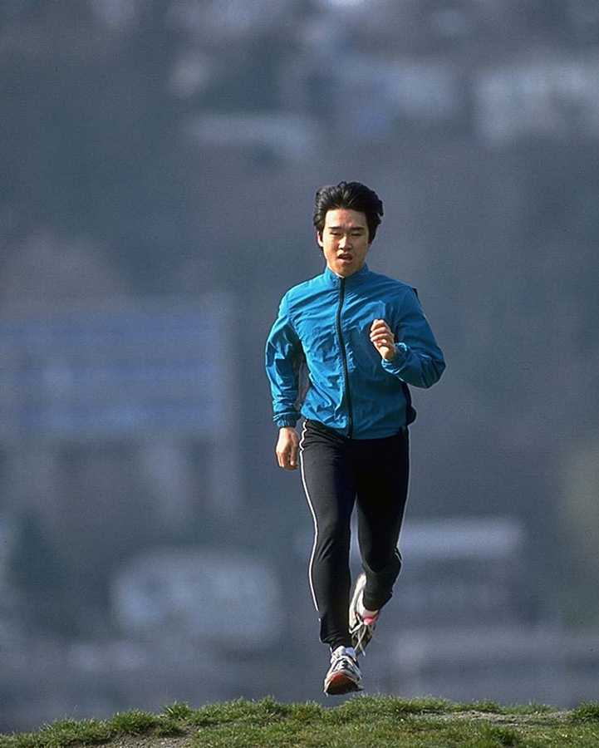
“You Are Nearing The End Of The Program!

Exercise 9.1

1. List 5 things you can do well?

_____________________________________________________________________________

_____________________________________________________________________________

_____________________________________________________________________________

2. How do you feel when you engage in the above activities?

_____________________________________________________________________________

_____________________________________________________________________________

_____________________________________________________________________________

3. Please state in your own words, how does doing an activity well increase your own self
esteem?

_____________________________________________________________________________

_____________________________________________________________________________

_____________________________________________________________________________

4. What does it mean to say “I can do what is necessary to get the job done”?

_____________________________________________________________________________

_____________________________________________________________________________

_____________________________________________________________________________

5. How can the above statement help you in your ability to increase your self esteem?

_____________________________________________________________________________

_____________________________________________________________________________

_____________________________________________________________________________

A note from the author: Your self esteem comes from yourself and from your actions and your activities. Others can influence your self esteem but you are in charge of allowing your self esteem to be altered or compromised by external factors. Protect your self esteem because it is a precious commodity that you need to resupply daily.

Exercise 9.2

1. What are some ways you can improve your self esteem?

_____________________________________________________________________________

_____________________________________________________________________________

_____________________________________________________________________________

2. List 5 strengths you have?

_____________________________________________________________________________

_____________________________________________________________________________

_____________________________________________________________________________

3. List 5 perceived weaknesses you have?

_____________________________________________________________________________

_____________________________________________________________________________

_____________________________________________________________________________

4. What are two ways you can improve your strengths and overcome your weaknesses?

_____________________________________________________________________________

_____________________________________________________________________________

_____________________________________________________________________________

5. How does thinking about your weaknesses or your perceived failures affect your approach to
new situations that require you to take personal risks or to become vulnerable?

_____________________________________________________________________________

_____________________________________________________________________________

_____________________________________________________________________________

6. List 10 affirmations to use in the future on a daily basis or as you need them:

_____________________________________________________________________________

_____________________________________________________________________________

_____________________________________________________________________________

Exercise 9.3

- What will keep you from practicing your daily affirmations?

_____________________________________________________________________________

_____________________________________________________________________________

_____________________________________________________________________________

- How will your using daily affirmations affect your self esteem?

_____________________________________________________________________________

_____________________________________________________________________________

_____________________________________________________________________________

- What self talk do you use that causes you to think negatively about yourself?

_____________________________________________________________________________

_____________________________________________________________________________

_____________________________________________________________________________

- How self talk do you use that causes you to think positively about yourself?

_____________________________________________________________________________

_____________________________________________________________________________

_____________________________________________________________________________

- What are 5 goals you can use to build your self esteem over the next 7 days?

_____________________________________________________________________________

_____________________________________________________________________________

_____________________________________________________________________________

A note from the author: Your self talk has a lot to do with how you think and feel about yourself. Don’t let your self talk keep you from being successful and happy. Practice positive self talk from the time that you wake up in the morning.

Module 10

Making The Climb:
Pulling It All Together

Murphy’s Law States:
Every solution breeds new problems.

A Road to Success States:
“The easiest thing in the world is to come up with an excuse not to do something. I found that the most important thing in life is to stop saying, “I wish and start saying I will.”

-David Copperfield-


“You Are Crossing The Finish Line Of The Program”

A note from the author: Now it is time to pull together all of the information and skills that you have learned in this stress management program. We are going to assist you to complete your own personal stress management program that you can implement and start using immediately. This is the final step in the program and it is individually tailored by you for you to identify and intervene on behalf of your own stress management needs. During this part of the program, you will pick a particular stressor/situation that you want to work on. Make copies of these forms so that you can use the originals over and over again. This part of the program is divided into steps and they are as follows:

Individualized Stress Management Program Plan

STEP ONE

Read the following lists and check those stress signs that you are currently experiencing. This step involves the recognition of your own stress symptoms from the list below:

MY PHYSICAL SIGNS OF STRESS

_____Tight neck and shoulders _____Pounding heart (not anxiety)
_____Chest pain (not heart problems) _____Headaches
_____High blood pressure _____Stomach upset
_____Fatigue _____Cold, sweaty palms
_____Eye strain _____Excessive perspiration
_____Gastro-intestinal upset _____Nervous tics
_____Teeth grinding _____Skin rashes
_____Increased urination (not diabetes) _____Weight loss/gain

MY EMOTIONAL SIGNS OF STRESS

_____Depression ____Other:__________________________
_____Irritability
_____Impatience
_____Suspiciousness
_____Anger
_____Apathy/hopelessness
_____Worry
_____Dislike of self

MY BEHAVIORAL SIGNS OF STRESS

_____Overeating _____Forgetfulness
_____Increased smoking/drinking _____Reckless driving
_____Fighting/arguing _____Drug use
_____Increased errors on the job _____Crying
_____Withdrawal from friends/activities _____Poor concentration
_____Lack of enthusiasm _____Other:__________________________

STEP TWO

Stress can come from almost every aspect of your life. There may be big changes or events that are stressing you such as disrupted family relationships, job changes or lay offs, major illnesses, sick family members, etc.) as well as many little events which, over time, can add to your stress level. Becoming aware of your specific stressors, both big and small, is the next step toward effectively managing your stress.

This step involves the development of your own stress list. List everything you worry about-anything and everything that causes you concern or makes you uneasy, including:

PERSONAL: Health and well being, comfort, success, safety, behavior
FAMILY: Loved ones, health, finances, changes
WORK: Concerns, co-workers/customers, performance, future, changes
COMMUNITY: Neighborhood, taxes, politics, school, crime
GLOBAL: War, economy, human rights, environmental worries
TRIVIA: the nagging little irritations of daily life

My Stressor List Includes:

1.

2.

3.

4.

5.

6.

7.

8.

9.

10.

STEP THREE

This step involves determining when your stressor becomes burnout. This involves identifying personality traits that you may have that may contribute to stress. Check those personality traits from the list that you currently are experiencing:

_____Perfectionism
_____Overly committed
_____Need to prove oneself
_____Strong goal orientation
_____Difficulty saying “no”
_____Difficulty delegating authority
_____Self sacrificing
_____Being a “giver” rather than a “receiver”
_____Other:___________________________________________________________________

Now, check those signs that the stressor has become burnout that you are currently experiencing:

_____Frustration and irritability
_____Easily angered
_____Feelings of emptiness and sadness (not Major Depression)
_____Inability to concentrate (not ADD)
_____Pessimism
_____A continual sense of being overwhelmed
_____Resentment
_____Loss of self esteem
_____ Depression and emotional exhaustion
_____Other:___________________________________________________________________

STEP FOUR

This step involves re-thinking the ways that you look at stress. You will need to consider the following as you proceed through the development of your own personal stress management plan. Consider the following when you are looking at a stressor to change/modify:

1. Learn to recognize the immediate response that you typically make to stress. This includes your thoughts about the stressor/situation, your emotional reactions to the stressor/situation and your actions to the stressor/situation.

MY IMMEDIATE RESPONSE TO STRESS IS:

______________________________________________________________________________________________________________________________________________________________________________________________________________________________________________________________________________________________________________________________________________________________________________________________________________________________________________________________________________

2. Reframe the event/situation in more positive terms. We often “awfulize” events that do not have to be seen that way. We have a choice as to how we see the events and how we interpret them.

MY AWFULIZING RESPONSE IN STRESSFUL SITUATIONS USUALLY IS;

____________________________________________________________________________________________________________________________________________________________________________________________________________________________________________________________________________________________________________________

A POSITIVE REFRAME OF THE CURRENT STRESSFUL EVENT/SITUATION IS:

_________________________________________________________________________________________________________________________________________________________________________________________________________________________________________________________________________________________________________________________________________________________________________________________________

3. Replace the “awfuls and shoulds” with more constructive thoughts about how to problem solve and to be less black and white in your thinking. You will be amazed at how much better you feel when you are able to say to yourself, “It’s not so bad”.

MY AWFULS AND SHOULDS INCLUDE THE FOLLOWING WHEN I AM STRESSED:

_________________________________________________________________________________________________________________________________________________________________________________________________________________________________________________________________________________________________________________________________________________________________________________________________

MY NEW CONSTRUCTIVE THOUGHTS IN THIS SITUATION ARE AS FOLLOWS:

___________________________________________________________________________________________________________________________________________________________________________________________________________________________________________________________________________________________________________________________________________________________________________________________________________________________________________________________________________________________________________________________________________________________

STEP FIVE

Step five involves applying the A-B-C-D-E Model of stress management to your every day living. Pick a particular stressor that you want to address in your stress management program. The A-B-C-D-E Model of stress management is as follows:

A= The activating event that starts a potential stress response

What activating event or situation started your stress response/reaction?

____________________________________________________________________________________________________________________________________________________________________________________________________________________________________________________________________________________________________________________

B= The belief or self talk that the person says to themselves about the event

What self talk or beliefs are you thinking and saying to yourself about the event?

____________________________________________________________________________________________________________________________________________________________________________________________________________________________________________________________________________________________________________________

C= The consequence or your stress reaction

What is the consequence of your reaction and thoughts and beliefs about the stressful event?

____________________________________________________________________________________________________________________________________________________________________________________________________________________________________________________________________________________________________________________

At this point, it is important that you QUESTION the irrational self talk that you hear from your thoughts and then replace the SHOULDS and AWFULS with more positive thoughts and positive possibilities. Add two new steps to change the SHOULDS and AWFULS:

D= QUESTION-“Why is it so terrible? What can I do instead of worrying or feeling
upset?”

What is so terrible about the situation that you cannot stand to consider it or what is so upsetting?

____________________________________________________________________________________________________________________________________________________________________________________________________________________________________________________________________________________________________________________

E= ANSWERS-“It’s not so bad, it’s not a disaster, I can stand it! I want things to be
different but it doesn’t have to be MY WAY”. “I can’t control it so there is no use
worrying about it”.

What can you say or do to help you realize that you will get through this situation or that you will resolve your stressors successfully as you have done in the past?

____________________________________________________________________________________________________________________________________________________________________________________________________________________________________________________________________________________________________________________

Instead of saying, “I should be” or “I must” or “It’s not MY FAULT”, try instead “I am”, “I want to”, “Let’s fix it” and “I’m doing what’s important to me”.

STEP SIX

Step Six is to “Avoid the Blame Game”. This involves not pointing fingers at others; not having rigid expectations of yourself or others; not having a low frustration tolerance of others, etc. Instead, do practice rational self acceptance; do accept your own imperfections; do accept the imperfections of others; and do respect but don’t over value achievement over other aspects of yourself are equally or more important than your positive qualities.

I can avoid the Blame Game by saying or doing the following:

______________________________________________________________________________________________________________________________________________________________________________________________________________________________________________________________________________________________________________________________________________________________________________________________________________________________________________________________________________

STEP SEVEN

Step Seven involves taking the data from the first six steps and then applying it to the stressor that you identified that you wanted to resolve or cope with. Now you will need to take the information that you have compiled and make a list of coping skills that you will use to decrease your stress and improve your coping skills with the stressor that you are working on.

The list of coping skills that I will use to cope with the stressor that I have identified and am developing a coping plan for:

COPING SKILL LIST

1.

2.

3.

4.

5.

6.

7.

8.
PLAN TO IMPLEMENT COPING SKILLS
________________________________________________________________
LIST SKILL IMPLEMENTATION DATE WHERE WHEN SUCCESSFUL
Yes No
_____________________________________________________________________________

1.

2.

3.

4.

5.

6.

7.

8.

9.

10.

A note from the author: We believe that you will be successful if you follow the steps in this stress management plan. We have used these steps with hundreds of clients successfully. You can use these steps to resolve any presenting stressor or problem that you may confront. We hope that you have enjoyed working the Stress Management Program and that you have been successful in your attempts to resolve your stressors and presenting concerns.

We want to thank you for purchasing this program and for working it and for being willing to change your life.

Our Final Thoughts

The author has designed this program with flexibility in mind. WI have provided you with the information and skills that you need in order to identify your stressors and to change or resolve them at any time. I believe that each of us has the innate capacity to help ourselves when we are given the right tools to do so.

I believe that you will be successful if you follow the steps in this success development program. I have used these steps with hundreds of clients successfully. You can use these steps to resolve any presenting stressor or problem that you may confront. I hope that you have enjoyed working the Success Building Program and that you have been successful in your attempts to resolve your stressors and presenting concerns.

The author also has written other similar programs to assist individuals to effectively confront and deal with other life issues that are problematic for them. Other self-change programs include Effective Parenting Of Pre-adolescent Children, Effective Parenting Of Adolescents and Attention Deficit/Hyperactivity Disorder: A Hands On Approach. I hope that you will decide to look at one of the other programs and use it in your life to effect personal change. I have other available topics that are in the process of being formatted and reproduced as self-change programs similar to this program. These include Managing Personal Change, Depression, Christian Parenting, Managing Your Moods Before They Manage You, Overcoming Personal Anxiety, etc.

I want to thank you for purchasing this program and for working it and for being willing to change your life. By doing so, you have made the world a better place for yourself and all who know you.

Robert Knapick, M.A., LMFT, LCDC

Robert Knapick, MA, LMFT, LCDC

BACKGROUND
Over 25 years of program leadership and project development that utilized my skills in achieve and enhance goals of the organizations. Throughout the years my talents have been used to assist organizations in developing new strategies or plans to make better use of time and money. These skills allowed me to move up quickly within the different organization that I was associated with and become successful as an independent contractor. My personality allows me to be leader that is creative, developing and a planner that goals oriented. Mr. Knapick is a licensed Marriage and Family Therapist, Licensed Chemical Dependency Counselor, Certified Instructor Trainer for Scuba Diving and hold numerous leadership awards and certification in Scuba Diving and Safety Training

SELECT PROFESSIONAL ACCOMPLISHMENTS
- Established a Crisis Intervention Program “Mobile Assessment Response Team” to service 4 emergency rooms in North Harris County. The response team handled 60+ calls per month.
- Established three nonprofit organizations, which received over $2,000,000 in grant support.
- Presented over 100 seminars and workshops for groups ranging in sizes from 10 to over 500.
- Developed a research/training program for youth to become involved in and participate with local university and research organizations. This organization is involved with the Boy Scouts of America Venturing Program and promotes positive youth activities that build leadership skills.
- Developed a private Jr. and Sr. High school for at-risk teenagers. The school had up to 75 students and some students were acquired through a contract with the Juvenile Justice Alternative Education Program.
- Developed a Day Treatment program inside the private school to provide counseling for the students and parents.
- Established private practice in a setting with a group of pediatricians, general practice physicians. Case load generated around $150,000 per year.
- Developed a day treatment program to work with 60 at risk adolescents in an adolescent residential program.
- Moved from case manager to Program Director of Adolescent Chemical Dependence Unit within a nine month period of time.
- Acquired contracts from four state agencies for a Residential Treatment Center for substance abusers ages 18 to 35 with a full capacity average daily census of 20.
- Established an innovative job-search training program for disabled persons, which is certified by the Texas Rehabilitation Commission, which has an earning capacity of over $80,000 annually.
- Over the past 20 years of experience have been awarded over 15 letters of commendations from agencies ranging from Spring ISD for serving on a committee to review books on Satanism to a local hospital for the admission of the first patient.
- Achieved the Platinum Pro 5000 Diver level within the Scuba Schools International Program, which is the highest award for a recreational diver.
- Awarded Best Dive Instructor Award in Houston, Texas in 2003 by the Houston Press Magazine.
- Licensed Marriage and Family Therapist, Licensed Chemical Dependency Counselor and Certified Christian Counselor
- Created, developed and administrated a new child / adolescent program for a med / surgical hospital.

E-mail Address: robert@a-road-to-success.com Web Address: www.a--road-to-success.com

References
Reality Therapy, William Glasser, MD, Harper Colophon Books, Harper & Row, Publishers, 1975
Your Perfect Right, Albert Alberni, Eighth Edition, Impact Publishers, 2001.
When I Say No, I Feel Guilty, Manual J. Smith, Ph.D., A Train Press, May, 2000.

