Knapick Therapies

Presents

Success Building Program:
“A Road to Success”
Program Workbook

Overcoming Life’s Obstacles through Stress Management


Success is the Journey not the Destination…

Developed by

Dr. Robert Knapick

Manual Index

Page Title Page Number

Acknowledgements 3

Forward 4

How To Use This Program 5

Module 1- Making A Plan: An Overview Of Stress Management 10

Module 2- Assessing Your Life: What Stresses You 20

Module 3- Adjusting Your Attitude: Understanding Your Feelings 31

Module 4- Equipping Yourself For Your Journey: Assertion Training 40

Module 5- Training: Relaxation Skills For Daily Living 52

Module 6- Mapping Your Journey: Goal Setting 65

Module 7- Setting Your Course: Time Management 75

Module 8- Establishing A Base Camp: Healthy Living 85

Module 9- Taking Personal Inventory: Improving Your Self Esteem 96

Module 10- Making The Climb: Putting It All Together 106

Our Final Thoughts 113

About The Authors 114

References 116

Preface

Stress is a common denominator to most illnesses. It is believed that over 90% of doctor visits are linked to some form of stress. It has been my experience that when I am under deadlines, time restrains and beyond the realistic ability to manage the demands on my mind and body, I will suffer a cold or pains in my joints. In fact, when I become aware of taking on too much to manage, I can predict when I will become sick. This being known, I try to take care of myself by stepping away from deadlines and take time for myself by engaging in some type of relaxation activity. If I am able to become aware of my stress level in time, I will not suffer the physical complications to my body.

The question is, “What type of relaxation activities/ techniques are available to help you balance work demands and your ability to take care of yourself?”. It is for that reason, I have written this book on “Stress Management, A Road to Success”. I first discovered the power of stress management when I assisted Heroin Addicts in finding employment. The technique used was assertiveness training, which is a valuable tool in helping you manage stress. This project, helping heroin addicts get jobs, was the basis of my first Master’s Thesis. The result of my thesis was the control group of clients who did not receive any training over the 30-day period continued to be unemployed. The control group of clients who received a simple version of assertiveness training had 2 clients obtaining employment. The experimental group who received assertiveness training and role playing resulted in all of the clients being employed following the 4 weeks of training. Clients felt confident in their job search, interviews, and dealing with problems on the job. One of the clients was fired by their supervisor. She stood up for herself and went to the head supervisor and was put into her supervisor’s role and the supervisor was relocated. My thesis was presented at the American Association of Behavior Therapy in Las Angeles, California. This project got me to thinking and I developed a small manual called, “Rules to Live By”. This manual was given to my clients and used to assist them in the development of skills that could be used to limit and remove stress in their lives. Later I put my concept into a Partial Hospitalization Program that helped clients overcome stress, which was the nexus to their mental and physical health issues. I have over 100 testimonials from patients who felt the groups that came from the manual provided them with healthy skills that allowed them to overcome physical and mental health issues in their lives. One of my favorite clients was a client who suffered from Agoraphobia, the fear of crowded spaces. She called me on Christmas Eve and was out of breath and full of excitement. She told me that she was in the middle of crowds of people in Walmart.
She had spent over 10 years locked up in her bedroom with foil over her windows and the inability to get out of her room. Food had to be placed next to her door and she did not socialize. Every now and then, I run into her and she has a big smile on her face and tells me how much she appreciated what she learned in the therapy groups.

One of the primary skills/ techniques that lead to the success of the Partial Hospitalization Program was Assertiveness Training. Due to this revelation, I decided to write this book on Assertiveness Training and A Road to Success. This book was laid out to help the reader gain a better understand the different steps needed to help you reach success.

Forward

It has taken several years to develop this program and to field test it and to publish it and to bring it to national distribution. This program embodies the knowledge and the 50 years of professional experience that the authors have accumulated and focused upon the development of this program.

The development of this program required hundreds of hours of thought, writing, programming and proof reading by the authors. This program was written with the idea in mind that family members of one of the authors was going to use this program to improve the quality of their lives while improving their coping skills and stress reduction abilities. This program is a labor of love by the authors in their attempt to make the world a better place and to improve the human condition.

The authors acknowledge that there are many books and programs that have been written on the subject of stress management. However, this program is unique because the authors have worked the program themselves and have had family members work the program. As a result of working this program, we are pleased that improvements were noted by family members after working this program. In addition, we have been using this program in our private practices for several years and we have been given feedback by our clients that it works!

What also makes this program unique is the electronic and paper formats of the program which allow individuals to work the program in different formats depending upon their particular needs. You will find this program to be “user friendly” in that it is written in a straight forward and concise manner that is easy to complete.

This program is designed to be educational and self help in its approach. It is designed to assist you in your efforts to improve yourself and the quality of your life. We believe that you can improve your stress management knowledge and skills in the comfort of your own home or office. It is not intended to replace professional counseling or psychotherapy services if they are needed.

We want to thank you for purchasing this program and for embarking on this program of stress management skill development as a part of your quest for self-knowledge and improvement.

The Authors

How To Use This Manual

This manual was designed to be user friendly and to be an important aid to you in the learning process. Each exercise that appears in this manual is also located in the computer program that you have purchased with this manual. Each exercise in this manual is numbered to correspond with the exercise in the computerized version of this program. When an activity in the manual is labeled as number 1.1 it is also 1.1 in the computer program. This will allow you to easily switch between the computer program and the manual for learning and task completion purposes.

We advise that you start out working the program at a pace that is consistent with your learning style and preference. We recommend that you work slowly and steadily at first so that you can become familiar with the learning activities and how you can optimally respond to them in the most efficient manner.

This program was designed by the authors to maximize your learning experience while providing you with hands on learning activities. We believe that learning occurs in various forms for each of us and we have provided you with a multi-sensory learning experience.

The index in this manual offers you the exact page locations of each module so that you can have this information at your fingertips. In addition, each learning module has a tab that identifies it for the learner. Each module is located sequentially for your immediate use. The learning activities match up with the exercises in the computer program so that you can use the computer program and the manual simultaneously together.

Now that you are ready to begin on your journey through the stress management program and the accompanying manual, we want to take this opportunity to wish you success on your path to stress free living and happiness.

We want to thank you for your purchase of this program and for your motivation to eliminate your stress and improve the quality of your life.

The Focus on Success Stress Management Program

Success means reaching a goal or obtaining a personal objective. Due to the fact that life is complex and not fair, we sometimes fall short of our Success. Through the Focus on Success Stress Management Program, individuals are able to overcome or remove obstacles that are in their pathway to Success.

Most of us have good intentions when we start out on a program of self improvement and change. But something often seems to get in the way of our good intentions and actions. We have designed a program that will allow you to engage in a program of personal change that is lasting and fulfilling.

This program was developed over a three year period. The authors, Dr. John Garlock and Mr. Robert Knapick, MA, LMFT, LCDC, have shared their combined 50 years of experience in the development of this program. We provide you with our program in both written and electronic format which allows you to work your stress management program in several ways in a variety of settings. Whether you are at home or at work, you can work our program in the comfort of your home or office.

The Focus On Success Stress Management Program

The accompanying program CD is designed to allow you to work the program either in traditional pencil and paper form or electronically. Upon the completion of the accompanying CD, you will be able to identify your daily stressors, complete a stress self analysis, establish obtainable personal stress management goals, understand personal boundaries and limits and help find ways to relax and have a healthy lifestyle that maximizes your potential while minimizing your stress.

The authors do not give permission to non-purchasers of this program to duplicate this material in any manner, whether by electronic or other means, without the expressed written consent of both authors.


Soar To New Heights With Our Self Learning Programs

Stress Management: A Road to Success

This program is designed to help you create Focus and Direction for your life. Upon the completion of this program, you should improve your communication, establish obtainable goals, understand personal boundaries, set limits for yourself and others and help find ways to relax and have a healthy lifestyle.

Welcome to Stress Management-The Road to Success

This program is a combination of stress reduction and management strategies. Each module offers exercises and assignments designed to help individuals cope with the pressures of life. It introduces the concepts associated with stress management skill development with two free professional telephone consultations. Upon the successful completion of the course you should have a better knowledge and understanding of how to control your stress and establish rules to live by. This program offers 10 modules designed that focus on several areas of your life. Modules include:
Module 1: Making A Plan: An Overview of Stress Management
Module 2: Assessing Your Life: What Stresses You?
Module 3: Adjusting Your Attitude: Understanding Your Feelings
Module 4: Equipping Yourself for Your Journey: Assertion Training
Module 5: Training: Relaxation Skills For Daily Living
Module 6: Mapping Your Journey: Goal Setting
Module 7: Setting Your Course: Time Management
Module 8: Establishing A Base Camp: Healthy Living
Module 9: Taking Personal Inventory: Improving Your Self Esteem
Module 10: Making The Climb: Pulling it All Together


Soar To New Heights With Your New Knowledge And Skills!
Good Luck in your journey to a Successful Life as you make your way down
“A Road to Success”



Program Instructions
Congratulations on starting you journey to developing a road to Success. As you progress through each module, you will need to complete your assignments and exercises.
Module 1

Making A Plan:
An Overview of Stress Management

Murphey's Law States:
Anything that can go wrong will go wrong!

Road to Success States:
Anything that can go wrong will go wrong, so be prepared…


Are you on Your Way Up or Down?

Module 1: Making A Plan:
An Overview of Stress Management

What is Stress?

The Road to Success Program will help you deal with negative stress. The fist step to dealing with negative stress is to understand stress. Stress is the "wear and tear" our bodies experience as we adjust to our continually changing environment; it has physical and emotional effects on us and can create positive or negative feelings, which will be covered in Module 3. As a positive influence, stress can help compel us to action; it can result in a new awareness and an exciting new perspective. As a negative influence, it can result in feelings of distrust, rejection, anger, and depression, which in turn can lead to health problems such as headaches, upset stomach, rashes, insomnia, ulcers, high blood pressure, heart disease, and stroke. With the death of a loved one, the birth of a child, a job promotion, or a new relationship, we experience stress as we readjust our lives. In so adjusting to different circumstances, stress will help or hinder us depending on how we react to it.


Halfway through the journey…
Stress can defeat your drive to succeed!

How Can I Eliminate Stress from My Life?
As we have seen, positive stress adds anticipation and excitement to life, and we all thrive under a certain amount of stress. Deadlines, competitions, confrontations, and even our frustrations and sorrows add depth and enrichment to our lives. Our goal is not to eliminate stress but to learn how to manage it and how to use it to help us. Insufficient stress acts as a depressant and may leave us feeling bored or dejected; on the other hand, excessive stress may leave us feeling "tied up in knots." What we need to do is find the optimal level of stress, which will individually motivate but not overwhelm each of us.


The Challenge of a Goal…
Is the Spice of Life!

How can I tell what is optimal stress for me?
There is no single level of stress that is optimal for all people. We are all individual creatures with unique requirements. As such, what is distressing to one may be a joy to another. And even when we agree that a particular event is distressing, we are likely to differ in our physiological and psychological responses to it.

The person who loves to arbitrate disputes and moves from job site to job site would be stressed in a job, which was stable and routine, whereas the person who thrives under stable conditions would very likely be stressed on a job where duties were highly varied. Also, our personal stress requirements and the amount which we can tolerate before we become distressed changes with our ages.

It has been found that most illness is related to unrelieved stress. If you are experiencing stress symptoms, you have gone beyond your optimal stress level; you need to reduce the stress in your life and/or improve your ability to manage it.


Need A Life Preserver Some Days?

What is Your Stress Level? (Activity 1.1)

Personal Stress Assessment

Read each statement below and then circle the number under the heading at the right that best describes your situation…

Statement | A  Not True or Rarely True | B  Sometimes True | C  Often or Always True
My sleep patterns have changed. | 1 | 2 | 3
I am often angry or irritable. | 2 | 3 | 4
My concentration and attention span are not good. | 1 | 2 | 3
I am using drugs, legal or illegal, to lower my stress. | 3 | 4 | 5
I seem to be having more accidents or making more mistakes. | 2 | 3 | 4
I feel like running away from everything | 3 | 4 | 5
I have frequent daydreams about a better time and place. | 1 | 2 | 3
I have destroyed property or caused injury in anger. | 3 | 4 | 5
I have more and more sickness and health problems. | 2 | 3 | 4
My memory is no longer reliable and seems to get worse, not better. | 2 | 3 | 4
I use gambling or shopping to forget about my troubles. | 3 | 4 | 5
I have nightmares. | 1 | 2 | 3
I feel I have a lot of responsibilities but not much authority. | 1 | 2 | 3
How I feel and what I do bothers me and seems to concern others. | 3 | 4 | 5
My appetite has either increased or decreased dramatically in recent times. | 2 | 3 | 4
More and more I prefer my own company and I actively avoid social contacts. | 2 | 3 | 4
I do not have enough time to do what needs to be done. | 1 | 2 | 3
I believe that I have stress related problems, which are serious. | 3 | 4 | 5

Total each Column
Add the totals at the bottom of all three Columns | A
 | B
 | C

Total of all three Columns

If you have a score of: 36-44 You have a Low Level of Stress
  - You have a Moderate Level of Stress
63-72 You have a High Level of Stress
How will this Assessment and “A Road to Success” help me?

Now that you have taken the stress assessment, you have a score to interpret and to follow up on. The scores for this measure are as follows:

If you have a score of: 36-44 You have a Low Level of Stress
  - You have a Moderate Level of Stress
  - You have a High Level of Stress

If you scored between 36-44 this indicates that you presently are experiencing a Low Level Of Stress. However, that could change tomorrow! If you are presently experiencing a lower level of stress, this will allow you to take the time to address the stressors in your life one at a time. You have the good fortune of being able to spend your time and energy resolving your stressors without feeling compelled to act to “put out a fire”.

If you scored between 45-63 this indicates that you are presently experiencing a Moderate Level of Stress. This indicates that you are likely not overwhelmed at this time, but the addition of any additional stressors may over whelm you and exceed your coping capacities. You need to take action to begin to resolve your stressors immediately. Our program will give you the tools to begin work immediately upon your identified stressors so that you can gain relief from them.

If you scored between 63-72 this indicates that you are presently experiencing a High Level Of Stress. This indicates that you may presently be over whelmed or nearing that point. You need to take immediate action to begin to resolve your stressors. Our program will give you the tools to begin work immediately upon your identified stressors so that you can gain relief from them. Please do not delay starting on your stress management program today!

No matter what circumstance you find yourself in with regard to your stress levels, our program will assist you to resolve your stress and to improve your coping skills immediately. No stressor is too big or too small to address with our program.

Let’s get to work now so that we can help you to improve your life today!



Our Problems are not as BIG as we think they are!

Assessing Your Response to Stress (1.2)

We respond to stress and its demands individually. Our reactions tend to vary according to the situation and our perception of our ability to cope.

To better understand your coping style(s) that you use when you encounter stress:

- On a scale from 1 to 4, place a mark on the line to indicate how you respond in each area. For example, if you tend to get overwhelmed very often, place a mark under the “1” or “2.” If you’re usually calm, make a mark under the “3” or “4.”
- Put stars next to your five strongest traits/behaviors. You will want to count on these strengths to help you meet the new expectations of your circumstances. Remember these for use later in the Stress Management Program.
- Circle the five traits/behaviors that you struggle with most. These will require intervention.

1 2 3 4
Overwhelmed _____________________________________ Calm
Controlling _____________________________________ Ability to let go
Tense _____________________________________ Relaxed
Depressed _____________________________________ Upbeat/Cheerful
Rigid _____________________________________ Flexible
Exhausted _____________________________________ Energetic
Fearful _____________________________________ Challenged
Dependent _____________________________________ Self-reliant
Insecure _____________________________________ Confident
Impatient _____________________________________ Patient
Defensive _____________________________________ Open
Humorless _____________________________________ Sense of humor
Risk avoidance _____________________________________ Risk seeking
Moody _____________________________________ Even-tempered
Passive _____________________________________ Assertive
Disorganized _____________________________________ Organized
Pessimistic _____________________________________ Optimistic
Closed to change _____________________________________ Open to change
Negative body language _____________________________________ Positive body language

A note from the authors: Make a list of the responses that indicate that you get overwhelmed and the responses that indicate that you cope with them successfully. Keep these lists for use later in the Stress Management Program. Be thinking about your reactions and about which reactions that you may want to change in the future. Next, work on the Personal Stressors Chart and fill it in with what you know about your stress patterns.

My Personal Stressors Chart (1.3)

Stressor | My Reaction  To The Stressor | Yes/No-Can I Control This? | Positive Response  To The Stressor

How Can I Manage Stress Better?

Identifying unrelieved stress and being aware of its effect on our lives is not sufficient for reducing its harmful effects. Just as there are many sources of stress, there are many possibilities for its management. However, all require work toward change: changing the source of stress and/or changing your reaction to it. How do you proceed? The following modules will help you through this process, which can be summarized by the following 6 goals for Stress Management.

1. Become aware of your stressors and your emotional and physical reactions.
Notice your distress. Don't ignore it. Don't gloss over your problems.
Determine what events distress you. What are you telling yourself about meaning of these events?
Determine how your body responds to the stress. Do you become nervous or physically upset? If so, what specific ways?

2. Recognize what you can change.
Can you change your stressors by avoiding or eliminating them completely?
Can you reduce their intensity (manage them over a period of time instead of on a daily or weekly basis)?
Can you shorten your exposure to stress (take a break, leave the physical premises)?
Can you devote the time and energy necessary to making a change (goal setting, time management techniques, and delayed gratification strategies may be helpful here)?

3. Reduce the intensity of your emotional reactions to stress.
The stress reaction is triggered by your perception of danger...physical danger and/or emotional danger. Are you viewing your stressors in exaggerated terms and/or taking a difficult situation and making it a disaster?
Are you expecting to please everyone?
Are you overreacting and viewing things as absolutely critical and urgent? Do you feel you must always prevail in every situation?
Work at adopting more moderate views; try to see the stress as something you can cope with rather than something that overpowers you.
Try to temper your excess emotions. Put the situation in perspective. Do not labor on the negative aspects and the "what ifs’."

4. Learn to moderate your physical reactions to stress.
Slow, deep breathing will bring your heart rate and respiration back to normal.
Relaxation techniques can reduce muscle tension. Electronic biofeedback can help you gain voluntary control over such things as muscle tension, heart rate, and blood pressure.
Medications, when prescribed by a physician, can help in the short term in moderating your physical reactions. However, they alone are not the answer. Learning to moderate these reactions on your own is a preferable long-term solution.

5. Build your physical reserves.
Exercise for cardiovascular fitness three to four times a week (moderate, prolonged rhythmic exercise is best, such as walking, swimming, cycling, or jogging).
Eat well-balanced, nutritious meals.
Maintain your ideal weight.
Avoid nicotine, excessive caffeine, and other stimulants.
Mix leisure with work. Take breaks and get away when you can.
Get enough sleep. Be as consistent with your sleep schedule as possible.

6. Maintain your emotional reserves.
Develop some mutually supportive friendships/relationships.
Pursue realistic goals, which are meaningful to you, rather than goals others have for you that you do not share.
Expect some frustrations, failures, and sorrows.
Always be kind and gentle with yourself -- be a friend to yourself.

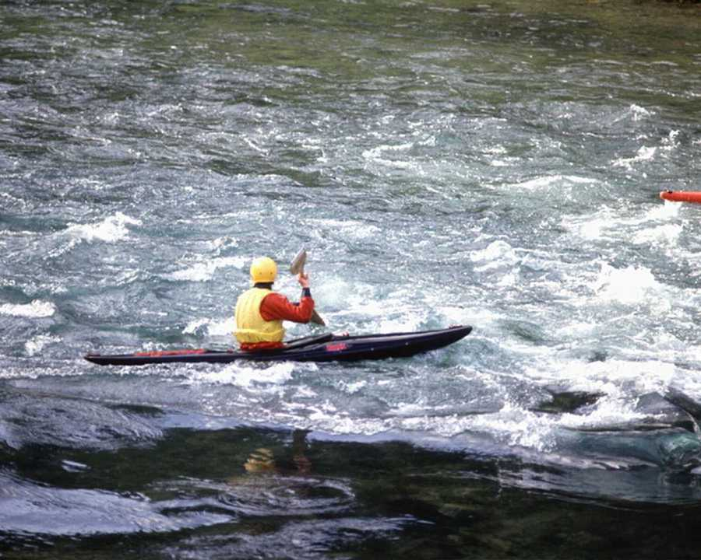
To handle Life’s struggles,
We must learn to relax and plan our future.

Program Instructions
Congratulations on starting you journey to developing a road to Success. As you progress through each module, you will need to complete your assignments and exercises. Upon the completion of the first 5 modules, you can contact us either via telephone (713) 927-3183 or via E-Mail (jagvw@earthlink.net) at Focus on Success to report your progress and receive feedback. Once you have completed Module 10 you may contact us again for a final program consultation and we will send you, from Focus on Success, your evaluation of the program and information regarding our program offerings. Focus on Success will provide you with the final evaluation and a Certificate of Completion for you to retain for your future use. The final evaluation will be returned to us along with your evaluation of the program. We take your feedback seriously and want to improve our products!


May our Lighthouse light lead you through shallow reefs to a Safe Harbor…
Module 2

Assessing Your Life:
What Stresses You?

Murphey’s Law States:
It is impossible to make anything fool proof because fools are so ingenious.

Road to Success States:
Preparation for Life’s Pitfalls, is 90% of the Journey

Are you Ready for your Journey?
Module 2: Assessing Your Life:
What Stresses You?

Stress is your body's response to any unusual demand (such as a threat, a challenge, etc.). Whether the demand is real or imagined, outside the body or within, your body will react to it with a number of common characteristics, called the stress response, or just plain stress. In general, lifesaving body functions speed up, and non-essential functions slow down.

What Triggers Stress in Your Life?
The unusual demand, which causes you to adapt or change, is called a stressor. We said that a stressor may be real or imagined. For instance, the boss passes Joe in the hall without giving his customary greeting. Joe worries that he has done something wrong. In reality, the boss is preoccupied with an argument with his wife. In this case, it isn't a real disturbance, but Joe's perception, which results in the classic response called stress. Let's consider some of the common stressors. As we do, ask yourself which of these disturb you, and which can you control.

Work or School
Work and/or school have specific demands on your life that may create stressful situations. If you get up in the morning and dread going to work, that sets the tone for your thoughts and feelings and actions throughout the day. We have choices about how we look at our work and the other activities that we choose to pursue. If you get up in the morning and the first thought in your head is, “This sucks, I really don’t want to go there today” then that will produce stress for you as you go through your day. Our thoughts lead to our feelings which lead to our actions. Do you live to work or work to live? That is an important question that you need to answer because it will dictate how you think and feel and act related to your work and other life activities.

Some of these demands include:

Unreasonable deadlines, competition, work overload
Boredom, lack of fulfillment in work and life
Performance grading, fear of failing, fear of new demands
Unclear or constantly changing tasks
Superiors who are non-supportive or are habitually critical


Life is Stressful…
Don’t let Work, Money or Others Rule Your Life

Family
Family members have the best intentions, but they do contribute to our stress level. Due to poor communication skills and unrealistic demands, family members cause us to be stressed and feel pressure on our lives. Having a teenager whom you are worried about and not knowing that to do to improve your communication and problem solving is a common stressor faced by parents of teens. Being a parent, spouse and child, all at one time, can be stressful as we try to fulfill the requirements of each role “all in one day”!

Parents
Spouse
Upheavals, friction
In-Laws
Ex-spouses
Raising children

What Pressure?
The pressure you feel when you are coming to a deadline or the completion of a goal is self-imposed. It is your choice to take on this pressure. Due to the lack of good communication skills, most pressures are the result of not clarifying expectations. Communication skills will be covered in Module 4. Also, our thoughts dictate our feelings and our actions. If we choose to think that we may fail or may not be successful, we can make that thought come true. We have expectations for ourselves and others and it is important to understand that our own expectations for ourselves and for others can be the biggest source of stress that we are facing. Monitor your thoughts and pay attention to what you are thinking because your thoughts direct your feelings and your actions.

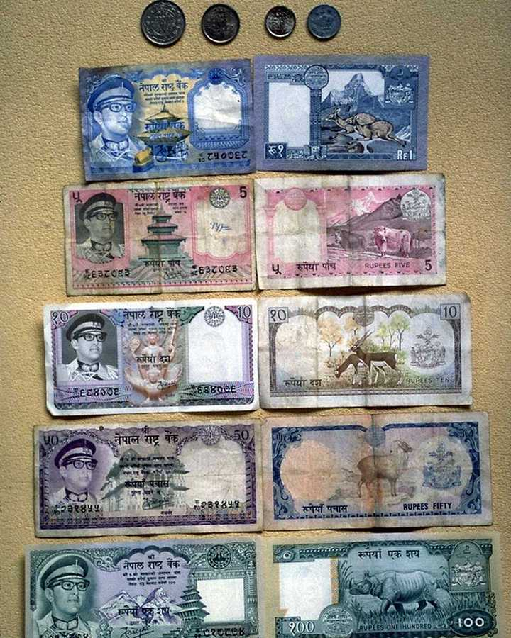
Money…. Money….. Money

Economic and Social
If you have the right perspective on life you will not allow economic nor social stress to control your life. Money, social status and relationships effect how we feel about ourselves. How we think about our money situation dictates how we may feel and act. Everyone can use more money. That is a fact of life. How we think and feel and act about it are choices that we make! Is your glass half empty or half full? That is an important question for you to ponder as you manage your economic stressors!
Finally, we are constantly under to pressure to have the “right clothes, cars, friends, etc. because THEY
told us to get them. Who are they? Is it our parents, families, Madison Avenue advertisers? Get “THEM” out of your head so that you can take over your life and live it the way you want to without having to keep up with the Joneses! If you want to keep up with them, you will need to understand that it is for appearances and possibly a role that you are playing that does not have to consume your life and your health and your resources.

Some of our economic and social stressors include:

Increased pressure, from others, or self, to achieve and gain material wealth
Personal health
Being overweight or underweight
Exposure to conflicting values on TV, in the newspapers and magazines, etc.
Inflation, depression, low salary
Increased mobility
Changing or uncertain male-female roles
Decline in organized religion, leading to unclear values
Personality shortcoming
Personal image

Sometimes we ask for things we don’t need....

In short, almost any life situation that requires change or adaptation can be considered a stressor. Even pleasant events, like promotions, vacations, or marriage, are stressors if they require many adjustments. It is your choice to decide what issues or concerns that you have that will become stressors and which ones will not. You decide what you want to take on and what you do not want to have to take on in your life. It’s your choice! Make careful and considerate choices today!

Stress is not necessarily bad. In fact, it has been called the spice of life that helps us grow and develop. A life with no stress is not only impossible, but would be quite boring. After all, who wants a life of "no runs, no hits, and no errors"?

There are different kinds of stressors that we encounter. “Eustress” is a positive type of stressor in that it requires that we “play at the top of our game” and it allows us to use our creativity and to perform at an optimal level. Closing a major deal at work or getting a promotion can be types of eustress that provide us with fulfillment and happiness and a sense of accomplishment and well being even if the situation was a stressful one for us. “Distress” is a negative type of stress in that it signals us that we are feeling over whelmed and having cognitive, emotional and physical reactions that may interfere with our normal functioning and require that we intervene to prevent additional problems from occurring. We all know when we feel distressed and we must resolve the presenting stressor(s) so that we can return to a comfortable level of functioning without the impact of additional stress. Our thoughts dictate our feelings which dictate our actions. “Stress” is a normal part of life and we are successfully managing stressors that arise in our lives on a daily basis. Since we are already handling some of our stress successfully we only have to concentrate on those stressors which exceed our coping capacities. This program is designed to assist you to focus upon any type of stressor that you might encounter whether it is a typical daily stressor or one that exceeds our coping capacities. Stress has been present ever since the world began and we can manage our stress in the ways that millions have managed their stress.
Exercise 2.1

- Why is it important to identify your stressors? What are some of yours?
______________________________________________________________________________________________________________________________________________________________

- What can you do to recognize your stress sources and your daily stressors and become aware of them in your daily living?
______________________________________________________________________________________________________________________________________________________________

- What can happen if you don’t recognize or become aware of your stress levels and stressors?
____________________________________________________________________________________________________________________________________________________________

- How do you manage your stressors? Does that vary from situation to situation? If so, how?
______________________________________________________________________________________________________________________________________________________________

- What can you do to modify and/or change your stressors?
______________________________________________________________________________________________________________________________________________________________


“Whenever I pursued my dreams I discovered something astonishing-
I discovered myself.
My secret has been to consider nothing impossible and then to treat the possibilities as probabilities.”

-David Copperfield-
How To Take Control Of Your Stress (Exercise 2.2)
Determine what stressors can be controlled and what cannot be controlled. Avoid wasting time and energy on what you can’t control; focus on where you can make a difference. These actions are basic to managing stress.
- Mastery is taking action on things you can control related to your stress.
- Letting Go is not trying to do the impossible. It involves accepting the situation and moving ahead.
- Wheel Spinning is trying to affect things beyond your control that are causing you stress.
- Giving Up is not taking action on things you could do something about. It is acting helpless and like a victim. This prolongs your stress reactions.

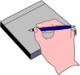 | My Personal Power Grid For Managing My Stressors:  For a recent stressor, indicate the actions you need to take (or stop) in each of the four areas.

 | I Can Control The Stressor |  | I Cannot Control The Stressor
Taking Action | I Can Obtain Mastery Of: |  | I Am Spinning My Wheels About:
 | Risk Zone
Taking  No Action | I Am Giving Up On: |  | I Am Letting Go Of:

A note from the authors: This exercise will allow you to begin to take charge of your personal stressors and will provide you with the opportunity to rank them in the four categories listed above. You can decide which stressors you want to master and which ones you want to let go of. Use this page over and over again over time so that you can continue your stress management activities well into the future.

When is Stress Harmful?

In days of old, our ancestors quickly resolved stress by fighting or running away or by physically working it out. In today's world, it is very hard for us to fight or run away from those stresses when it has to do with traffic or things beyond our control. If we do decide to take matters into our own hands we find ourselves out of a job because we put our foot through the computer. Today is not like yesteryear, when we could put our sword through whatever problem we might have been experiencing. Even when we do overcome a particular problem, there seems to be ten more produced at times. And before one stressor is resolved, another may present itself. So stress becomes prolonged and builds up. Our ability to cope can soon become exhausted.


Your health is in your hands.

Without a physical release or a break, the wear and tear of stress can result in physical or emotional illness, especially where we are most vulnerable. The following are some illnesses that have been associated with excess stress:

heart disease asthma diarrhea arthritis
high blood constipation colitis hay fever
pressure diabetes depression obesity
ulcers insomnia anxiety backaches
headaches ulcers rashes alcoholism

Some of these illnesses are known as psychosomatic illnesses, meaning the mind (psyche) influences the body (soma). A psychosomatic illness is not just imaginary, or in the head. Rather, it is a real illness in which the mind either causes the illness, aggravates the symptoms, or slows recovery. Have you ever told someone, “You make me sick”? You were probably right about that. However, we have choices about how we react to situations. We can choose not to make ourselves sick or, for that matter, any thing else that is unhealthy for us. Americans spend 6 billion dollars each year for head ache relief. We are letting our thoughts rule our feelings and our actions in unhealthy ways. It is often not the stressor itself that makes us sick but rather our decision to think, feel and act in certain unhealthy ways that cause us to get sick. Think about how you might allow your thoughts and feelings and actions to make you sick. More people are admitted to the hospital with stress related disorders than with any other type of problem. One final thought, most experts believe that 50 -75% of all illnesses are psychosomatic.

Even though stress is something observed in the body, doctors know that the mind and body cannot be separated. What effects one affects the other. For example, some people develop a habit of worrying. Prolonged, unreasonable worry and anxiety can trigger and maintain the stress response. Muscle tension from stress can in turn make the person feel even more anxious. Now an unhealthy psychosomatic cycle can be formed. A person may become depressed, and seek comfort in drugs, as his physical health slips away more and more stress is created.

Health and performance peak when the amount of stress is optimal (Easters). Psychosomatic illnesses, however, occur more frequently when there is too much or too little stress. For example, the pressure from work overload is an obvious stressor. However, job boredom is also a stressor. You may feel frustrated when you are not fulfilling your potential or when you are not able to use your skills.

What is the optimal amount of stress? This is different for each of us. Some thrive on challenges and long hours; others like a slower pace. Each of us must find the level of stress that is best for us.

Warning Signs Of Stress (These are the main ones we encounter)

Here are some warning signs that may suggest an unsuitable amount of stress in a person's life:

- tense muscles
- inability to think clearly or concentrate
- racing thoughts
- irritability, edginess
- inability to relax
- pounding or racing heart
- overpowering desire to cry or run-a-way
- losing the joy of life
- increased use of alcohol, tobacco or drugs
- nightmares
- change in appetite
- weight gain or loss
- too much caffeine
- itching or hives
- hyperventilation
- worrying
- loss of sleep
- depression
- anxiety attack

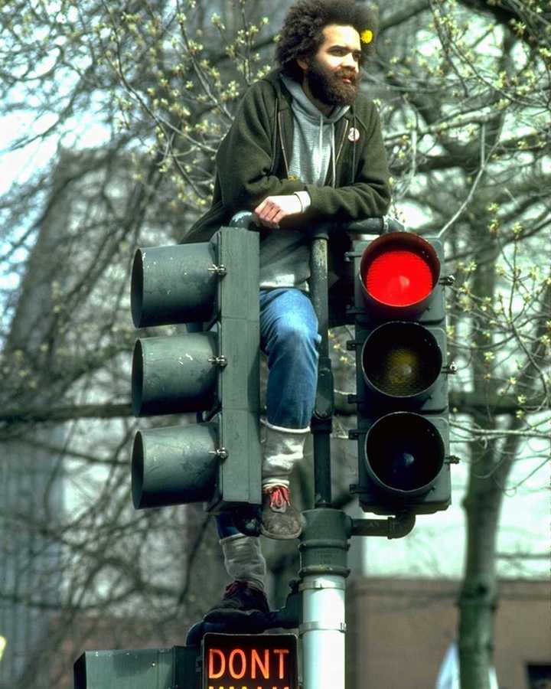
Do You Have Any Warning Signs?

Warning signs are critical and should not be taken lightly. Without taking control of your stress level, you are at risk of a heart attack, high blood pressure, and chronic health problems. We recommend that you get a complete physical each year including blood panels so that you can monitor your health on a yearly basis. We have a simple rule of thumb: the greater the degree of stress that you are experiencing, the greater the increase in self help and self care activities that you should incorporate in your daily living. If you are in tune with your body, you will be able limit the impact stress has on your body. This will allow you to apply stress management techniques and take control of the stress in your life. Once you are in control of stress, you can experience what is called the Spice of Life.

The Stress Adjustment Scale is presented on the next page. It is part of your stress assessment. Please complete it and then review your score to determine your total points on the scale. Then, make a list of your identified stressors and write the points for each one next to that particular stressor. Next, look at the stressors and rank order them in order of importance and priority. Then, ask yourself the following questions in Exercise 2.3:

1. What identified stressor(s) can I work on and change that have a higher probability of getting resolved and reducing my over all stress level?

2. What identified stressor(s) can I ask someone to assist me with that have a higher probability of getting resolved and reducing my over all stress level?

3. What stressor(s) depend on some actions being taken by others and can I request that the action be taken so that the stressor(s) will have a higher probability of getting resolved and reducing my over all stress level?

4. What stressor(s) are immediate and which ones are capable of being postponed until I have a higher probability of being successfully resolved at some future time?

5. What stressor(s) are out of my control that I should be aware of but not try and continue to worry and fret about them to the detriment of my mental health and well being and daily functioning?

6. What stressor(s) are long term that I have to develop a plan to cope with over the long haul?

7. What stressor can I start work on today that has a high probability of improving today or soon?

8. What stressor(s) can I turn over to my Higher Power in order to let it go so I can go on with my life?

9. What stressor(s) will probably be alright if I do nothing about it?

10. What stressor(s) are wasting my time and I can write it on a piece of paper and throw it away and finally be done with it?

11. Has stress become my life or can I reclaim my life or can I decide to live a quality life in spite of the stress that I am encountering.
“Before there can be wonders there must be wonder.”
-David Copperfield-

Stress Adjustment Scale (Activity 2.2)
List points for events, which you experienced within the past six months or are experiencing.

Points Event Scale of Impact
______ DEATH OF SPOUSE 100
______ DIVORCE 73
______ MARITAL SEPARATION 65
______ JAIL TERM 63
______ DEATH OF CLOSE FAMILY MEMBER 63
______ PERSONAL INJURY OR ILLNESS 53
______ MARRIAGE 50
______ FIRED AT WORK 47
______ MARITAL RECONCILIATION 45
______ RETIREMENT 45
______ CHANGE IN HEALTH OF FAMILY MEMBER 44
______ PREGNANCY 40
______ SEX DIFFICULTIES 39
______ GAIN OF NEW FAMILY MEMBER 39
______ BUSINESS READJUSTMENT 39
______ CHANGE IN FINANCIAL STATE 38
______ DEATH OF A CLOSE FRIEND 37
______ CHANGE TO DIFFERENT LINE OF WORK 36
______ CHANGE IN # OF ARGUMENTS IN FAMILY 35
______ MORTGAGE OVER $30,000 31
______ FORECLOSURE OF MORTGAGE OR LOAN 30
______ CHANGE IN RESPONSIBILITIES AT WORK 29
______ TROUBLE WITH In-Laws 29
______ OUTSTANDING PERSONAL ACHIEVEMENT 28
______ SPOUSE BEGINS OR STOPS WORK 26
______ BEGIN OR END SCHOOL 26
______ CHANGE IN LIVING CONDITIONS 25
______ REVISION OF PERSONAL HABITS 24
______ TROUBLE WITH BOSS 23
______ CHANGE IN WORK HOURS OR CONDITIONS 20
______ CHANGE IN RESIDENCE 20
______ CHANGE IN SCHOOLS 20
______ CHANGE IN RECREATION 19
______ CHANGE IN CHURCH ACTIVITIES 19
______ CHANGE IN SOCIAL ACTIVITIES 18
______ MORTGAGE OR LOAN LESS THAN $10,000 17
______ CHANGE IN SLEEPING HABITS 16
______ CHANGE IN # OF FAMILY OUTINGS 15
______ CHANGE IN EATING HABITS 15
______ VACATION 13
______ MINOR VIOLATIONS OF THE LAW 12
______ MAJOR HOLIDAYS 11

______ TOTAL POINTS

Persons who have total points of 300 or more have an 80% higher chance of developing a major illness that those below 300. That does not mean that you should panic or think that you are going to have a heart attack or some type of physical crisis. What it does mean is that you have encountered significant stressors and you are attempting to cope with them. The higher the score that you obtain, the greater the self care and support you should obtain. You have been coping with stress for years. A higher score means that you need to immediately attempt to eliminate some of your identified stressors and focus upon increased self care and support.

Exercise 2.4

- What are three physical signs/symptoms of stress that you are experiencing?
______________________________________________________________________________________________________________________________________________________________

- Do you think that you are having psychosomatic symptoms? If so, what are they?
______________________________________________________________________________________________________________________________________________________________

- What warning signs of stress are you having?
______________________________________________________________________________________________________________________________________________________________

- What stress sign is most important to you? Which one is least important to you?
______________________________________________________________________________________________________________________________________________________________

- What can you do to prevent stress signs/symptoms?
______________________________________________________________________________________________________________________________________________________________


What A Great Accomplishment!

Module 3
Adjusting Your Attitude:
Understanding Your Feelings

Murphey’s Law States:
If there is a possibility of several things going wrong the one that will cause the most damage will be the one to go wrong.

Road to Success States:
Attitude: If we allow ourselves to make mistakes and learn from them,
we can never fail.

How Do You Feel?
Module 3: Adjusting Your Attitude:
Understanding Your Feelings

Feelings are the labels we put on emotions. Due to our tendencies to judge ourselves and others, we often put labels on our emotions and judge them as being good or bad. This contributes to our high stress levels because we are unable to judge ourselves or others in positive ways. Anger is one of the easiest emotions to identify, but unless we define our feelings, we are unable to know were the anger is coming from and why we are choosing to use the emotion of anger as our response pattern in a particular situation.

Sometimes we feel good, and sometimes we feel bad. Both kinds of feelings are normal. Of course, we all enjoy good feelings. But when we don't like the way we are feeling, sometimes we don't know what to do about it. One thing to consider is to stop judging your emotions as being “good or bad” and to start judging your emotions in terms of how helpful or unhelpful they are for you in solving problems that come up in your life. If a particular emotional response is not helping you in certain situations, it would likely benefit you to discontinue using that response.

Here is a plan that will help you help yourself when your feelings are bothering you.
ACCEPT your feelings. Say to you, "I am sad." "I am frightened." "I am angry." "I am embarrassed." It's all right to have feelings.

RELAX and take "time out" before you act. Take slow deep breaths and relax all the muscles of your body. Pretend you are in a safe place.

THINK about ways to help yourself. Thinking helps you do something smart instead of harming yourself or making things worse.

Do something to help you. Maybe it would help to talk to someone, or to do something you enjoy. If it doesn't work, go back to thinking about it and try and develop a new strategy to deal with the stressor.

Sometimes accepting your feelings is easier said than done. Not accepting your feelings is in a sense a rejection of an important part of who you are. We all have defense mechanisms that we use to avoid our feelings. The problem with being defensive is that it often causes others around us to become defensive which interferes with our ability to problem solve and reduce our stress levels. Accepting your feelings allows you to integrate them into your own personal experience which then leads to your being able to understand them and access them and use them appropriately in your daily living.

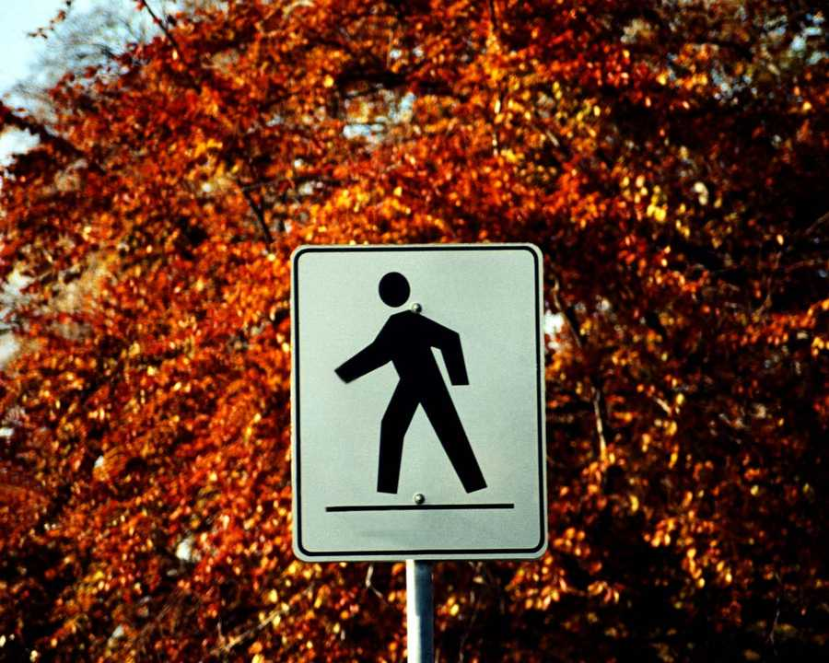
How does this Picture make you feel?

Relaxing is a key skill in learning how to overcome personal stress. Just changing your breathing to simple inhales and exhales allows your brain and body to get the oxygen that it needs to function. You may have noticed that it is harder to try and reason and to cope when you have shallow breathing and you feel stressed.

Thinking about ways to help you in a particular situation can lead to increased problem solving and less self destructive ways of coping. Acting out of emotion can lead to negative consequences and a loss of self esteem and self worth. Think before you act is an old adage that is still useful today.

Doing nothing is an answer just like solving a particular problem is an answer. Doing nothing leads to nothing. There is an old saying, “Nothing ventured is nothing gained”! Helping yourself feels good and you can take the credit for the solution just as you have been taking credit for the problem.

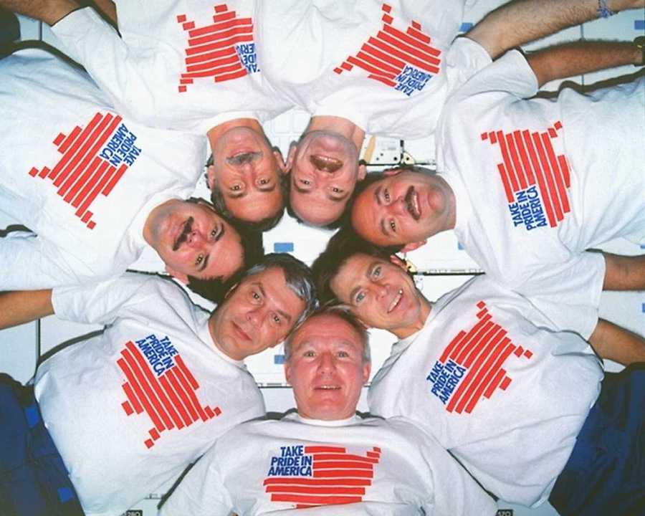

Taking Pride In One's Self Is Contagious!

FEELINGS LIST

It is wonderful to know that we have so many positive feelings and that we can access them when we need to. Feelings are an important part of who we are and what we do on a daily basis. Learn to embrace your feelings and yourself.

Pleasant Feelings

ADMIRED DEDICATED JUST RECEPTIVE
ADORABLE DEVOTED KIND RELIABLE
AFFECTIONATE EASY-GOING KINDLY RESPECTFUL
AGREEABLE EMPHATIC KIND-HEARTED RESPONSIBLE
ALTRUISTIC FAIR LENIENT SENSITIVE
AMIABLE FAITHFUL LOVABLE SYMPATHETIC
BENEVOLENT FORGIVABLE LOVING SWEET
BENIGN FRIENDLY MELLOW TENDER
BIG-HEARTED GENEROUS MILD THOUGHTFUL
BROTHERLY GENUINE MORAL TOLERANT
CARING GIVING NEIGHBORLY TRUSTFUL
CHARITABLE GOOD NICE TRUSTWORTHY
CHRISTIAN GOOD-HUMORED OBLIGING UNDERSTANDING
COMFORTING GOOD-NATURED OPEN UNSELFISH
CONFIDENT HELPFUL OPTIMISTIC WARM
CORDIAL HONEST PATIENT WARM-HEARTED
COURTEOUS INTERESTED PLEASANT WELL-MEANING
CONSIDERATE HUMANE REASONABLE WISE

AMUSED EXALTED HUMOROUS SERENE
AT EASE EXCELLENT INSPIRED SPLENDID
BLISSFUL EXCITED IN-HIGH SPIRITS SUPERB
CHEERFUL FINE JOVIAL TERRIFIC
COMICAL FANTASTIC JOYFUL THRILLED
CONTENTED FIT JUBILANT TREMENDOUS
DELIGHTED GAY MAGNIFICENT TRIUMPHANT
ECSTATIC GLORIOUS MAJESTIC TURNED ON
ELATED GOOD MARVELOUS VIVACIOUS
ENCHANTED GRAND OVERJOYED WITTY
ENTHUSIASTIC GLAD PLEASED WONDERFUL
SATISFIED GREAT PROUD HAPPY

ABLE DURABLE INFLUENTIAL SPIRITED
ADEQUATE DYNAMIC INTENSE STABLE
ASSURED EFFECTIVE LION-HEARTED STOUTHEARTED
AUTHORITATIVE ENERGETIC MANLY STRONG
BOLD FEARLESS MIGHTY SURE
BRAVE FIRM POWERFUL TOUGH
CAPABLE FORCEFUL ROBUST VIRILE
COMPETENT GALLANT SECURE WELL EQUIPPED
COURAGEOUS HEALTHY SHARP SELF-CONFIDENT

Unpleasant Feelings List

DEPRESSED DESPISED HORRIBLE PATHETIC
ABANDONED DESPONDENT HUMILIATED PITIFUL
ALIEN DESTROYED HURT REBUKED
ALIENATED DISCARDED IN THE DUMPS REGRETFUL
ALONE DISCOURAGED JILTED REPRIMANDED
ANIMATE DISFAVORED KAPUT REJECTED
AWFUL DISMAL LEFT OUT ROTTEN
BATTERED DONE FOR LOATHED RUINED
BELOW PAR DOWN CAST LONELY RUN DOWN
BLUE DOWN HEARTED LOUSY SAD
BURNED DOWN TRODDEN LOW STRANDED
CAST OFF DREADFUL LONESOME TEARFUL
CHEAPENED ESTRANGED MISERABLE TERRIBLE
CRUSHED EXCLUDED MISHANDLED UNHAPPY
DEBASED FORLORN MOODY VALUELESS
DEFEATED FORSAKEN MOURNFUL UNLOVED
DEGRADED GLOOMY OBSOLETE WASHED UP
DEMOLISHED GLUM OSTRACIZED WHIPPED
DEPRESSED GRIM OUT OF SORTS WORTHLESS
DESOLATE HATED MISTREATED REBUKED
DESPAIR HOPELESS OVERLOOKED WRECKED

AFFLICTED DISPLEASED LOST SWAMPED
ACCUSED DISSATISFIED NAUSEATED THE PLAYTHING OF
AT THE FEET OF DISTRUSTFUL OFFENDED THE PUPPET OF
AT THE MERCY OF DISTURBED PAINED TORMENTED
AWARD DOUBTFUL PERPLEXED TOUCHED
BAFFLED FOOLISH PUZZLED UNGAINLY
BEWILDERED FUTILE RIDICULOUS UNLUCKY
BLAME GRIEF SICKENED UNPOPULAR
CLUMSY HELPLESS SILLY UNSATISFIED
CONFUSED HINDERED SKEPTICAL UNSURE
CONTAINED IMPAIRED SPEECHLESS DISLIKED
DISGUSTED IMPATIENT STRAINED IMPRISONED

AFRAID FEARFUL JITTERY SHY
AGITATED FIDGETY JUMPY STRAINED
ALARMED FRIGHTENED NERVOUS TENSE
APPREHENSIVE HORRIFIED ON THE EDGE TERRIFIED
BASHFUL ILL AT EASE OVERWHELMED TERROR-STRICKEN
DESPERATE INSECURE RESTLESS UNCOMFORTABLE
DREAD INTIMIDATED SCARED UNEASY
EMBARRASSED JEALOUS SHAKY WORRYING

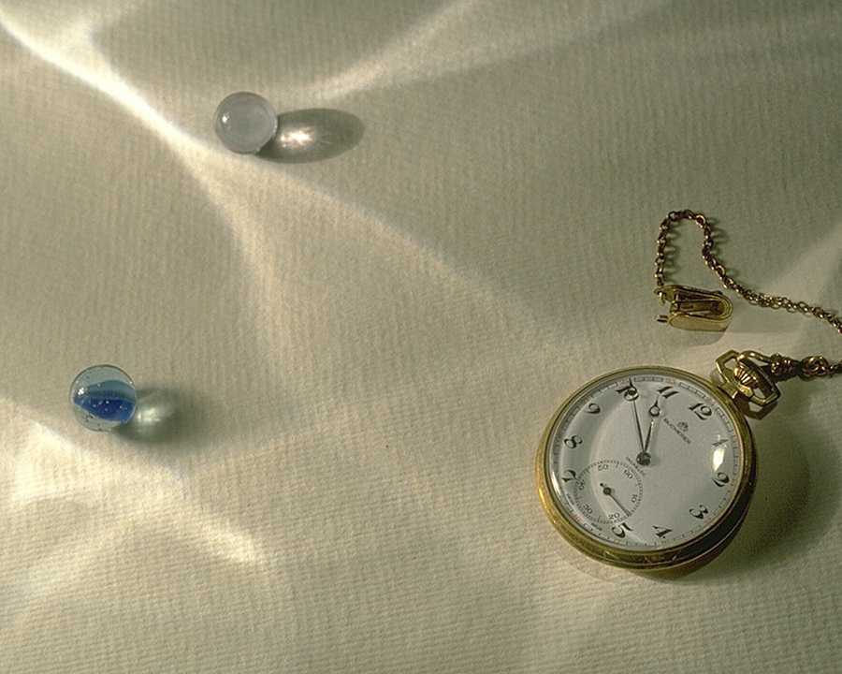
Is Time on Your Side?

Unpleasant Feelings (Continued)

ABUSED DIMINISHED MALIGNED SCOFFED AT
BELITTLED DISCREDITED MINIMIZED SCORED
CARPED AT DISDAINED MOCKED SHAME
CAVILED AT DISPARAGED NEGLECTED SLANDERED
CENSURED DISGRACED SLIGHTED UNSERIOUSLY TAKEN
CRITICIZED HUMILIATED OVERLOOKED THOUGHT NOTHING OF
DEFAMED IGNORED POKED FUN AT UNDERESTIMATED
DEPRECIATED JEERED POOH-POOHED UNDERRATED
DERIDED LAUGHED AT RIDICULED ROASTED

ANEMIC FLIMSY INSECURE UNABLE
BROKEN FRAGILE INSUFFICIENT UNARMED
BROKEN DOWN FRAIL LAME UNCERTAIN
CHICKEN FAKE MAIMED HARMLESS
COWARDLY HELPLESS MEEK UNFIT
CRIPPLED IMPOTENT MOUSY UNIMPORTANT
DEBILITATED INADEQUATE PARALYZED UNBOUNDED
DEFECTIVE INCAPABLE POWERLESS UNSUBSTANTIATED
DEFICIENT INDEFENSIBLE PUNY USELESS
DEMORALIZED INEFFECTIVE SHAKEN VULNERABLE
DISABLED INEPT SMALL WEAK
EXHAUSTED INFERIOR STRENGTHLESS WEAK-HEARTED
FEEBLE INFIRM TRIVIAL ZAPPED

AGITATED ANTAGONISTIC BITING CALLOUS
AGGRAVATED ARROGANT BLOODTHIRSTY COLD-HEARTED
AGGRESSIVE AUSTERE BLUNT COMBATIVE
ANGRY BAD-TEMPERED BULLYING CANTANKEROUS
ANNOYED CONTRARY COOL HARD-HEARTED
CORROSIVE HARSH MEAN RUTHLESS
CRANKY HATEFUL MURDEROUS SADISTIC
CROSS HEARTLESS NASTY SAVAGE
CRITICAL HELLISH OBSTINATE SEVERE
CRUEL HIDEOUS OPPOSED SPITEFUL
DEADLY HOSTILE OPPRESSIVE STERN
DICTATORIAL HYPERCRITICAL OUTRAGED STORMY
DISAGREEABLE ILL-TEMPERED PERTURBED UNFEELING
DISCONTENTED IMPATIENT POISONOUS UNFRIENDLY
DOGMATIC INCONSIDERATE PREJUDICED UNMERCIFUL
ENRAGED INHUMAN PUSHY UNRULY
UNHAPPY INTOLERABLE RECKLESS VICIOUS
GRUESOME IRRITATED REVENGEFUL VIOLENT
HARD MAD ROUGH WRATHFUL

Exercise 3.1

- List 5 positive feelings that apply to you?
____________________________________________________________________________________________________________________________________________________________

- What made you choose those feelings?
____________________________________________________________________________________________________________________________________________________________

- When do you have those feelings most?
____________________________________________________________________________________________________________________________________________________________

- List 5 feelings you would like to have that you are presently not using?
____________________________________________________________________________________________________________________________________________________________

- What can you do to help you develop those feelings?
____________________________________________________________________________________________________________________________________________________________

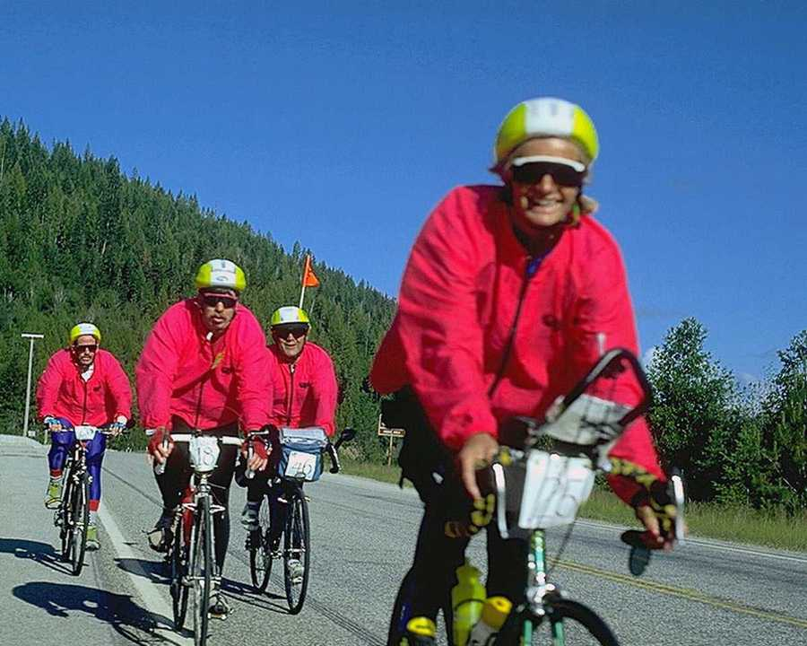
What A Positive Feeling It Is To Achieve Together!
When we experience negative feelings, we often feel confused and overwhelmed. That is a perfect time to make the decision to grow and change. There is an old saying, “I’m sick and tired of being sick and tired” and it applies to living with continuous negative feelings. Sooner or later, those negative feelings can become your reality. At times, we can get clinically depressed and talk alone will not pull us out of our depression. If you believe that you might be clinically depressed, contact your physician to arrange for an evaluation for a possible antidepressant medication. We all have highs and lows in our lives. The negative emotions that we experience tell us that something is not going according to plan and that we are focusing on self defeating thoughts which will lead to negative actions. It is important to realize that our negative thoughts and feelings generally are the result of choices that we have made about the stressors in our lives or about situations that we encounter that we most often have not control over. It can suck the life out of us when we encounter people with negative thoughts and feelings and actions. We want to avoid them. How many people are avoiding us because we suck the life out of them?

Since negative feelings are a choice and most often result from our thoughts about certain situations, we can choose to change our thoughts which will change our feelings and our actions. Change begins with your desire to change along with your actions. Answer the questions below as a step in your personal program to overcome stress.


Remember who won the Race between the Turtle and the Rabbit?
Slow Down…
Exercise 3.2

- List 5 negative feelings that apply to you?
____________________________________________________________________________________________________________________________________________________________

- How did you develop those feelings?
____________________________________________________________________________________________________________________________________________________________

- When do you have those feelings most?
____________________________________________________________________________________________________________________________________________________________

- List 5 feelings you would like to change?
____________________________________________________________________________________________________________________________________________________________

- What can you do to help you change those feelings?
____________________________________________________________________________________________________________________________________________________________

You Can Get A Natural High Being Successful!

Module 4

Equipping Yourself For Your Journey:
Assertion Training

Murphey’s Law states:
“If everything seems to be going well, you have obviously overlooked something. “

A Road to Success States:
“Mistakes are a part of life…
Be responsible for yours and everything will be okay.”

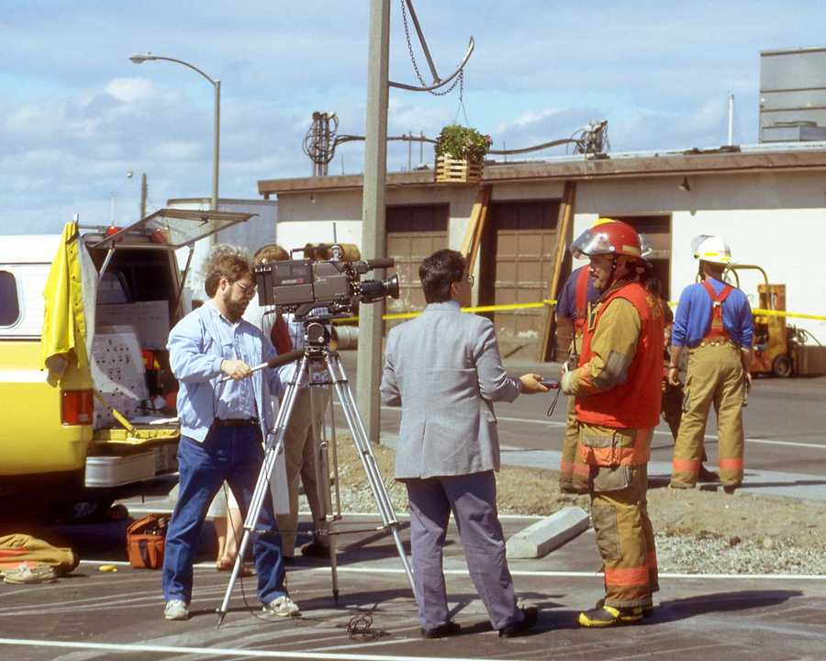
Respond with Authority

Module 4: Equipping Yourself For Your Journey:
Assertiveness Training

The main goal of Assertiveness Training is:

to be able to express your rights and to stand up for your personal rights when you choose to or need to.

Once you have accepted this goal and completed this program module you will have developed a belief in your rights and recognize when they are being infringed upon. One issue to be clear of is that this is a choice and you are the only person that can declare when you believe that your rights are being violated and that you need to stand up for your rights. You then must be able to discriminate between appropriate assertive behavior and submissive or aggressive behavior. Once this has occurred, you then should begin developing and practicing specific assertive skills that you can use in the various situations that you encounter in daily living activities. Many programs of this nature fall short of fulfilling their purpose because they do not have the participant practice their assertiveness skills. It is very important that you become aware of when and how you are practicing assertiveness and why. Also, practice being assertive as much as possible in selected situations and then discuss how you felt with someone who is supportive of your assertiveness skill development.

Before you are introduced to the concept of assertiveness and what constitutes assertive behavior, you first need to know what assertive behavior is not. If you asked five people for a definition of assertiveness you would get five different answers. We all believe that we know what assertiveness is and is not but the authors have found that the definition varies from person to person. Because of the differing views on assertiveness, it is important for you to come up with your own working definition of what assertiveness is and what it is not.

It is the experience of the authors that people can be assertive in some situations and not others. This variance in assertive behaviors is caused by variables which include who the person is that you are speaking to, what you want to accomplish, whether or not you are angry about the situation you are trying to assert yourself about, what your goal is for the assertive interaction and fears about how the other person will respond or may be hurt by your assertiveness, to name a few.

Non-Assertive Behavior

The failure to stand up for ones rights, either by failing to express a feeling or preference or by allowing another person to infringe upon your rights. The non-assertive individual will be reluctant to express their thoughts and feelings and will become hurt and angry but would rather be hurt and/or angry then risk a potential confrontation with the other individual. Non-assertive behavior basically results in the other individual being taken better care of by the non-assertive individual. The non-assertive individual accepts their lot in life but usually has a negative emotional payoff for it. Taking better care of others than ourselves causes us to develop a self view that can become low self esteem and low self worth.

Aggressive Behavior Is:

This includes standing up for one's rights in such a way as to violate the rights of others. We often know when someone is being aggressive due to their voice tone, confrontative body language and their intimidating manner. They act like this because it has gotten them what they wanted in the past and they are sure it will work again and again. The aggressive individual winds up alienating others and often does not know why others do not like them but no one will ever tell them why! There are times to be assertive but aggressiveness can bring aggressive behavior in return and this ends up in all types of problems for all involved.

Assertive Behavior is:

It also includes standing up for one's rights without denying the rights of others through a direct, honest, and appropriate expression of one's thoughts and feelings. This does not mean that you will always get what you want. It does mean that you have assertively interacted and that you represented yourself well in the interaction that occurred irrespective of the outcome of the interaction. We all appreciate open and honest people who communicate in a fair and mutually beneficial and satisfying manner. Assertive behavior allows you to get your point across without your having to become angry or upset. If you never ask, you will never know if you could have gotten what you want in a particular situation.

Assertive Behavior is a learned skill and goes against many social norms. In order for a person to learn this new behavior, he or she will need to define specific boundaries for him or her self. This is accomplished through first understanding what your rights are. Below is a list of your personal rights. If any of these rights have been violated, you have the right to speak out.

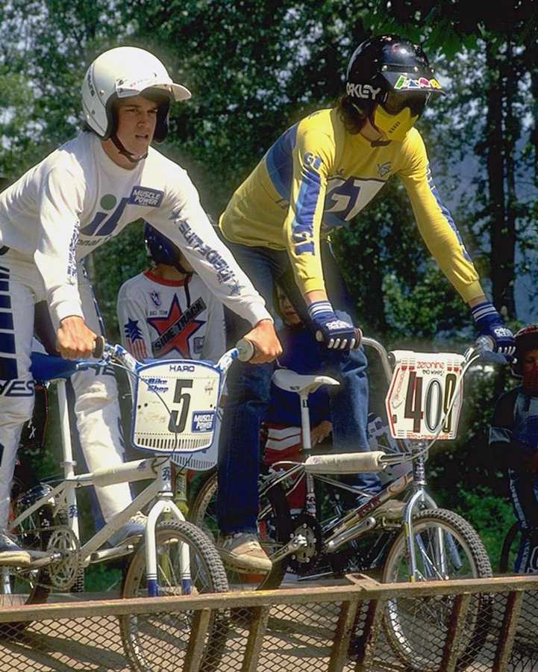
Riding A Bike Requires Assertiveness!

YOUR BILL OF RIGHTS

As a Human Being I have the right:

1. to be considered as a mature adult.

2. to make my needs be equally important to the needs of others.

3. to make mistakes and to be responsible for them.

4. to make my own decisions.

5. to say "no" (without feeling guilty).

6. to express my opinion.

7. to feel and express anger, as well as other emotions.

8. to be listened to.

9. to say "I don't know" or "I don't understand".

10. to feel positive toward myself and my accomplishments.

Each of these rights is the foundation upon which an individual should live their life. In many cases, we find our own rights being violated. At times, the violation is unintentional and other times it is not. Whatever the reason, we find ourselves in a “one down” position if our personal rights are being violated. It is also important to understand that we must also not violate the rights of others if we want our rights to be respected as well. If you are in any relationships where your rights are being violated, you will want to consider how to stop the violation of your rights in a manner that respects all parties involved. At times, it may become necessary to discontinue certain relationships if your rights continue to be violated. How we take care of ourselves indicates to others how we want them to interact with us. It is important to note the old saying, “Give and inch and they will take a mile”. The authors believe that individuals who desire healthy reciprocal relationships must have good personal boundaries that do not permit their own exploitation and manipulation. We also believe that it is important to “practice what you preach” when it comes to relationships with others.

In the past we did not have a definition for these rights, we only felt bad or uncomfortable when they were violated. Now that you have an understanding of these rights, it is your responsibility to stand up for them. If you don't stand up for your rights, "WHO WILL?" You must make a personal decision to honor yourself and to protect yourself by standing up for your personal rights. Why would you grant other people rights that you do not grant to your self? We must have fairness and equality in all of our relationships in order for us to maintain good personal boundaries and positive self esteem.

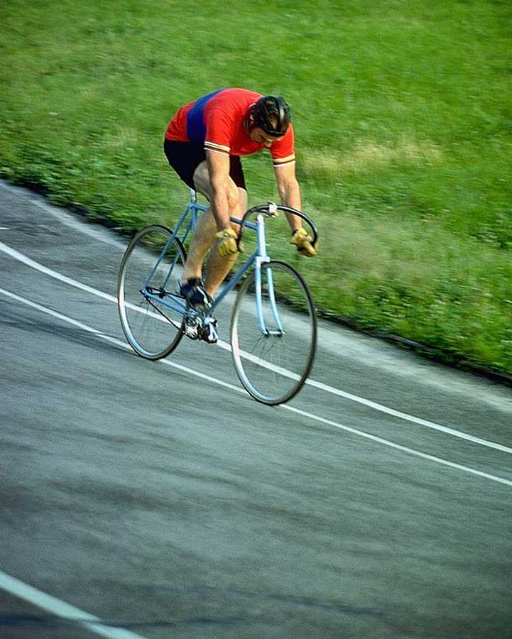
Sometimes we must be solitary to reflect upon our own rights....
Exercise 4.1

- How would you describe your assertiveness skills today?
______________________________________________________________________________________________________________________________________________________________

- What Right(s) do you feel you have difficulty standing up for?
______________________________________________________________________________________________________________________________________________________________

- Who/What makes you feel inferior and unable to stand up for your rights? Why?
______________________________________________________________________________________________________________________________________________________________

- What can you do if you feel inferior in certain situations?
______________________________________________________________________________________________________________________________________________________________

- What are three things you will do different the next time someone asked you to do something you don’t want to do?
______________________________________________________________________________________________________________________________________________________________


You can practice being assertive while having fun!
ASSERTIVE SKILLS

Now that you have been introduced to your personal rights, you need to know to gain control over your rights without infringing on the rights of others. Assertive Skills (taken from the book Your Perfect Right) are needed to help you gain important information about the person or person's you are communicating with. Once you have been introduced to these important assertiveness techniques, you can practice specific techniques of assertiveness. The three skills needed are:

1. Free Information
2. Self Disclosure
3. Open Questions

FREE INFORMATION is a listening skill. By using this skill, you are able to listen to what the person is saying or attempting to say. For this skill you will need to look past the specific words and listen to what the person means by their statements. You will need to listen intently to what the person is saying. Once you have an understanding of what the person is saying or trying to say you will have something to talk about with them. A value technique to use with this skill is the counseling skill called “Restatement”. Using this skill will require that you listen to the person’s entire verbalization and then you restate it as follows: “What I hear you saying is .............”. This gives the person who is talking the opportunity to learn that you fully understand what they saying. It is flattering to most people to have someone really listen to them.

SELF DISCLOSURE is an exposure skill. With this skill you are able to disclose specific information about yourself. Once a person has provided you with information about them self, you can disclose different things about yourself. By using these two skills, good communication can occur. It is important not to disclose more than the individual that you are talking with. Self disclosure is an important part of communication if it is used in conjunction with self disclosure by the other party.

OPEN QUESTIONS are questions that are not usually answered with a "yes" or "no", but instead encourages the other person to elaborate on something they said. Questions like "How", "Where", and "What" are good ways to allow a person to open up you to you. These questions are important because they allow you to learn new information that may be important in your future interactions with that person.
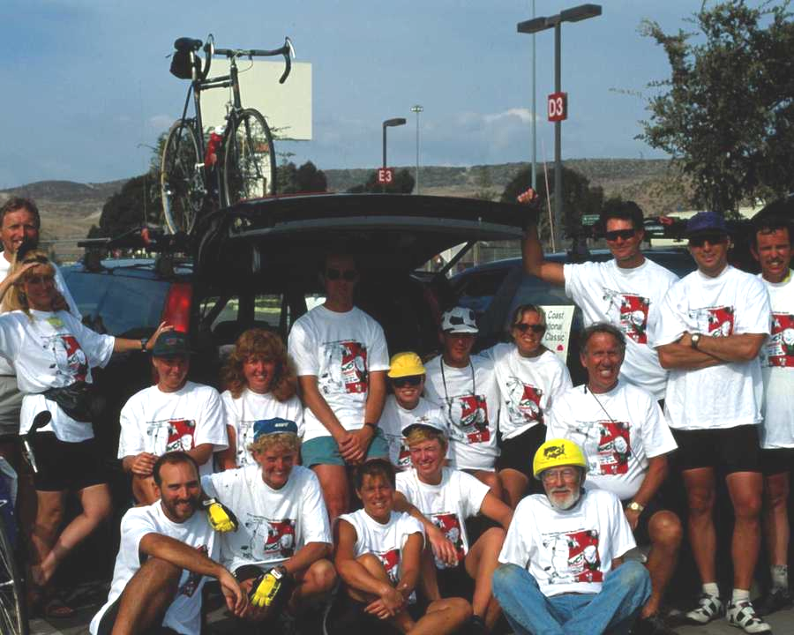
We can communicate assertively and enjoy doing it!
ASSERTIVE TECHNIQUES

The following assertive techniques (taken from the book Your Perfect Right) are only a selection of the many assertive techniques you will learn. If you would like to learn more about assertiveness techniques, you can purchase this book at any book store.

As you begin to use assertiveness on a regular basis you will find that you will develop your own techniques.

1. Broken Record
2. Fogging
3. Negative Assertion
4. Positive Self-Assertion
5. Escalating Assertion
6. Workable Compromise

BROKEN RECORD- This is one of the first techniques you will learn in beginning your assertive behavior. In a nut shell, it is calm persistent repetition. An important part of being verbally assertive is to be persistent and keep saying what you want over and over again without getting angry, irritated, or loud. It is sometimes the case that people are so focused on themselves that they cannot hear what we are saying. The broken record allows you to be more effective in stating your point.

FOGGING- This tool is needed when you are being accused of having a negative behavior. When criticized, you can assertively cope by offering no resistance or hard psychological striking comments to the critical statements thrown at you. Agree with the truth, then agree with the odds, and finally agree with the principles. Once you have done this you can then state your personal opinion. By agreeing initially, you affirm the person’s right to have an opinion without agreeing with it. After all, they believe that they are right and maybe they are. This is the path of least resistance because you do not confront the person directly but rather allow them to have their say and then you can state your personal opinion. Agreeing with a person’s statements allows the other person to have their say while allowing you to listen to their complaint or concern. Then, you can state your own opinion and you have listened courteously to them and they are more likely to reciprocate.

NEGATIVE ASSERTION- This skill allows a person to overcome hostile or constructive criticisms of their faults. This is done by agreeing with the critical statements that are being made without being apologetic about them. We all have faults and we will have them pointed out to us by others, situationally speaking.

POSITIVE SELF-ASSERTION- This skill allows a person to state positive accomplishments to others. A person must state positive and appropriate statements about themselves. It is appropriate to state our strengths to others in an objective and fair manner. We need to be able to state positive things about ourselves and others.
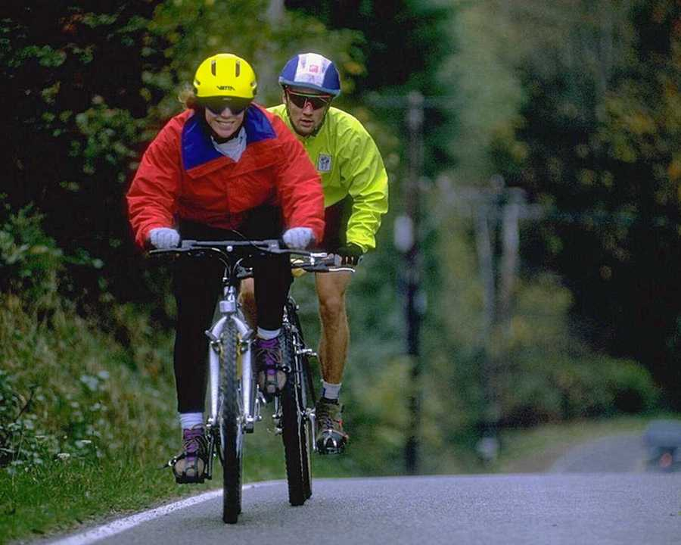
To ride a bike, you have to be assertive in your riding habits!
ESCALATING ASSERTION- This skill involves starting with a minimally assertive statement and becoming more and more assertive as needed in a particular situation. You can usually accomplish your goal with a minimal amount of effort and this approach has a smaller possibility of getting a negative reaction from the other person. When the other person fails to respond and ignores your assertion, you gradually escalate the assertion and become increasingly firm in your statements. You can start out at one level of assertiveness and increase it in your statements until you accomplish your goals.

WORKABLE COMPROMISE- In using your verbal skills it is practical, whenever you feel that your self-respect is not in question, to offer a workable compromise to the other person. You can always bargain for your material goals unless the compromise affects your personal feelings of self-respect. If the end goal involves a matter of your self-worth, however, there can be no compromise. Compromise is a good skill to learn because most of the situations we encounter in life will benefit from the consideration or implementation of compromise in the solution that is reached.

We use many skills cooperatively interacting with others!
NON-VERBAL COMPONENTS OF ASSERTION

Words alone do not make a person assertive. In fact, one study concluded that 75% of what a person retains in a conversation is through non-verbal communication. It is for that reason that you need to understand how to be assertive non-verbally. The three areas of body language that relate to basic non-verbal assertiveness are:

1. Eye Contact
2. Facial Expressions
3. Body Stance

EYE CONTACT- This refers to how well you maintain eye contact with the person you are communicating with. The goal is to:

1. Look the other person in the eyes.
2. Don't shift eyes away from a person when making an assertive statement.
3. Maintain eye contact following an assertive statement.
4. Don't lower eyes when you express negative feelings or say “no”.
5. Accept compliments with full eye contact.

FACIAL EXPRESSIONS- It is very important that your facial expressions compliment your assertive words. If the two are not complimentary, your impact with the other person will be lessened. The goal is to:

1. Keep face firm when you are expressing negative feelings.
2. Let your face mirror your emotions.
3. Smile when you feel like smiling.
4. Use as many facial muscles as you can when expressing your emotions.

BODY STANCE- It is very important that your body posture and stance be in an assertive mode when making an assertive statement. If you are slouched over or you do not project with your body your message will be diluted. Here are some tips about body stance:

1. Stand up with your backbone straight.
2. When making an assertive statement lean slightly forward.
3. Use your hands to make your point.
4. Pull your shoulders back.

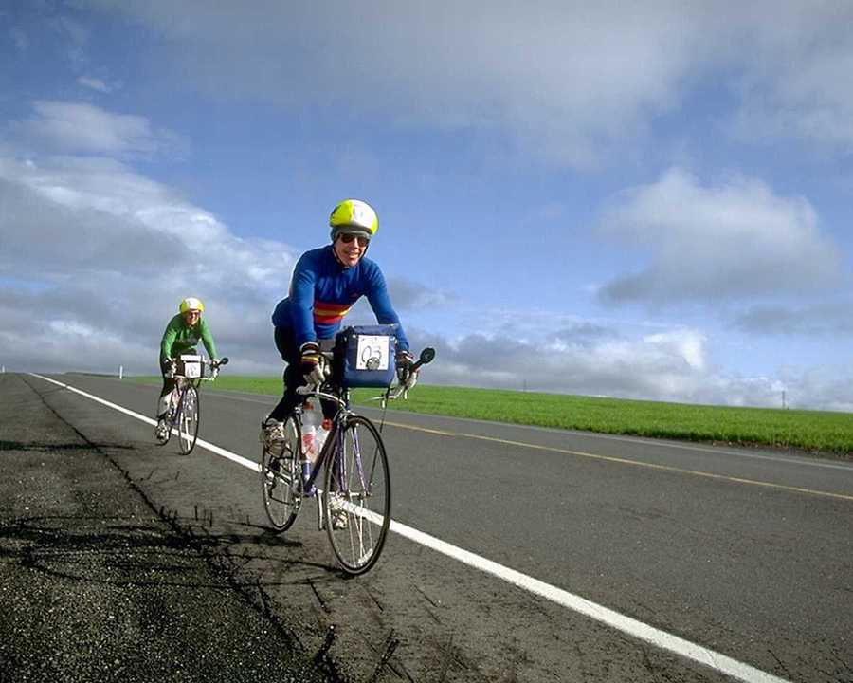
We use our whole body in all types of situations!
Exercise 4.2

- What assertive techniques have you used in the past week? Were they successful?
______________________________________________________________________________________________________________________________________________________________

- What non-verbal skills do you use when you are assertive?
______________________________________________________________________________________________________________________________________________________________

- What assertive techniques are you willing to use to stand up for your rights?
______________________________________________________________________________________________________________________________________________________________

- What prevents you from standing up for your rights?
______________________________________________________________________________________________________________________________________________________________

- How will you feel when you stand up for your personal rights?
______________________________________________________________________________________________________________________________________________________________


Your Journey Through Life leads You Down Many Unusual Paths.
REFRAMING FOR SUCCESS

When asked about past negative situations or behaviors, it is necessary to reframe the situation in order for a person can see your perspective of the situation. When framing a sentence or response, the process would be to put together various words resulting in the conveyance of an idea or thought. In reframing, the same idea or thought is arrived at by use of a different context. The meaning of any behavior or event in life depends on the "frame" in which that event is perceived, i.e., how we personally view the event, and its meaning to our lives. When we change the "frame", we change the meaning. It is often necessary to reframe events in more positive terms to avoid negative thoughts and actions.

The process of reframing is not new. Often fables and fairy tales include behaviors or events that change meanings when the "frame" around them changes. The ability to reframe for ourselves can offer flexibility and insights to our existence. It can help an individual adopt a new attitude toward life events when a new attitude will serve that individual best. It can prevent rigid perceptions and help us see ourselves as others often do. When starting reframing activities, it is important to start with a situation that has a high probability of success. Start out with simple situations and then move to more complex situations.

In conclusion, the main goal for assertive behavior is to allow you to express your opinions and needs to others without violating the needs of others. Though assertiveness you will be in control of your life and have a positive outlook on life because you are able to solve your own problems successfully.

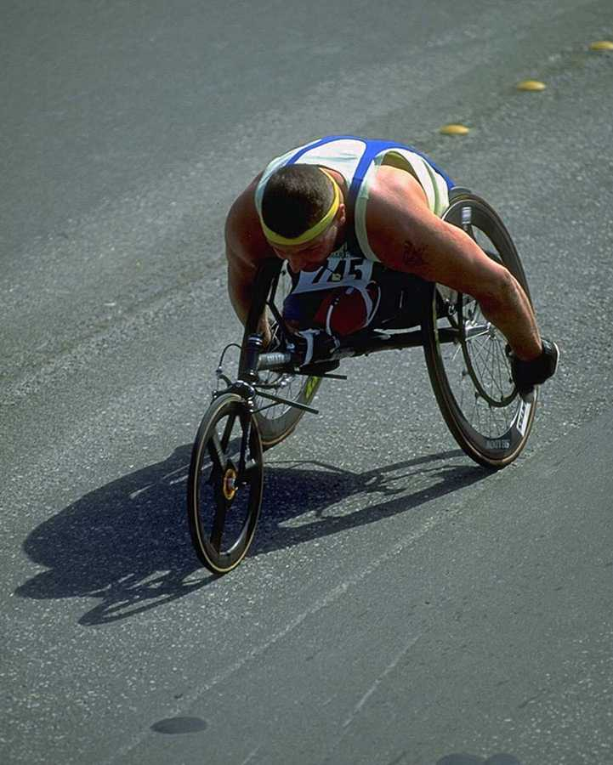
One’s Man’s Disadvantage Is Another Man’s Advantage.....
Exercise 4.3

- How can you use reframing in your day to day life?
______________________________________________________________________________________________________________________________________________________________

- What is the goal of reframing? What goals do you try and accomplish using reframing?
______________________________________________________________________________________________________________________________________________________________
3. What is a problem that you can reframe immediately and start to solve?
_____________________________________________________________________________
_______________________________________________________________________________

We can see a beautiful day instead of a tall mountain to climb!
Module 5

Training:
Relaxation Skills For Daily Living

Murphey’s Law states:
“When the plane you are on is late, the plane you want to transfer to is on time.”

A Road to Success States:
“When the world make too much noise…
escape by relaxing your mind through being at peace with yourself.”


Take time to Relax

Module 5: Training:
Relaxation Skills

RELAXATION SKILLS

Relaxation is the opposite of stress. Relaxation means that the mind and body are calm. As the mind and body remain in a calm state of reduced arousal, they become refreshed and restored.

Although sleep is essential, even sleep is not pure relaxation. In sleep, we alternate between periods of deep rest and dreams and our minds are extremely active. Emotionally charged dreams or fretful sleep can cause us to wake up even more tired than when we went to sleep.

Very effective physical restoration occurs when we relax even while awake. Although you may not reach the deepest level of rest possible in sleep, the fact that you can steadily remain at a level of reduced arousal can be more refreshing than sleep.

The aim of relaxation, then is to free yourself from stressors long enough to refresh and restore your mind and body. Relaxation allows you to temporarily interrupt your stress cycle and to reduce the impact of your stressors on your daily functioning.


Relaxation can occur in many situations and environments!
RELAXATION IS NOT...

Relaxation does not mean that the mind becomes dull, or ceases to function or that you fall asleep. Rather, the mind is focused and alert during relaxation. Mental clarity and greater concentration result from periods of relaxation. Relaxation is not leisure and recreation. As we discussed, these require adaptation. Although these can be useful and satisfying distractions from the world's stressors,
relaxation goes beyond distraction from our presenting stressors.

Relaxation is not tranquilizing drugs (alcohol, valium, sleeping pills, etc.). These depress or impair the brain or nervous system, making people less responsive to their surroundings. Relaxation calms the body and mind, but without clouding the senses. In fact, studies show that people who daily practice relaxation actually react quicker to stressors, and recover more quickly than those who do not practice relaxation.

Relaxation in no way decreases productivity. In fact, the reverse is true. Relaxation increases work efficiency because energy is not uselessly wasted. Relaxation does not depend on adopting a new lifestyle or philosophy. Relaxation only requires a few minutes once or twice a day, and an attitude of calm. Like physical exercise, relaxation exercises begin with just a few minutes a day and work up to perhaps 10 - 20 minutes a day. They can be done anytime (except after meals, when digestion interferes with relaxation), and are especially effective after physical activity.


We have so many places to relax if we will allow ourselves to do so!
Exercise 5.1

- What relaxation techniques are you presently using?
______________________________________________________________________________________________________________________________________________________________

- Plan a relaxation exercise that you can do each day!
______________________________________________________________________________________________________________________________________________________________

- What are 3 goals you have for relaxing?
______________________________________________________________________________________________________________________________________________________________

4. Where and when and how will you begin your relaxation activities?
______________________________________________________________________________________________________________________________________________________________

When we relax we feel like we are back in touch with nature and solitude!
EFFECTS OF RELAXATION

Research has shown that people who practice relaxation do not get stressed under pressure. They learn to calm unnecessary electrical activity in the brain. As they practice, they become conditioned to remain relaxed throughout the day (The centers in the brain that cause relaxation actually learn to predominate over the unnecessary activity.). Relaxation training also calms areas in the brain that control thinking and emotions, so that responses to stressors are calmer. People, who get so excited they cannot think straight, need to calm down first so they can respond appropriately.

Because the mind and body are closely connected, relaxation can be achieved in two ways. First, the body can be relaxed, and the mind will follow. Progressive muscle relaxation, yoga, massage, and biofeedback are examples of this approach. Second, the mind can be relaxed and the body will follow. Meditation, therapeutic massages, suggestions visualizing peaceful scenes, and soft music are examples of this approach. When relaxation does occur, the racing of the mind and body ceases. The heart rate goes down, muscle tension decreases, and disease symptoms may lessen.

Initially, you may learn relaxation skills to prevent disease. However, as you practice, you may discover a number of positive psychological results. You might find that you feel more in control and happier. The person who is in control can work efficiently, but also can choose to deeply relax when it is appropriate. In addition, relaxation seems to access the parts of the brain where creative thoughts originate. You might remember attacking a problem for hours without finding a solution. Then, as you relaxed and "let go" your mind seemed to assemble the pieces of the puzzle and present a solution. Our creativity increases when we are relaxed.

Perhaps this occurred at night in bed, in the bathtub, or on vacation. On the contrary, people who can only work doggedly, and can't seem to let the mind spin free occasionally, get creative insights and hunches less frequently. In spending a few minutes in relaxation, people momentarily stop striving to control and organize their surroundings. They just uncritically observe and enjoy it. People who do this find themselves learning to appreciate and enjoy the beauties of life more. The enjoyment and pleasures that this brings usually improves work productivity and efficiency, but a true relaxation break is even more effective.

Relaxation training often creates a profound serenity, a feeling of calm and joy. Try it! The benefits might surprise you. A good plan is to try each skill for a week or more to find the ones that best suit you. You may find that you like several of the relaxation skills that you learn and you can use them whenever you like.

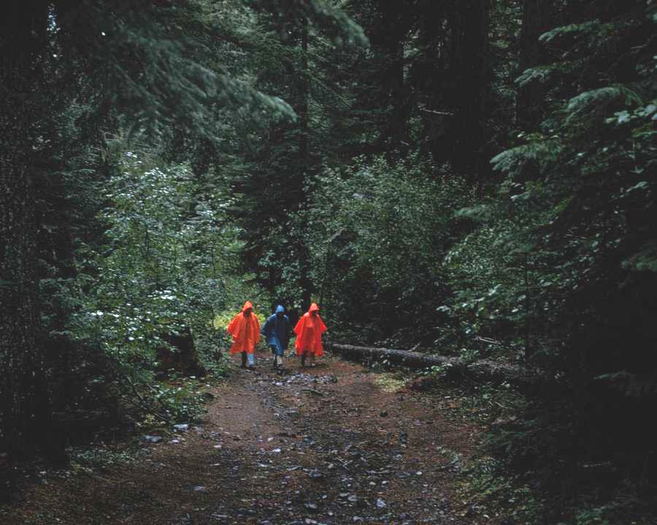
A relaxing walk leads to a relaxing experience!

RELAXATION SKILLS

The skills for relaxation have been broken into two categories 1) Body relaxation and 2) Mind relaxation. It is important that you follow the few simple rules before you start to learn how to relax.

RULES TO FOLLOW IN ORDER TO DEVELOP RELAXATION SKILLS:

- Practice slowly the techniques of self relaxation for five to seven days.
- Practice at least once every day without skipping a day.
- Do not try to speed up the process of relaxation until you have mastered the technique slowly for five day.
- If you do not achieve immediate results, do not become discouraged. Each time you practice, it will be easier.
- Do not practice in the same position more than twice consecutively.
- Change hours of practice sessions.
- If you are interrupted during a practice session, always take a moment to "count yourself awake".

Learning relaxation skills is like learning how to receive pleasure without investing a lot of time and effort. It is important to acquire relaxation skills incrementally and to master them one at a time so that you have several alternative relaxation tools to use in any given situation. You may also want to purchase a relaxation CD or tape with sounds or music that you prefer to use when you relax. You can make your own relaxation CD or tape so that you get the exact relaxation experience that you are seeking.

Relaxation can occur alone or with others in all types of settings!
Exercise 5.2

- What types of relaxation skills do you want to learn?
______________________________________________________________________________________________________________________________________________________________

- What type of relaxation do you feel you can utilize in your life?
______________________________________________________________________________________________________________________________________________________________

- What prevents you from relaxing? From taking the time to relax?
______________________________________________________________________________________________________________________________________________________________
- When and where can you relax?
______________________________________________________________________________________________________________________________________________________________
5. What do you need to obtain in order to start your relaxation process?
______________________________________________________________________________________________________________________________________________________________


You can find a lot of experiences that will relax you!
BODY RELAXATION

Jacobson, in "YOU MUST RELAX", persuasively maintains that physical-relaxation techniques provide an excellent way to break the cycle of fear, worry, and tension. Observing that physiological tests "indicates that when you maintain or recall anything, you tense muscles somewhere, as if you were actually looking or speaking or doing something". He counsels that the individual should learn to observe the muscular sensations that accompany negative thoughts. Jacobson claims that by relaxing these muscular tensions, ability to maintain the negative psychological state is diminished.

BREATHING

A good place to start is with a simple, yet very effective skill that uses breathing to relax. Breath control is perhaps the oldest known stress-reduction skill, and is common to almost all relaxation skills.

The type of breathing used in relaxation is called diaphragmatic breathing (the diaphragm is the muscle below the lungs; it drops down against the stomach when you breath in, and raises when you breathe out). In diaphragmatic breathing, the stomach seems to inflate when you breathe in, and deflate when you breathe out.

There is essentially no movement in the chest or shoulders. The diaphragmatic breath gets air into the lower parts of the lungs, where air sacs are densest, so more oxygen gets into the blood with less effort. It is also thought that this type of breathing stimulates the vagus nerve, a major nerve in the body, which relaxes the body when activated.

Slowly and easily take a deep breath, filling the bottom of your lungs as well as the top. As you breathe in, whisper the syllable "re". Pause for a moment, then breathe out, whispering the syllable "lax". Don't force the air in and out of your lungs; let it flow slowly and naturally: Re-e-e-e (pause) La-a-a-a-x (pause).

Deep muscle relaxation prepares the individual to sleep - "perchance to dream"- or, if mental alertness is retained, to imagine more vivid and spontaneous visual fantasies than can usually be obtained with normal muscle tones.


Relaxing in the sunlight is mighty fine!
DEEP MUSCLE RELAXATION PROCEDURES

1. Lie down in a comfortable and quiet place.

2. Systematically (a) tense a specific muscle group
(b) study the feeling of tension,
(c) relax, studying the feeling of letting go. (the slash (/) indicates a pause)

3. Clench fists / flex wrists / hands to shoulders, flex biceps / shrug shoulders (touch ears) / wrinkle forehead up / frown / close eyes tight / push tongue against roof of mouth / press lips together / take deep breath, then breath out / suck stomach way in / tense stomach muscles / tense buttocks / lift legs, tensing calves / curl toes down, tensing arches

Review each activity above, letting go tension in each muscle group even more. Feel the peaceful, positive feeling that accompanies deep relaxation.


Find a relaxing spot and start the relaxation process!

PROGRESSIVE MUSCLE RELAXATION PROCEDURES

Find a comfortable place to lie down or sit down. Remove any constricting clothes or shoes. Make sure that their will be no interruptions, distractions, or noise. Now, relax your body by repeating these words in your mind...

FEET... RELAX...RELAX...RELAX...
ANKLES...RELAX...RELAX...RELAX...
KNEES...RELAX...RELAX...RELAX...
THIGHS...RELAX...RELAX...RELAX...
HIPS...RELAX...RELAX...RELAX...
BASE OF SPINE...RELAX...RELAX...
STOMACH AREA...RELAX...RELAX...RELAX...
AREA OF THE LEFT LUNG...RELAX...RELAX...RELAX...
AREA OF THE RIGHT LUNG...RELAX...RELAX...RELAX...
RELAX...RELAX...RELAX...RELAX...
LEFT SHOULDER...RELAX...RELAX...RELAX...
RIGHT SHOULDER...RELAX... RELAX...RELAX...
LEFT ARM... RELAX...RELAX...RELAX...
RIGHT ARM...RELAX... RELAX...RELAX...
NECK MUSCLES... RELAX...RELAX...RELAX...
FACIAL MUSCLES...RELAX...RELAX...RELAX...
FROM THE SCALP TO THE TOES...RELAX...RELAX...RELAX...
RELAX...RELAX...RELAX...RELAX...RELAX...

After injecting your suggestion, you slowly start counting from sixty to zero without stopping. Upon reaching zero, you should slowly start counting from one to ten; give yourself suggestions that on the count of ten you will awaken feeling fine and completely refreshed.


You can progressively relax while enjoying nature’s bounty!
MIND RELAXATION

One of the best supported concepts in psychology is this: WE FEEL AND BEHAVE ACCORDING TO THE IMAGES AND THOUGHTS IN OUR MINDS.

Thus, as we imagine a peaceful relaxing scene, our bodies and minds relax.

To do this, get in a comfortable position, close your eyes and relax your body. Take a few deep breaths, and then imagine the sensations of one of your favorite scenes (sounds smells, feelings, colors, textures, and sights).

IMAGERY ACTIVITY

Take a comfortable position, close your eyes. Take 3 diaphragmatic breaths as you let go of the day's tension. Relax your body from toe to head. Make a tape of the following imagery activity to play while you are relaxing:

Imagine yourself walking along a quiet wooded brook, on a warm spring day...you begin to walk away from the brook out of the woods into a lush green meadow... after a few steps you pause, and leave your worries behind... you continue to walk out into the meadow where you recognize little bunnies hopping through a beautiful carpet of spring flowers...next to the brightly colored flowers you notice a field full of bright green clover, with an occasional dandelion... the flowers are dancing as a gentle wind flows through the field... the soft breeze blowing over your skin soothes and relaxes you... as you feel relaxed you lay down in the field to absorb the heat from the sun... as you look up you begin to make animal shapes from the clouds...you see an elephant, a dog, a clown, a heart, and a bird...just topping the trees you see a beautiful hot air balloon with magnificent colors... you sit up and wave to the pilot... and he waves back...a few birds circle lazily in the sky as the balloon leaves... other birds are singing in the trees... you are peaceful and happy... all is right with the world...

Stay here for a few moments. This is your safe place, and you can return here to rest each day if you wish. You can feel happy, relaxed, and confident when you leave your safe place to continue you day's activities.

Now move your hands, your arms, your legs, and begin to hear the sounds around you. You can slowly open your eyes and begin to see the new world around you.


We can make new visual images anywhere!

Exercise 5.3

- What resources do you have to help you become more relaxed?
______________________________________________________________________________________________________________________________________________________________

- Make a relaxation plan to help you in your everyday living?
______________________________________________________________________________________________________________________________________________________________

- Name three obstacles you have that prevent you from relaxing?
______________________________________________________________________________________________________________________________________________________________

- How can you overcome these obstacles?
______________________________________________________________________________________________________________________________________________________________

- How will you feel if you accomplish your goals for relaxation?
______________________________________________________________________________________________________________________________________________________________

Relaxation can become contagious!

Relaxation Is Important

We have provided you with a lot of information about relaxation and how to use relaxation skills in your life. Each of us is an individual and for that reason, we have chosen to provide you with several relaxation skills that you can choose to use whenever you like. You may already know several relaxation skills and you can add them to your arsenal of tools to use when you are stressed and you need to relax.

If we have learned how to become stressed then we must learn how to relax. These skills are needed to offset the daily stressors that we encounter. We believe that each of us must obtain an amount of relaxation equal to the amount of stress we are facing.

We hope that this module has assisted you to begin your mastery of the relaxation process.

Find time to Relax along your Journey…
Module 6

Mapping Your Journey:
Goal Setting

Murphey’s Law States:
The only perfect science is hind-sight.

A Road to Success States:
Meeting your long range goal is not as important as the success of meeting your short range goals.

Every Goal Starts with a Desire…

Module 6: Mapping Your Journey:
Goal Setting

GOAL SETTING

How many times have you set a goal and then you were let down when you did not reach that goal? An example of this is that proverbial New Years Resolution. How many times have you broken that goal to lose 10 lbs. or make $10,000.00 more? There are two main reasons why you possibly were not able to make your goals 1) the goals were unrealistic or 2) the goals took too long to achieve. In either case, you were disappointed by the failure to achieve the goals that you had set. You are likely very successful in other areas of your life with the exception of this type of activity. Maybe you lose your motivation when the results of your efforts are not immediate. Not achieving a goal is not necessarily a failure. Goals involve thoughts and feelings and actions that are coordinated together with the end purpose of achieving the goal.

There are three types of goals 1) short range goals, 2) medium range goals, and 3) long range goals. Do not ever attempt to only have a long range goal. You must have steps in order to reach the long range goal. The steps are the short and medium range goals.


Each step is progress towards the goal!
Exercise 6.1

- What beliefs keep you from achieving your goals? Do you self talk yourself out of the goal?
______________________________________________________________________________________________________________________________________________________________
- Do you make time to Plan your goals or do you just set them and wait for them to be achieved?
______________________________________________________________________________________________________________________________________________________________

- What steps do you need to complete in order to achieve your goal(s)?
______________________________________________________________________________________________________________________________________________________________

- What are three things you will do this week to start your goal?
______________________________________________________________________________________________________________________________________________________________

It takes a lot of steps in order to meet the goal!

SHORT RANGE GOALS

Short range goals are those goals which can be reached in a 24 hour to one week period of time. The primary way to obtain short range goals is to list 1 or 2 things you must finish within a 24 hour period to obtain the medium or long range goal. Do not overload yourself and make sure the short range goals you have set can all be completed in the allotted period of time without overtime. If you completed 2 goals each day for an entire year you would have been able to complete over 700 tasks. If you cannot reach a long range goal with over 700 completed tasks, your long range goal is truly unrealistic.


Each step is a step towards the goal!

MEDIUM RANGE GOALS

Medium range goals are those goals that can be reached within a one week to twelve month period of time. This goal is based on the combination of the short range goals into an overall goal. Short range goals are milestones in your progress. An example of a medium range goal is: making 200 calls within a month period of time. The medium range goals are the primary foundation on which success is made. The medium range goals are designed to provide you with stability that cannot be taken away from you.

LONG RANGE GOALS

Long rang goals are LIFE GOALS. They are goals that are designed to improve your status in life. They are the only goals that have the option to change. It may take you several years to reach your long range goals. Long range goals are those goals that keep the spice of life going. Your long range goal might be to own your own home, have a Ph.D. in a field of your choice, or it may to be in very good health. These goals may never be met. It is not important that you meet these goals, it is only important that they exist so that you can have dreams to work toward. Without dreams, life can become very boring and monotonous. Never become obsessed with reaching these goals. There should only be three or four long range goals in your life at any one time.

REACHING YOUR GOALS (Activity 6.2)

The first step in reaching your goals is to list a several long range goals. This is your one time you can dream and wish for the stars. You can wish for a 36-foot sail boat, a college degree, a home, a $50,000.00 income, or any other dream you might have. List your Long Range Goals:

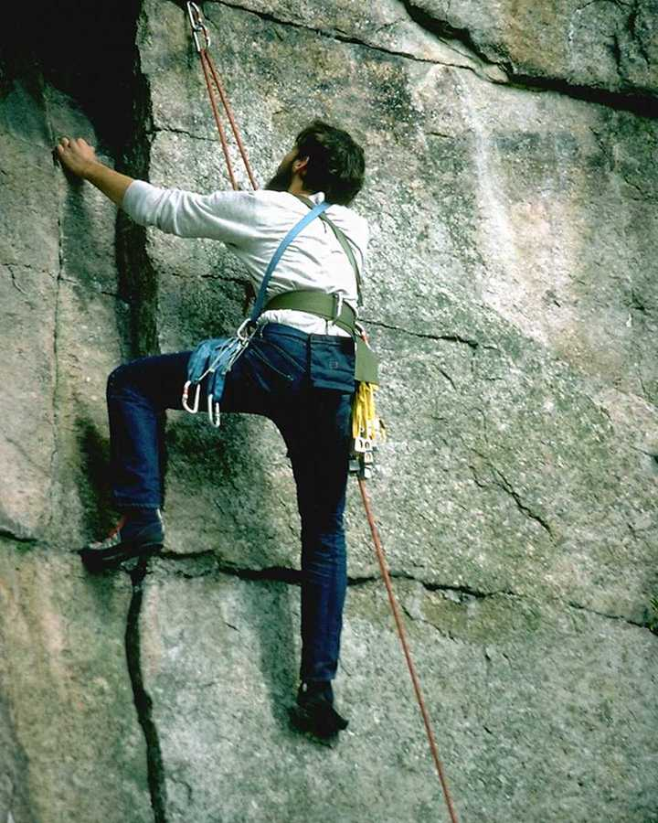
The goal is achieved through hard work and perseverance!
LIFE GOALS (Activity 6.3)

Now choose three to four of your long range goals you wish to work on and use the following outline for each goal.

LIFE GOAL I:
______________________________________________________________________________

______________________________________________________________________________

LIFE GOAL II:
______________________________________________________________________________

______________________________________________________________________________

LIFE GOAL III:
______________________________________________________________________________

______________________________________________________________________________


Everyone has a goal in life and can attain it if they try!

LIFE GOAL OUTLINE (Activity 6.4)

Long Range Goal: __________________________________________________________________
_________________________________________________________________________________

I. Medium Range Goal:_______________________________________________________________
_________________________________________________________________________________

Summary of Short Range Goals:
_________________________________________________________________________________
_________________________________________________________________________________

II. Medium Range Goal:______________________________________________________________
_________________________________________________________________________________

Summary of Short Range Goals:
_________________________________________________________________________________
_________________________________________________________________________________

III. Medium Range Goal:______________________________________________________________
_________________________________________________________________________________

Summary of Short Range Goals:
_________________________________________________________________________________
_________________________________________________________________________________

The Medium Range Goals are in relation to the Long Range Goals and the Short Range Goals are in relation to the Medium Range Goals. As one Medium Range Goal is met the next Medium Range Goal begins. This outline can be used for any project or projects you are working on. Start goal setting today so that you can begin the process of personal change.


Sometimes we need help in achieving our goals!
Exercise 6.5

- What are three long range goals for your life?
______________________________________________________________________________

______________________________________________________________________________

- How do your medium range goals play into rewards that you are seeking?
______________________________________________________________________________

______________________________________________________________________________

- List 5 rewards you can give to yourself when you complete a medium range goal?
______________________________________________________________________________

______________________________________________________________________________

- List 3 short range goals for this week.
______________________________________________________________________________

______________________________________________________________________________

- How will you feel if you accomplish your goals for today?
______________________________________________________________________________

______________________________________________________________________________

Start with running a block, then a mile then 10 miles!
REWARDS: THE BUILDING BLOCKS TO SUCCESS

It is very important that you experience success every day. Be sure to pat yourself on the back when you complete a goal. That means that when you complete the allotted short range goals in a day’s period of time, you should be proud of yourself for completing another step in reaching your long range goal. After you reach a medium range goal you should reward yourself. This means that when you reach the goal of making 200 contacts in a month, you should not delay the celebration. When you reach your long range goals you need to have a party and invite friends to rejoice in your celebration.

Without the rewards for achieving milestones, your life will never seem fulfilled and you will become depressed. There will be many times that the excitement of the celebration will help you get through another day. Rewards can include vacations, trips, and a night on the town, or even monetary rewards (bonuses). Remember you are the boss, and you need to reward your employee (yourself) for a good days work. If you do not reward yourself, no one else will.


Rewards come in so many shapes and forms and experiences!

Exercise 6.6

- Name three rewards you like to receive for your efforts?
______________________________________________________________________________

______________________________________________________________________________

- How often do you reward yourself? Hourly, daily, weekly, monthly?
______________________________________________________________________________

______________________________________________________________________________

- What prevents you from rewarding yourself?
______________________________________________________________________________

______________________________________________________________________________

- What are the benefits of rewards for you?
______________________________________________________________________________

______________________________________________________________________________

Rewards are worth the effort!
Module 7

Setting Your Course:
Time Management

Murphey’s Law States:
The legibility of a copy is inversely proportional to its importance.

A Road to Success States:
The Past is History, The Future is a Mystery and
The Present is a Blessing…

Make Peace with Time…

Module 7: Setting Your Course:
Time Management

COMING TO PEACEFUL TERMS WITH THE CLOCK:

Who controls your life, you or the clock? Does the clock tell you when to get up, eat, meet deadlines, and go to bed? Do you feel there isn't enough time to do everything you want? In worrying about getting everything done, do you try to do several things at once, without concentrating fully on any? Do you pace yourself, so that you don't need to frantically rush at the last minute?

Several years ago, I lived on a deadline from 7:00 a.m. to 11:00 p.m. Every minute seemed pressed and I felt that no one could live without me. Then one day I looked at my life and realized that when I got sick and had to miss a day of work, the world did not fall apart. I found that if I organized my day I could get anything accomplished. I put new priorities on life and decided to organize my thoughts and write them down. In the fall of 1987 I left the real world and lived in the Bahamas for three months to write and understand how much control I do have over my life. In the Bahamas I found that there was a world that had no dead lines and no time schedules. At times it was hard to determine what time of the year is was. I remember eating lunch with a friend one day and saying, "Gee, did you know that it’s Thanksgiving?" When I came back to the real world, I realized that the clock is there to help us and not to keep us in prison.

No matter how hard you try, you cannot ever get 25 hours in a day. If you use your time wisely, you will find that every day will seem complete and fulfilling. If you overload yourself and squander it, you will always feel in a hurry and depressed because you never complete anything. By wisely managing your time, you can minimize stress.

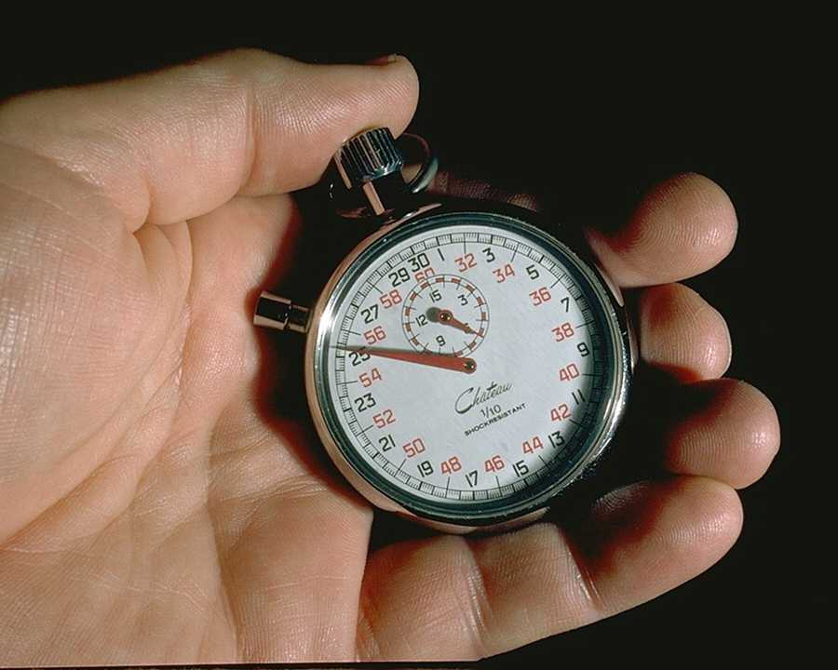
Is time your friend or possibly your enemy?
Exercise 7.1

- How can you come to peace in your relationship with time?
______________________________________________________________________________

______________________________________________________________________________

- What are some goals you need to set in order to stop feeling like you are always behind schedule?
______________________________________________________________________________

______________________________________________________________________________

- How can you make a to-do list effective for you?
______________________________________________________________________________

______________________________________________________________________________

- What prevents you from handling one piece a paper at a time?
______________________________________________________________________________

______________________________________________________________________________


We can find time to do the things that we need to do!
Expert Alan Lakein, presents these simple, but powerful ideas to wisely manage time, so that we can work smarter, not harder:

I. LIST GOALS AND SET PRIORITIES THAT YOU CAN KEEP

II. MAKE A DAILY TO DO LIST AND THEN DO IT

III. HANDLE ONE PIECE OF PAPER AT A TIME

IV. DO IT NOW, NOT TOMORROW

V. MAKE TIME TO PLAY


Set your own priorities and find the time to achieve them!
LIST GOALS AND SET PRIORITIES

Too many people get so bogged down doing unimportant tasks that they lose sight of the things that really want to do. They just run out to time. Unless goals (things you really want to do) are written down, they usually don't get done. It is too easy to become absorbed with unimportant, routine tasks which immediately confront us unless goals are constantly before us. Seeing is believing!

Make sure that when you list your goals, you have priorities set on which goals are to be done first. In a list of 10 goals for a day the priority is that the first three goals be completed before the other goals are begun on.

MAKE A DAILY TO DO LIST

At the beginning of the week, it is wise to plan events for each day of the week. Lakein advises that you look at the things you want to accomplish. Set priorities by labeling high priority goals "A", things less important "B", and things that can wait "C". During the day, get the "A's" done first. Most people spend 80% of their time working on "B's" and "C's". Before starting each day, go over your daily "To Do" list, making any necessary changes.

Constantly ask yourself, "What is the best use of my time right now?" Lakein advises to delegate as much as possible. Be aware of ways to use your time better. For example, if you must wait, try to read, or do something on your "To Do" list. Plan enough time to accomplish your desired tasks. Over scheduling creates stress, so allow ample time, plus a little more.


A rainbow awaits us when we have a plan that works for daily living!

HANDLE EACH PIECE OF PAPER ONCE

Some people waste time shuffling papers, stacking and restacking them. Don't pick up a piece of paper until you are ready to do something with it. Don't put it down until you have done something with it.
If you have piles of papers, take a day to go through them with the goal of getting rid of them as soon as possible. Only necessary papers are needed for goal completion. If you are a clutterer by nature, go to the following web site: www.clutterless.org and join the free organization for clutterers.

Get off junk mailing lists. Throw out junk mail. Or at least save it up until you have time to look at it all at once. Junk is just that-junk!

DO IT NOW

Procrastination increases anxiety. Problems generally don't go away; they just get worse if we procrastinate. Take care of necessary tasks now, so that you can relax without guilt. If an important task seems overwhelming, and you don't feel you can find enough time to do it, break it up into smaller tasks. That can be done gradually. You'll find it's not as overwhelming as you gather momentum.

Don't worry about perfectionism, or about failing. Just start one step at a time.

What about the "C's" that never seem to get done? Sometimes, it relieves stress and worry to take a few hours each week to devote to low priority items. By reducing the number of things to worry about, you might feel better able to concentrate on the "A's". But this should only be done occasionally. Get in the habit of spending most of your time on the things you want to do!

Time cannot be stopped…

MAKE TIME TO PLAY

All work and no play make Jack a dull boy. This is so true! A person needs to have rewards in life. If all a person does is work and work, he or she will become dull and unaware of natural highs. In listing your priorities it is important that PLAY is on that list of priorities.

This means that vacations, weekends to the lake or beach, trips to the movies, eating out, and other relaxing activities need to be in your budget of time. It is helpful to put these play times following the accomplishment of a goal, in order to reward you for your hard work.


Make Peace with Time…
Take time to plan recreational activities!

IRRATIONAL BELIEF'S

Irrational beliefs interfere with our ability to engage in goal oriented behavior. We all have irrational beliefs but we do not have to act on them. We have choices about our thoughts and feelings and actions. Take charge of your thoughts today!

Irrational beliefs include:

- It is a dire necessity that we be loved by everyone, and everyone just approve of almost everything we do.
- We must be perfectly competent, adequate, intelligent and achieving in all things in order to consider ourselves worthwhile.
- Certain people are evil or inept, and should be blamed and punished.
- It is a terrible, awful catastrophe when things don't go the way they should.
- Unhappiness is caused by external events, and we have little ability to control or change our feelings about those events.
- If something is or may be dangerous or fearsome, we should be terrible concerned about it and should constantly dwell on it.
- It is easier to avoid life's difficulties and responsibilities than face them.
- The influence of the past must affect our present behavior and cannot be overcome.
- There is a perfect solution to a problem.
- Maximum pleasure comes from always relaxing and enjoying yourself.
- When others disapprove of us, it always means we are wrong.
- Our worth as human beings depends on how much we achieve or produce.

Our beliefs lead to our actions!

Exercise 7.2

1. What irrational belief do you most identify with?
______________________________________________________________________________

______________________________________________________________________________

2. What are the sources of your irrational beliefs?
______________________________________________________________________________

______________________________________________________________________________

3. What steps do you need to make to prevent you from developing irrational beliefs?
______________________________________________________________________________

______________________________________________________________________________

4. What are three things you will do this week to challenge your irrational beliefs?
______________________________________________________________________________

______________________________________________________________________________


We can control our irrational beliefs so that we can have joy in daily living!
Turn irrational beliefs into rational beliefs

You do not have to continue to have irrational beliefs if you do not want to. The steps to change irrational beliefs are not complicated and can be utilized whenever you need them. These steps are as follows:

1. Write down your irrational beliefs one at a time.

2. Pick one to start working on that will be somewhat easy to achieve.

3. Write down the irrational belief and the rational belief across from it.

4. Decide what thoughts and feelings and actions you will need to change in order to start the thought
change process.

5. Make a written contract with yourself to change the irrational belief along with the rewards to make it worthwhile to do so.

6. Put changing the irrational belief on the top of your “To Do” list.

7. Whenever you have the irrational belief substitute the rational belief in its place.

8. Monitor your thinking to reduce the occurrences of negative thinking and beliefs.

9. Be vigilant about the times and places that the negative belief occurs the most.

10. Do a thought stopping technique where you place a rubber band around your wrist and you pop your wrist with the rubber band to produce pain which is paired with the negative belief occurrence?

11. Give yourself a reward for time periods when the negative belief does not occur or when you manage it successfully.

12. If you relapse with the negative belief, continue to monitor it and replace it with a positive belief and
use thought stopping to discontinue the negative belief as often as is possible.

You will be amazed how easy it is to take control of irrational beliefs and to modify them. You will feel better when you can control your irrational beliefs so that they do not direct your behavior.


A Road to Success Provides You with a Guiding Light…
Module 8

Establishing A Base Camp:
Healthy Living

Murphey’s Law States:
When working toward the solution of a problem, it always helps if you know the answer…
Provided, of course, that you know there is a problem.

A Road to Success States:
I learned that there were two ways I could live my life: Follow my dreams or doing something else. Dreams are not a matter of chance, but a matter of choice. When I dream, I believe I am rehearsing my future.”
-David Copperfield-


Be Special… Because you are Unique…

Module 8: Establishing A Base Camp:
Healthy Living

THE KEY TO HEALTHY LIVING IS TO EAT A HEALTHY DIET AND EXERCISE.

If a person has a healthy eating and workout program, he or she will tend to be in better mental health. It is important that a person who is trying to limit stress in their life look at the physical side of their health also. For this reason a person must look at what he or she eats and how active their life is.

The key to healthy living is keeping life simple and planning out your life’s activities. If a person sits back and waits for a healthy life, he or she will soon be disappointed. A healthy lifestyle takes time and effort. The first area a person must look at is their diet. We advise that you have a physical exam prior to undertaking any diet program or exercise program.

THE HEALTHY DIET

The idea of going on a diet makes most people hungry, because a diet translates into starvation. Diet is defined as a list of foods we eat on a regular basis. The fact is everyone is on a "DIET". The problem is we have a choice to eat a healthy diet versus an unhealthy diet. Example:

Typical Fast Food Lunch:

Cheese Burger, French Fries, and Malt

Typical Healthy Diet Lunch:

Grilled Chicken Breast, Crisp Salad, Steamed Green
Beans and a Glass of Ice Tea.

Sensible eating habits are essential in managing weight. Think of eating as necessary for good health and not dieting. We cannot expect to be healthy unless we eat healthy. When we eat well, we tend to look, feel, and perform better.

Healthy eating and food go hand in hand!

RULES FOR A HEALTHY DIET

A. EAT A BALANCED MEAL

Foods balanced from the FOUR basic food groups supply all essential nutrients. Each day an adult should balance food selections from the FOUR BASIC FOOD GROUPS.

FOOD GROUP DAILY SERVINGS: EXAMPLE OF 1 SERVING

MEAT 2 2 OZ. OF FISH OR POULTRY
2 EGGS OR 1 CUP OF BEANS

MILK 2 1 GLASS OF MILK OR 1 CUP
OF YOGURT

FRUIT/VEGETABLE 4 OR 1 ORANGE, BANANA, OR PEACH
MORE 1/2 CUP OF GREEN BEANS

BREAD/GRAIN 4 OR 1 SLICE OF WHOLE GRAIN BREAD
MORE 1 CUP OF COLD CEREAL
1/2 CUP OF COOKED PASTA


With a healthy diet, you are light on your feet!

B. REDUCE CARBOHYDRATES, SUGARS, AND SALTS

In considering nutrition needs in America, the U.S. Senate Select Committee on Nutrition and Human Needs announced the following guidelines to reduce psychosomatic illnesses and generally improve the quality of life:

1. Increase Complex Carbohydrates Eat more fruit, fresh vegetables
and whole grains

2. Reduce Salt and Sugar Replace commercially
processed foods with
homemade or fresh foods

3. Reduce Saturated Fat and use less fatty meats
Cholesterol. use more fish and poultry


Being light on your feet is related to your healthy diet and lifestyle!

C. HEALTHY DIET LIFE RULES

1. Start the first meal being the largest and the last meal the smallest.

2. Build in snacks and snack times using fresh fruit and vegetables.

3. Drink two glasses of water 20 minutes before each meal to allow your stomach to feel full.

4. Don't eat past 8:00 p.m.

5. Don't eat or limit: FRIED FOODS, RED MEAT WITH FAT, FATS, SALT, SUGARS, YELLOW VEGETABLES, NUTS, BEANS, AND OVER COOKED FOODS.

6. Eat more: FRESH UNCOOKED OR STEAMED FOODS, BAKE OR BROIL MEATS, INCREASE YOUR CONSUMPTION OF FIBER, USE WHOLE GRAIN PRODUCTS, AND DRINK MORE WATER.

7. Limit your diet selection to 60 GRAMS OF CARBOHYDRATES PER DAY.

8. EXERCISE FOR TWENTY MINUTES PER DAY.

9. Organize each day to limit your stress levels.

10. ENJOY being on a HEALTHY DIET vs. an UNHEALTHY DIET through enjoying a variety of healthy fresh foods.


You can do anything you set your mind to if you are healthy!

Exercise 8.1

- How would you describe your personal diet?
______________________________________________________________________________

______________________________________________________________________________

- What will be your healthy diet, once you decide to change your life?
______________________________________________________________________________

______________________________________________________________________________

- What will be some personal rules for your healthy diet?
______________________________________________________________________________

______________________________________________________________________________

- What obstacles do you foresee in creating a healthy diet?
______________________________________________________________________________

______________________________________________________________________________

- Name three things you will do this week to get on a healthy diet?
______________________________________________________________________________

______________________________________________________________________________

Your Journey Starts with One Step…
HEALTHY WORKOUT PLAN

In order to use this program effectively you must commit 20 minutes per day to exercise. One type of exercise to use is jumping rope. This kids game can be your key to losing those unwanted pounds as well as improving your health and making you feel well. The time you devote to jumping rope, riding a bike, playing racquetball, or what ever you choose will only help you to stay in good health. Jumping rope is an excellent way of exercising. Choosing aerobic exercises increased the fat burning process. Aerobic means that your heart rate is held at an increased level for a sustained period of time. This needs to be for a period of approximately 20 minutes per day. By doing this on a daily basis it will pay off by melting pounds and inches from your body as well as:

1) Increase your thinking ability 2) Reduce Stress
3) Improve your stamina 4) Increase your self esteem

A. WEEK ONE

Start out slowly. You might as well give up if you start out too fast. The goal of week one is to get you into the habit of allotting time to jump rope each day for twenty minutes. If, for any reason, you stop your routine or have it interrupted, please return to week one and not to your previous level of training. During your twenty minute jumping time, feel successful and accomplished by being able to jump through the rope 100 times. Do not be concerned with speed or with mistakes, the goal is to jump through the rope 100 times. If you have extra time on your hands practice other forms of exercise.

B. WEEK TWO TO FOUR

By this time you should have mastered the concept of jumping though a rope and have a set time you jump rope for twenty minutes. Now it is time to increase the number of times you jump though the rope. Each week increase the number of times you jump through the rope by 100 (Example: Week two= 200, Week three= 300, and so on). Do not worry about spending the whole time jumping. Feel successful if you make your goal for the week.

C. BEYOND WEEK FOUR

Now it is time to fill the whole twenty minutes with jumping rope or another aerobic exercise. It is important to tailor your jumping with your ability. Some people with joint problems need only to step through the rope (like walking). Some people might find that they can make time to jump morning, noon and night. The best time to jump is just before you go to bed.


“On your mark, get set; go to better health and less stress!”
Exercise 8.2

1. How would you describe your personal exercise plan?
______________________________________________________________________________

______________________________________________________________________________

2. What will be your main exercise of choice, once you decide to change your life?
______________________________________________________________________________

______________________________________________________________________________

3. What will be some personal rules and goals for healthy exercise plan?
______________________________________________________________________________

______________________________________________________________________________

4. What obstacles do you foresee in creating a healthy exercise plan?
______________________________________________________________________________

______________________________________________________________________________

5. Name three things you will do this week to get on a healthy exercise plan?
______________________________________________________________________________

______________________________________________________________________________


“Increase your health by leaps and bounds”

III. A HEALTHY SCHEDULE

It is important to manage your time wisely in order to make time to jump and eat healthy. It is for this reason a daily planner or PDA is a part of a healthy schedule package. The daily planner can be attached to your day timer, your notebook, your dashboard, refrigerator, or your briefcase. This daily planner is designed to be used every day. You can also use your PDA for this purpose. You need to check off:

[ ]- Glass of Water
[ ]- Healthy Breakfast
[ ]- Morning Goals
[ ]- Glass of Water
[ ]- Healthy Lunch
[ ]- Afternoon Goals
[ ]- Two Glasses of Water
[ ]- Healthy Dinner before 8:00 P.M.
[ ]- 20 Minutes of Jumping Rope
[ ]- Optional 20 Minutes of Jumping Rope or Bike Riding
[ ]- Optional 20 Minutes of Jumping Rope or Bike Riding

A. A GLASS OF WATER BEFORE EACH MEAL

The purpose of drinking a glass of water before each meal is to expand your stomach to signal to your brain it is full. It is best to drink the water 20 minutes before each meal, because it takes your stomach nerve 20 minutes to signal your brain it is full. Healthy living requires that we drink 6-8 glasses of water per day in order to hydrate our bodies, to flush toxins out of the body, and to maintain the health of the kidneys. We recommend drinking distilled water if at all possible.

B. HEALTHY MEALS

All meals need to be thought of as HEALTHY. Do not think of it as being on a diet. Use the rules for a healthy diet. If you slip and eat fried foods or junk foods, put an X in the box next to the meal. Please be honest because you only hurt yourself if you are not honest.

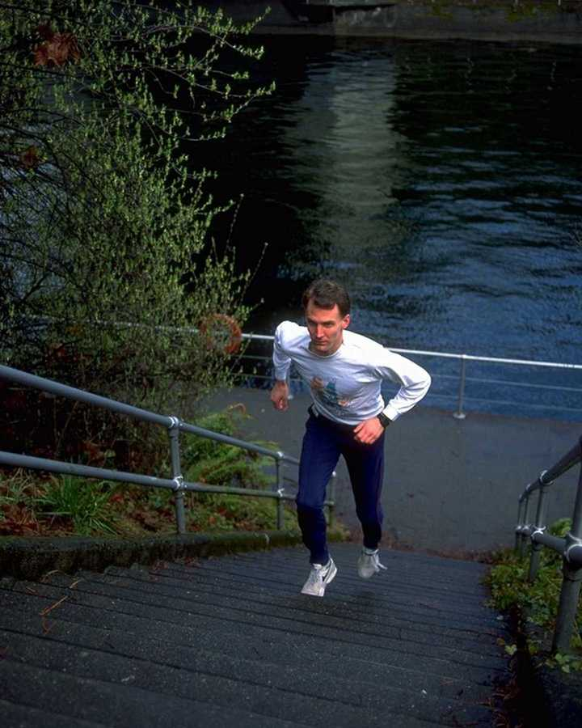
“Stress reduction requires a holistic approach to health”
C. PLANNING YOUR DAY

It is very important to make this new lifestyle free of negative stress. The goal of this program is to provide you with the information and skills needed to make you a new person. For this reason you need to make a list of personal goals you wish to accomplish each day. As taught in time management classes, you need to list 5 to 10 goals to be reached each day and MAKE sure you reach a minimum of 3 to 5 of these goals. If you have reached at least 3 goals per day you have had a successful day. Please make these goals attainable. Do not set goals that cannot be reached. The goals can encompass any area of your life. The goals are intended to be achieved.

D. JUMPING ROPE

It is important to find a time you can make to jump rope. This time needs to be set aside each day and easy to perform jumping rope. Think of jumping rope as important as taking a shower. Just as we make time to shower we need to make time to jump rope.


“At the end of the day, count your blessings and the goals
you achieved that day”
Exercise 8.3

1. How would you describe your personal daily schedule?
______________________________________________________________________________

______________________________________________________________________________

2. What will be your daily schedule, once you decide to change your life?
______________________________________________________________________________

______________________________________________________________________________

3. What will be some personal rules and goals for healthy schedule?
______________________________________________________________________________

______________________________________________________________________________

4. What obstacles do you foresee in creating a healthy schedule?
______________________________________________________________________________

______________________________________________________________________________

5. Name three things you will do this week to get on a healthy schedule?
______________________________________________________________________________

______________________________________________________________________________

“Allow for personal freedom and set your personal sights high”
Module 9
Taking Personal Inventory:
Improving Your Self Esteem

Murphey’s Law Sates:
A memorandum is written not to inform the reader but to protect the writer.

A Road to Success States:
Passion is Every Thing…
-David Copperfield-

What is Your Passion?

Module 9: Taking Personal Inventory:
Improving Your Self Esteem

IMPROVING YOUR SELF ESTEEM

Self-esteem means the evaluation you give yourself regarding your worth as a person. In general, people who regard themselves favorably cope and perform better in all types of stressful situations. Gradually and systematically raising self-esteem, then, is a significant way to help us cope with stress. It is good to set realistic goals. A deep-rooted belief that if one is quite capable, worthy, and "good enough" (despite some real imperfections) that it is a realistic goal. Feel perfect, all-powerful, or boastful is not a realistic goal. Actually, boasting reflects a need to win the approval of others, High self-esteem people are already secure in their own sense of worth, and do not need to boast.

Self-esteem improvements start by accepting yourself where you are, and growing from there.

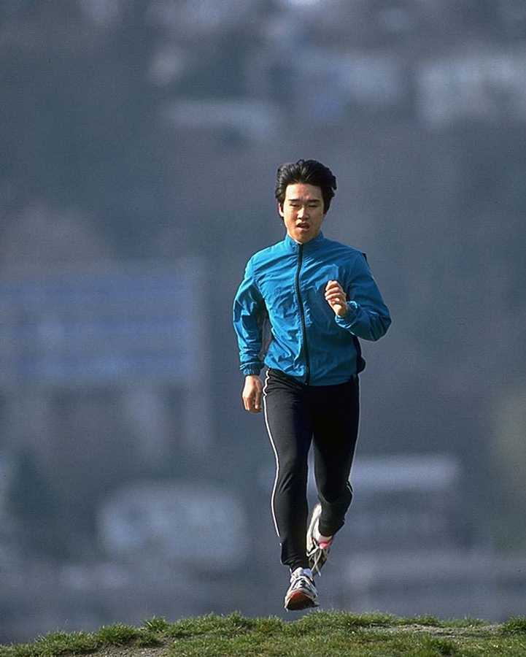
“You can get high on life while running on your path in life”
Exercise 9.1

1. List 5 things you can do well?
______________________________________________________________________________

______________________________________________________________________________

2. How do you feel when you engage in the above activities?
______________________________________________________________________________

______________________________________________________________________________

3. In your own words, how does doing an activity well increase your self esteem?
______________________________________________________________________________

______________________________________________________________________________

4. What does it mean to say “I can do what is necessary”?
______________________________________________________________________________

______________________________________________________________________________

5. How can the above statement help you in your ability to increase your self esteem?
______________________________________________________________________________

______________________________________________________________________________

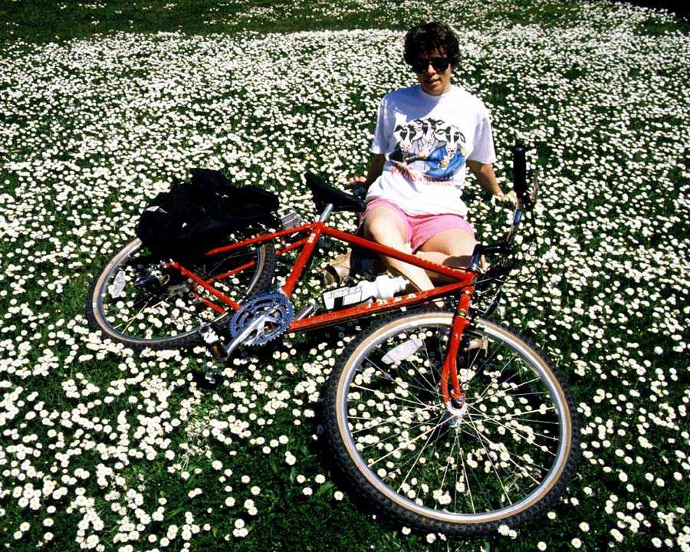
“It is a beautiful thing to feel good about yourself and your environment”
SELF ESTEEM PRINCIPLES

High self-esteem people are confident in their ability in principle to learn and do what is necessary to achieve a satisfying life. They don't need to feel totally capable now or all-knowing now. Instead, they believe in their ability to rise to most challenges. They allow challenges to occur and rise to the challenges as they need to. They understand that they will do their best and that their best is good enough!

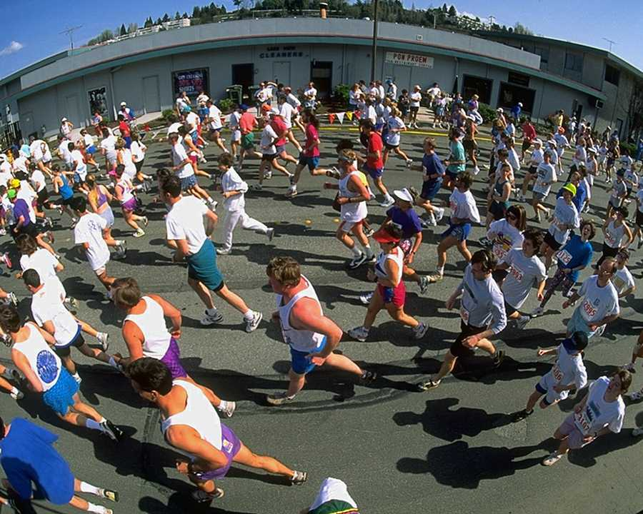
“Building self esteem is like running a marathon-Keep building and you will cross
The finish line to positive self esteem and self worth”

SELF ESTEEM MODEL

We are not always sure which comes first: self-esteem or satisfactory activity. Undoubtedly, they act in a cycle upon each other. In our model we will simply choose to start with satisfactory activity.

1. Satisfactory Activity
2. Sense of "I Can Do What is Necessary"
3. High Self Esteem

1. SATISFACTORY ACTIVITY

This does not imply honors, awards or achievements, although these can be happy results of competent behavior. Neither does it imply that something must necessarily be done perfectly. Rather, it is making sound judgments, or acting competently, lovingly, appropriately, etc. This occurs at distinct points in life and does not necessarily or directly lead to self esteem. For instance, a person who is very successful in business may or may not have high self-esteem. This requires the maintenance of self maturity and the development of resiliency in confronting the challenges we all face in life. Wasting time is the wasting of your most precious resource.

2. SENSE OF "I CAN DO WHAT IS NECESSARY"

This is an assertive attitude that you have the necessary skills and/or knowledge to handle a situation that comes your way. I means that you are confident that you have made the necessary arrangements to provide time, energy, and space to handle the given task. How will you know if you can do it until you try?

3. HIGH SELF-ESTEEM

This is the feeling of a job done right and to your fullest ability. It is compared only to yourself and not to anyone or anything. This if a feeling of doing your best at a given task. At no time should you attempt to compare yourself to other people. If you did your best, you can feel proud of being number one.


You Are a Winner…
WAYS TO IMPROVE YOUR SELF-ESTEEM

Exercise and meditation

Improve your ability to communicate be improving your vocabulary, communication skills, and grammar.

Enjoy hobbies, which remind yourself of your unique worth.

List as many strengths as you can think of under the same categories of physical, mental, emotional, spiritual and social. Every strength counts, no matter how small it seems.

Do something for others. The psychologist, Frankel, who survived the concentration camps of World War II, states that people find meaning in their lives through touching others in a spiritual manner

List your strengths and weaknesses under the categories of physical, mental, emotional, spiritual, and social. Accept what you are good at and what can't be changed, and change what you feel you'd like to change. For example, if you tend to be impatient, resolve to develop patience. Carry an index card around with positive affirmations, such as:

"I AM PATIENT; I HAVE UNDERSTANDING WHEN PEOPLE BEHAVE INCOMPETENTLY."

"I CALMLY EXPLAIN TO PEOPLE WHAT I EXPECT OF THEM BEFORE I GET ANGRY."

"I VIEW UNDESIRABLE EVENTS AS INCONVENIENT, NEVER AWFUL OR CATASTROPHIC."

Read this card throughout the day, and/or put it on your mirror.


“Pass on your success to others so they can share in your accomplishments”
Exercise 9.2

1. What are some ways you can improve your self esteem?
______________________________________________________________________________

______________________________________________________________________________

2. List 5 strengths you have?
______________________________________________________________________________

______________________________________________________________________________

3. List 5 weaknesses you have?
______________________________________________________________________________

______________________________________________________________________________

4. What are two ways you can improve your strengths and overcome your weaknesses?
______________________________________________________________________________

______________________________________________________________________________

5. List 10 affirmations to use in the future:
______________________________________________________________________________

______________________________________________________________________________
“Conquering stress is like conquering a mountain”
DAILY SELF ESTEEM AFFIRMATIONS

1. I LIKE MYSELF.

2. I LIKE MYSELF WITHOUT COMPARING MYSELF TO OTHERS.

3. ALL PEOPLE ARE OF GREAT WORTH - INCLUDING ME.

4. I HAVE DECIDED THAT I AM WORTHWHILE.

5. I AM CONFIDENT, SELF-ASSURED, AND TRANQUIL.

6. I BELIEVE IN MY RICH POTENTIAL TO GROW.

7. I VALUE MY ABILITY TO WORK.

8. I RESPECT MYSELF BECAUSE I GENERALLY DO MY BEST.

9. I AM AS COMFORTABLE WITH MY STRENGTHS AS I AM WITH MY WEAKNESSES.

10. I ACCEPT MYSELF, AND ENJOY STRIVING TO BETTER MYSELF.

11. I HAVE UNWAVERING FAITH IN MY ABILITY TO PROGRESS.

12. I AM WORTHY OF LOVE AND RESPECT FROM MYSELF.

13. I AM WORTHY OF LOVE AND RESPECT FROM OTHERS.

14. GIVEN THE TIME AND THE DESIRE, I CAN DO ANY REASONABLE TASK I CHOOSE.

15. I FEEL COMFORTABLE IN SOCIAL AND BUSINESS SITUATIONS.

16. I HAVE A CHEERFUL DISPOSITION. I CAN LAUGH AT MY MISTAKES.

17. I DESERVE REGULAR TIME TO RELAX.

18. SECURE IN MYSELF, I CAN CARE ABOUT AND TOUCH OTHERS.

19. I DELIGHT IN MY ACHIEVEMENTS, NO MATTER HOW SMALL.

20. I ENJOY MAKING OTHERS FEEL HAPPY AND LOVED.

Reading these daily affirmations should be repeated daily for two weeks or more. It is helpful to visualize the affirmations upon waking and before going to bed. Try placing the affirmations on a cassette tape, allowing time between affirmations to visualize each as though it is already true. During the day you might work on one or two affirmations. Place them on index cards and refer to it often. During the day write out affirmation 10 times.

“Affirm yourself from the start of the day”
Exercise 9.3

- What will keep you from practicing your daily affirmations?
______________________________________________________________________________

______________________________________________________________________________

- How will your using daily affirmations affect your self esteem?
______________________________________________________________________________

______________________________________________________________________________

- What self talk do you use that causes you to think negatively about yourself?
______________________________________________________________________________

______________________________________________________________________________

- How self talk do you use that causes you to think positively about yourself?
______________________________________________________________________________

______________________________________________________________________________

5. What are 5 goals you can use to build your self esteem over the next 7 days?
______________________________________________________________________________

______________________________________________________________________________


“Developing good self esteem is not like climbing a mountain”
Module 10

Making The Climb:
Pulling it Together

Murphey’s Law States:
Every solution breeds new problems.

A Road to Success States:
“The easiest thing in the world is to come up with an excuse not to do something. I found that the most important thing in life is to stop saying, “I wish and start saying I will.”

-David Copperfield-

Are You Ready for Your Race?
Module 10: Making The Climb:
Pulling It All Together

Now it is time to pull together all of the information and skills that you have learned in this stress management program. We are going to assist you to complete your own personal stress management program that you can implement and start using immediately. This is the final step in the program and it is individually tailored by you for you to identify and intervene on behalf of your own stress management needs. During this part of the program, you will pick a particular stressor/situation that you want to work on. Make copies of these forms so that you can use the originals over and over again. This part of the program is divided into steps and they are as follows:

Individualized Stress Management Program Plan

STEP ONE

Read the following lists and check those stress signs that you are currently experiencing. This step involves the recognition of your own stress symptoms from the list below:

MY PHYSICAL SIGNS OF STRESS

_____Tight neck and shoulders _____Pounding heart (not anxiety)
_____Chest pain (not heart problems) _____Headaches
_____High blood pressure _____Stomach upset
_____Fatigue _____Cold, sweaty palms
_____Eye strain _____Excessive perspiration
_____Gastro-intestinal upset _____Nervous tics
_____Teeth grinding _____Skin rashes
_____Increased urination (not diabetes) _____Weight loss/gain

MY EMOTIONAL SIGNS OF STRESS

_____Depression ____Other:__________________________
_____Irritability
_____Impatience
_____Suspiciousness
_____Anger
_____Apathy/hopelessness
_____Worry
_____Dislike of self

MY BEHAVIORAL SIGNS OF STRESS

_____Overeating _____Forgetfulness
_____Increased smoking/drinking _____Reckless driving
_____Fighting/arguing _____Drug use
_____Increased errors on the job _____Crying
_____Withdrawal from friends/activities _____Poor concentration
_____Lack of enthusiasm _____Other:__________________________
STEP TWO

Stress can come from almost every aspect of your life. There may be big changes or events that are stressing you such as disrupted family relationships, job changes or lay offs, major illnesses, sick family members, etc.) as well as many little events which, over time, can add to your stress level. Becoming aware of your specific stressors, both big and small, is the next step toward effectively managing your stress.

This step involves the development of your own stress list. List everything you worry about-anything and everything that causes you concern or makes you uneasy, including:

PERSONAL: Health and well being, comfort, success, safety, behavior
FAMILY: Loved ones, health, finances, changes
WORK: Concerns, co-workers/customers, performance, future, changes
COMMUNITY: Neighborhood, taxes, politics, school, crime
GLOBAL: War, economy, human rights, environmental worries
TRIVIA: the nagging little irritations of daily life

My Stressor List Includes:

1.

2.

3.

4.

5.

6.

7.

8.

9.

10.


Look for Guidance…

STEP THREE

This step involves determining when your stressor becomes burnout. This involves identifying personality traits that you may have that may contribute to stress. Check those personality traits from the list that you currently are experiencing:

_____Perfectionism
_____Overly committed
_____Need to prove oneself
_____Strong goal orientation
_____Difficulty saying “no”
_____Difficulty delegating authority
_____Self sacrificing
_____Being a “giver” rather than a “receiver”
_____Other:________________________________________________________________________
Now, check those signs that the stressor has become burnout that you are currently experiencing:

_____Frustration and irritability
_____Easily angered
_____Feelings of emptiness and sadness (not Major Depression)
_____Inability to concentrate (not ADD)
_____Pessimism
_____A continual sense of being overwhelmed
_____Resentment
_____Loss of self esteem
_____ Depression and emotional exhaustion
_____Other:_____________________________________________________________________


Find your Safe Harbor…
STEP FOUR

This step involves re-thinking the ways that you look at stress. You will need to consider the following as you proceed through the development of your own personal stress management plan. Consider the following when you are looking at a stressor to change/modify:

1. Learn to recognize the immediate response that you typically make to stress. This includes your thoughts about the stressor/situation, your emotional reactions to the stressor/situation and your actions to the stressor/situation.

MY IMMEDIATE RESPONSE TO STRESS IS:

__________________________________________________________________________________________________________________________________________________________________________________________________________________________________________________________________________________________________________________________________________________________________________________________________________________________

2. Reframe the event/situation in more positive terms. We often “awfulize” events that do not have to be seen that way. We have a choice as to how we see the events and how we interpret them.

MY AWFULIZING RESPONSE IN STRESSFUL SITUATIONS USUALLY IS;

______________________________________________________________________________________________________________________________________________________________________________________________________________________________________________________

A POSITIVE REFRAME OF THE CURRENT STRESSFUL EVENT/SITUATION IS:

________________________________________________________________________________________________________________________________________________________________________________________________________________________________________________________________________________________________________________________________________

3. Replace the “awfuls and shoulds” with more constructive thoughts about how to problem solve and to be less black and white in your thinking. You will be amazed at how much better you feel when you are able to say to yourself, “It’s not so bad”.

MY AWFULS AND SHOULDS INCLUDE THE FOLLOWING WHEN I AM STRESSED:

MY NEW CONSTRUCTIVE THOUGHTS IN THIS SITUATION ARE AS FOLLOWS:

____________________________________________________________________________________________________________________________________________________________________________________________________________________________________________________________________________________________________________________________________________________________________________________________________________________________________________________________________________________________________________

STEP FIVE

Step five involves applying the A-B-C-D-E Model of stress management to your every day living. Pick a particular stressor that you want to address in your stress management program. The A-B-C-D-E Model of stress management is as follows:

A= The activating event that starts a potential stress response

What activating event or situation started your stress response/reaction?

______________________________________________________________________________________________________________________________________________________________________________________________________________________________________________________

B= The belief or self talk that the person says to themselves about the event

What self talk or beliefs are you thinking and saying to yourself about the event?

______________________________________________________________________________________________________________________________________________________________________________________________________________________________________________________

C= The consequence or your stress reaction

What is the consequence of your reaction and thoughts and beliefs about the stressful event?

______________________________________________________________________________________________________________________________________________________________________________________________________________________________________________________

At this point, it is important that you QUESTION the irrational self talk that you hear from your thoughts and then replace the SHOULDS and AWFULS with more positive thoughts and positive possibilities. Add two new steps to change the SHOULDS and AWFULS:

D= QUESTION-“Why is it so terrible? What can I do instead of worrying or feeling upset?”

What is so terrible about the situation that you cannot stand to consider it or what is so upsetting?

______________________________________________________________________________________________________________________________________________________________________________________________________________________________________________________

E= ANSWERS-“It’s not so bad, it’s not a disaster, I can stand it! I want things to be different but it doesn’t have to be MY WAY”. “I can’t control it so there is no use worrying about it”.

What can you say or do to help you realize that you will get through this situation or that you will resolve your stressors successfully as you have in the past?

______________________________________________________________________________________________________________________________________________________________________________________________________________________________________________________

Instead of saying, “I should be” or “I must” or “It’s not MY FAULT”, try instead “I am”, “I want to”, “Let’s fix it” and “I’m doing what’s important to me”.

STEP SIX

Step Six is to “Avoid the Blame Game”. This involves not pointing fingers at others; not having rigid expectations of yourself or others; not having a low frustration tolerance of others, etc. Instead, do practice rational self acceptance; do accept your own imperfections; do accept the imperfections of others; and do respect but don’t over value achievement over other aspects of yourself are equally or more important than your positive qualities.

I can avoid the Blame Game by saying or doing the following:

__________________________________________________________________________________________________________________________________________________________________________________________________________________________________________________________________________________________________________________________________________________________________________________________________________________________

STEP SEVEN

Step Seven involves taking the data from the first six steps and then applying it to the stressor that you identified that you wanted to resolve or cope with. Now you will need to take the information that you have compiled and make a list of coping skills that you will use to decrease your stress and improve your coping skills with the stressor that you are working on.

The list of coping skills that I will use to cope with the stressor that I have identified and am developing a coping plan for:

COPING SKILL LIST

1.

2.

3.

4.

5.

6.

7.

8.

PLAN TO IMPLEMENT COPING SKILLS
____________________________________________________________________
SKILL IMPLEMENTATION DATE WHERE WHEN SUCCESSFUL Y N
__________________________________________________________________________________

1.

2.

3.

4.

5.

6.

7.

8.

9.

10.

We believe that you will be successful if you follow the steps in this stress management plan. We have used these steps with hundreds of clients successfully. You can use these steps to resolve any presenting stressor or problem that you may confront. We hope that you have enjoyed working the Stress Management Program and that you have been successful in your attempts to resolve your stressors and presenting concerns.

We want to thank you for purchasing this program and for working it and for being willing to change your life.


Have you come to peace with yourself?
Our Final Thoughts

We have worked developing this Stress Management Program over the past several years. We have field tested it with numerous clients in our private practices. We have experienced success with hundreds of clients using this program. We are pleased to offer you this program for your use and implementation.

The Stress Management Program offers you the opportunity to make meaningful and permanent changes in your life. You have the opportunity to modify your habit patterns and to improve the quality of your life from this point on. We chose the various program modules with the idea that each one would assist you in an important aspect of your life that likely would require intervention.

Our stress management program is an educational and self help program and is not a therapy or counseling program. This program will allow you to learn more about stress management and how to promote self change but it is not a substitute for professional one to one therapy or counseling services in a professional’s office. However, meaningful change and growth can occur through self help and educational programs as is evidenced by the positive impact of 12 step programs in the lives of millions of people.

Please feel free to provide the authors with feedback regarding this program by emailing the authors at the following email address: scubabob@scubabob.net .

Again, thank you for purchasing this stress management program.

Dr. Robert Knapick

